Powhatan Confederacy Petition

**Attachments**

## Powhatan Genetic Study

### Ashton James Snow Jefferson (Morris) 23andMe Results

**Autosomal**

**Attachments: 1 & 2**

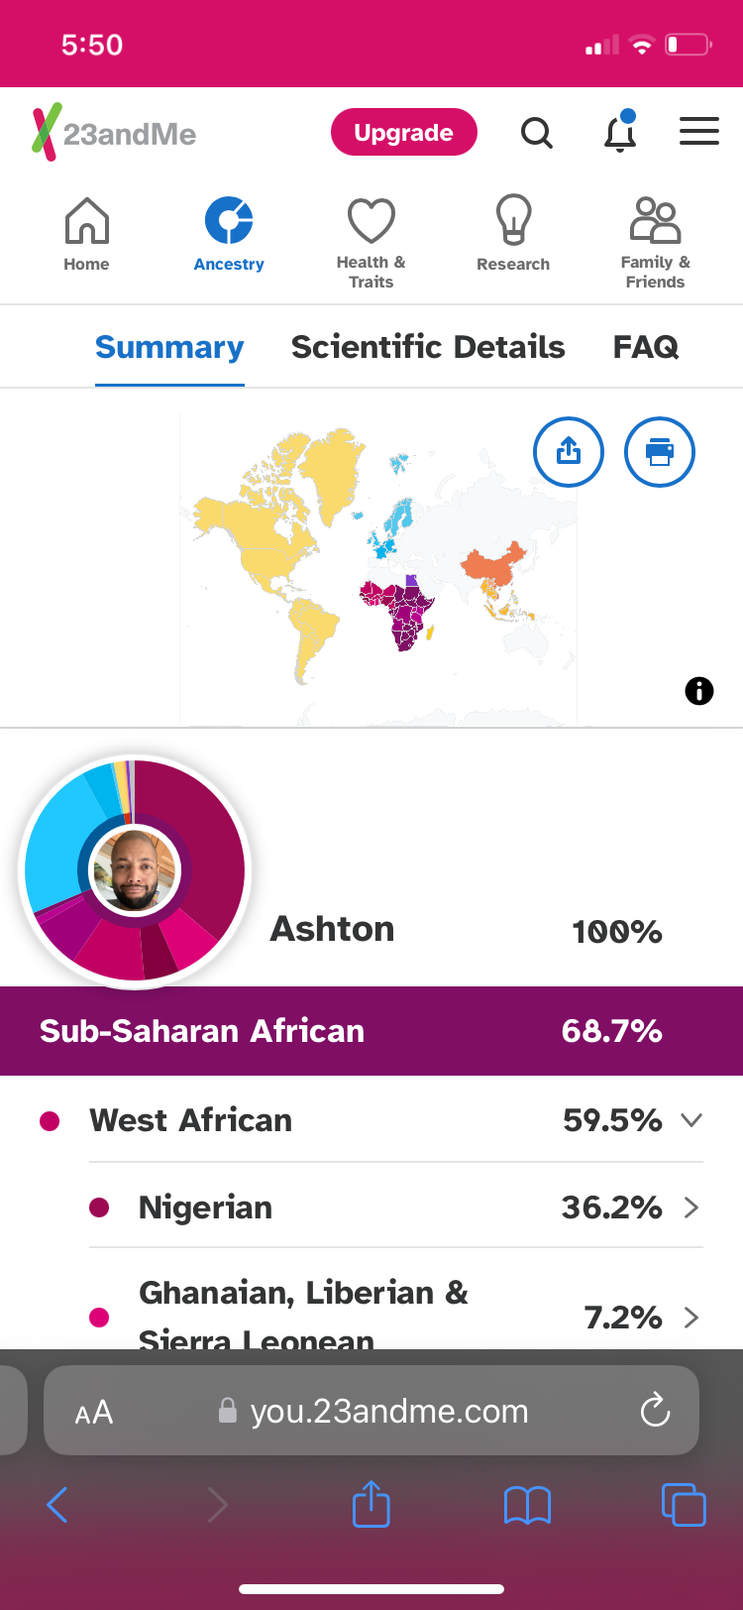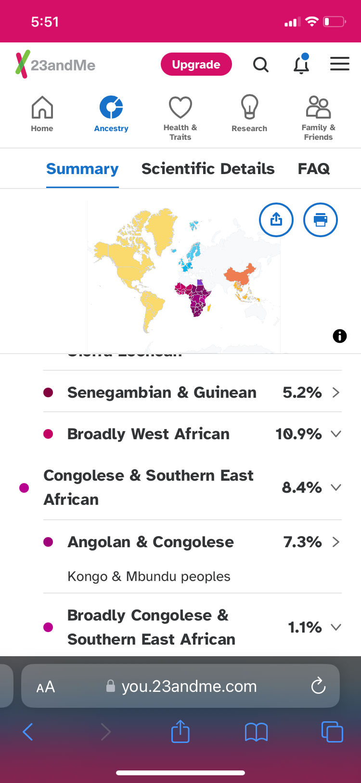

**Attachments: 3 & 4**

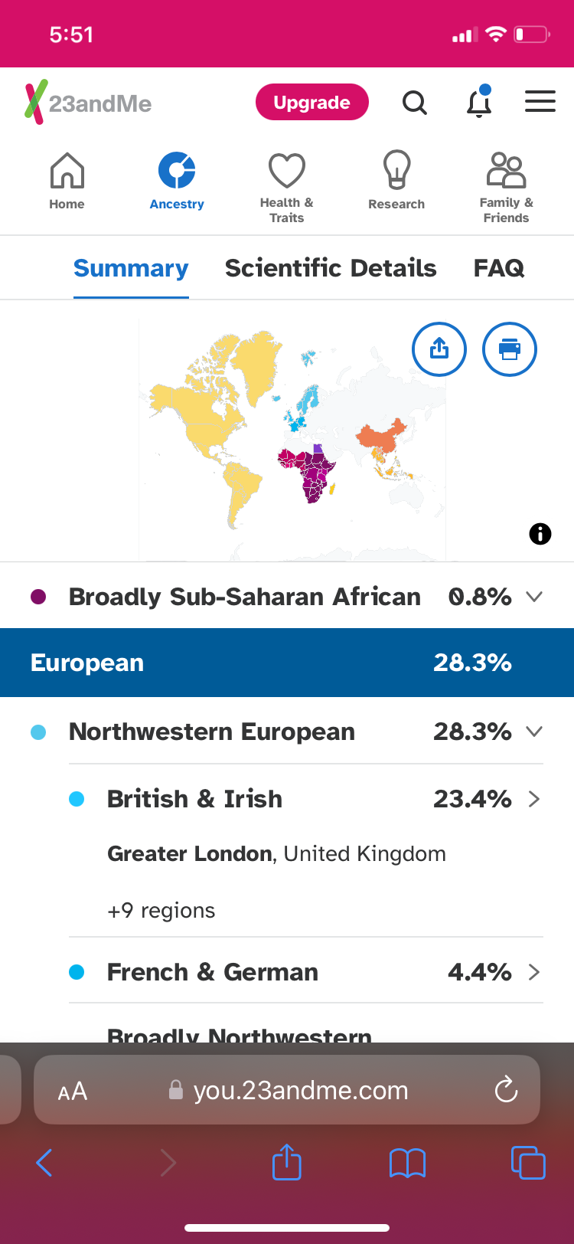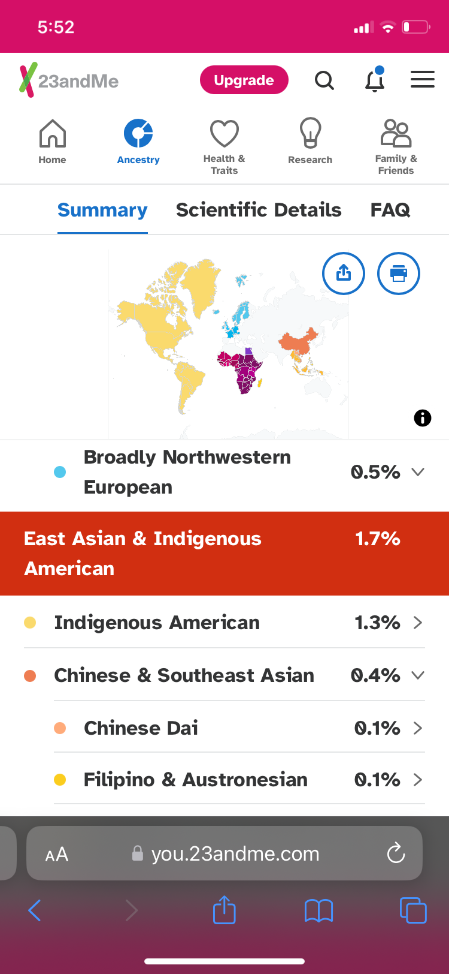

**Attachments: 5 & 6**

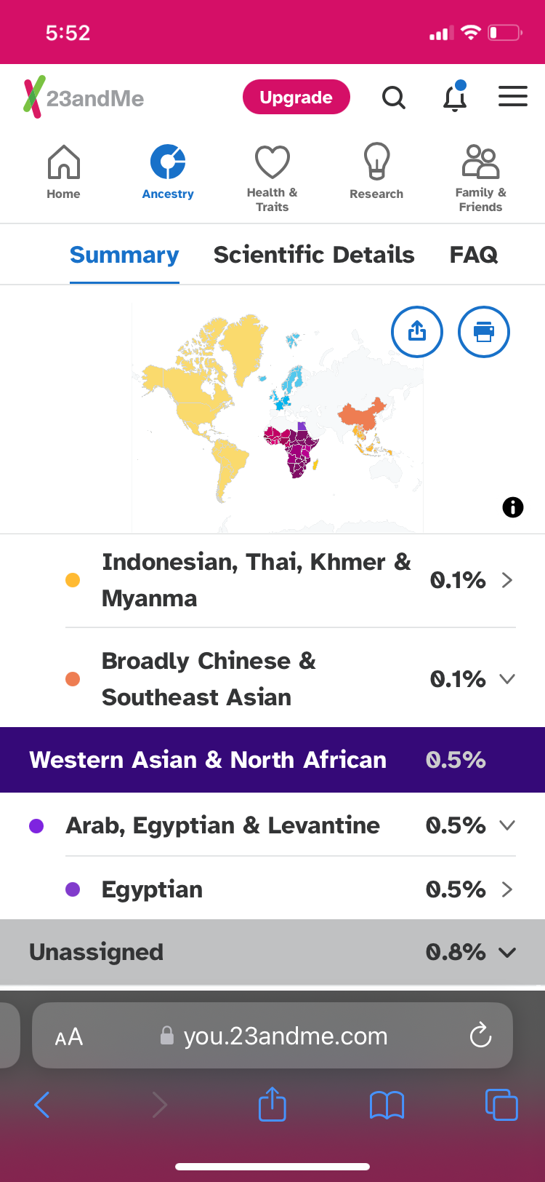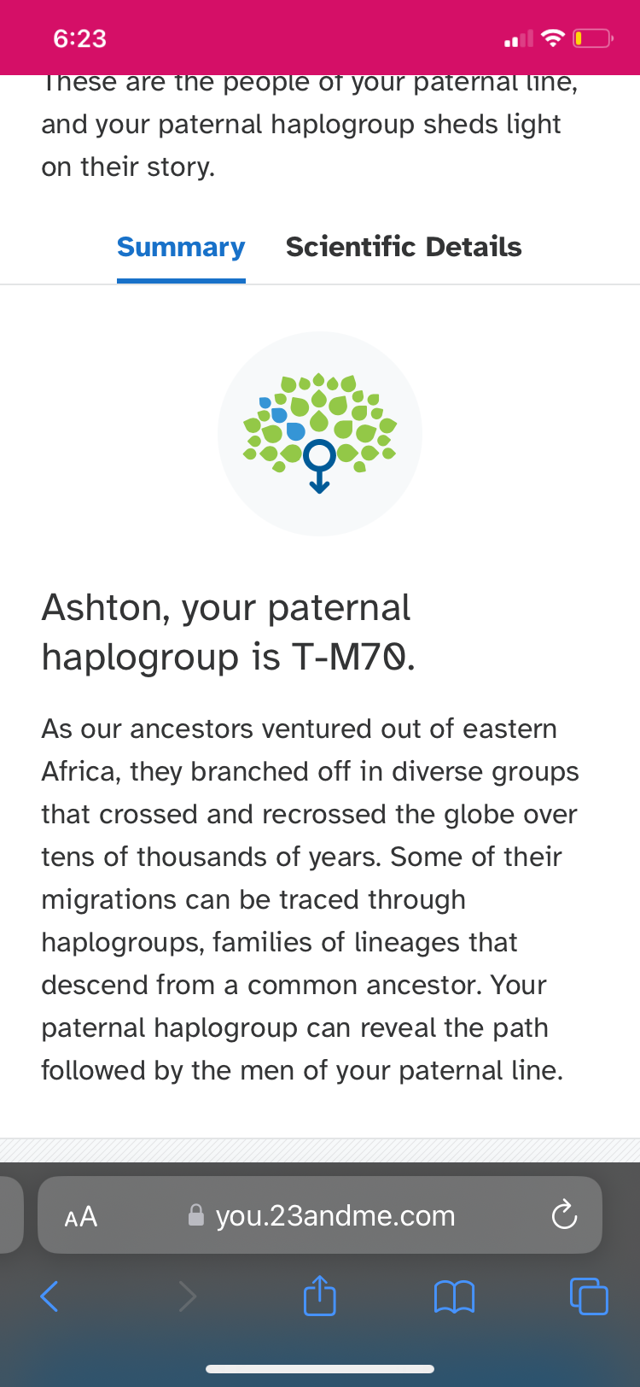

**Notes:**

1. **Ashton has 1.3% Indigenous American ancestry.**
2. **All Indigenous Americans have a percentage of East Asian DNA.**
   1. **This can be seen from other Powhatans, Navajo, and Latinos with Indigenous American ancestry.**

**Chromosomal**

**Attachment: 7**

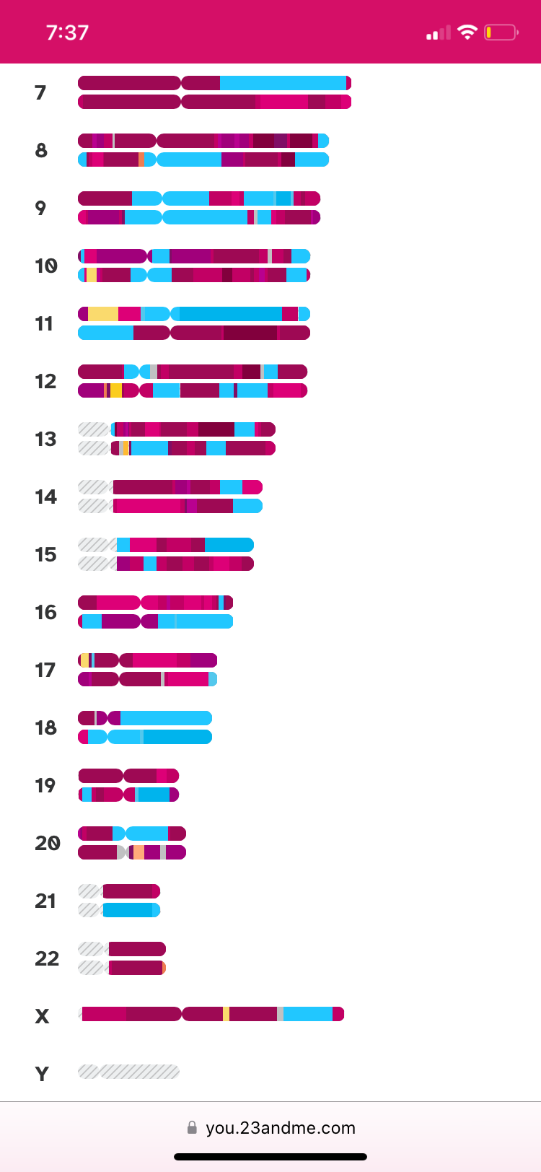

**Notes:**

1. **Ashton’s x-chromosome is visible on this visualization provided by 23andMe.**
2. **Ashton’s x-chromosome has Indigenous American (yellow) markers.**
   1. **This means Ashton’s maternal line is indigenous to the United States.**
   2. **Specifically, Ashton’s x-chromosome comes from a Native American woman from McDowell, West Virginia, USA.**

**Attachments: 8 & 9**

**Tribal member Reginald Parker**

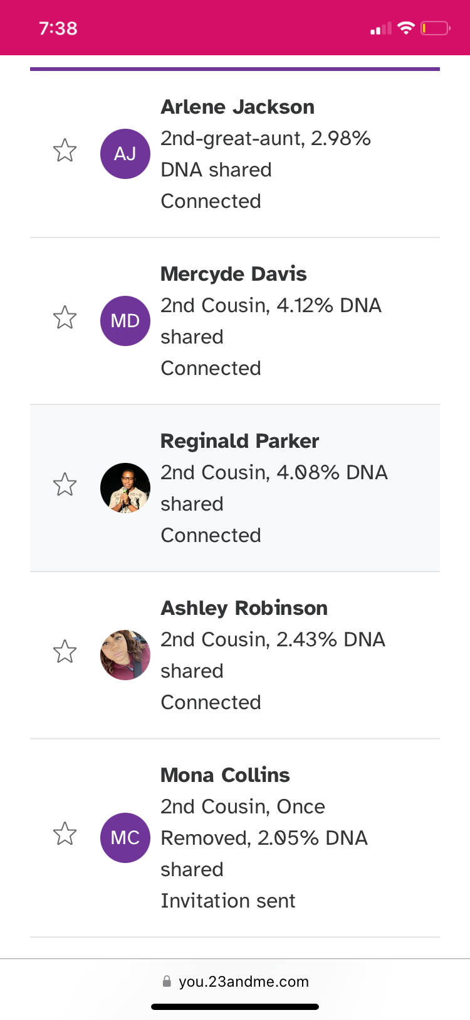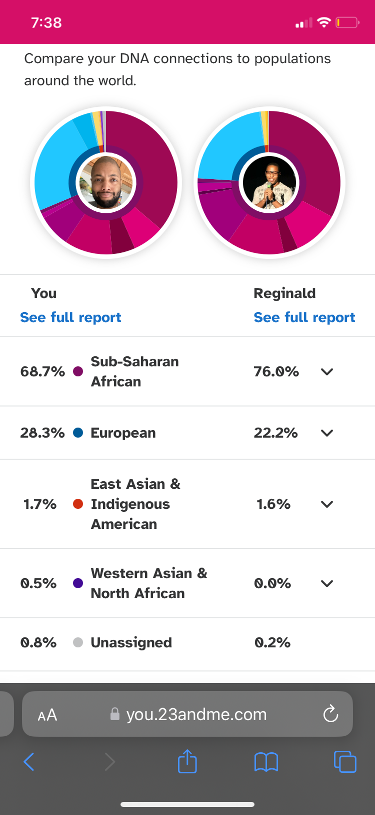

**Attachments: 10 & 11**

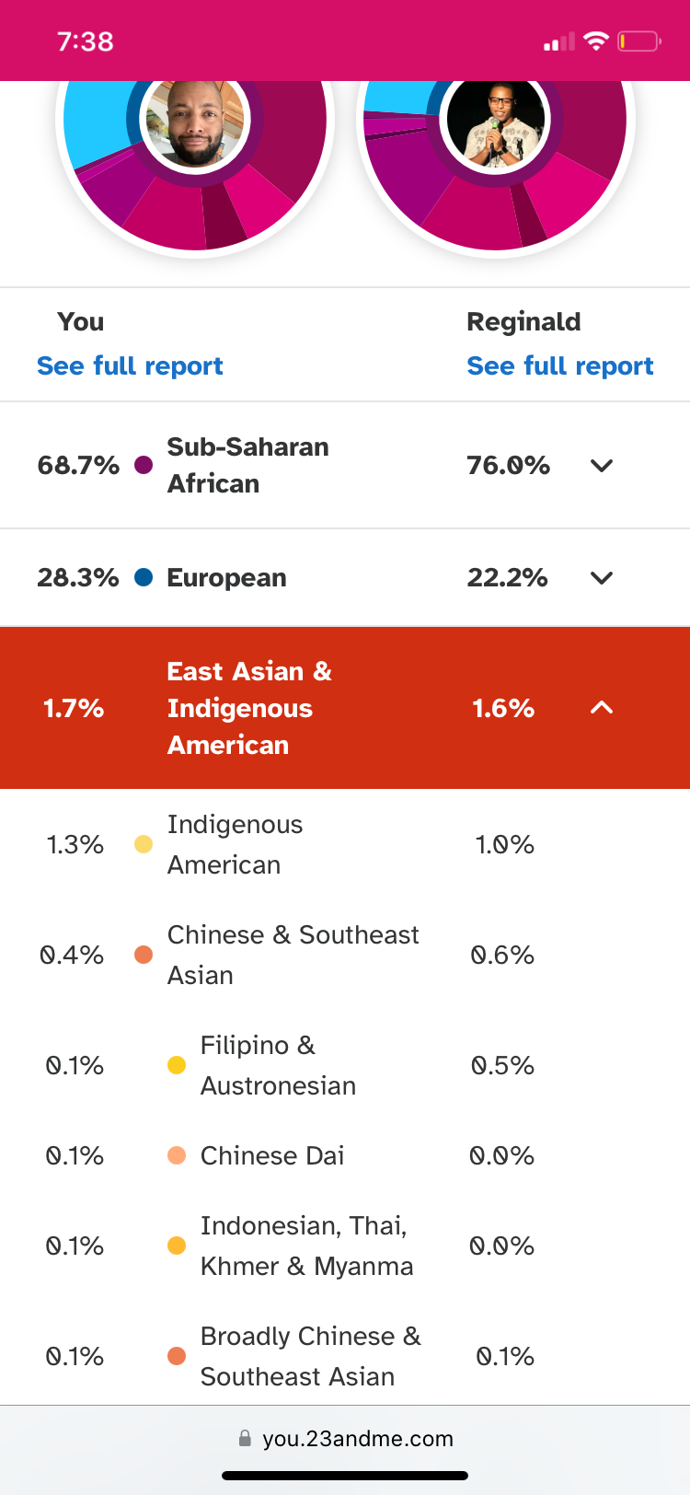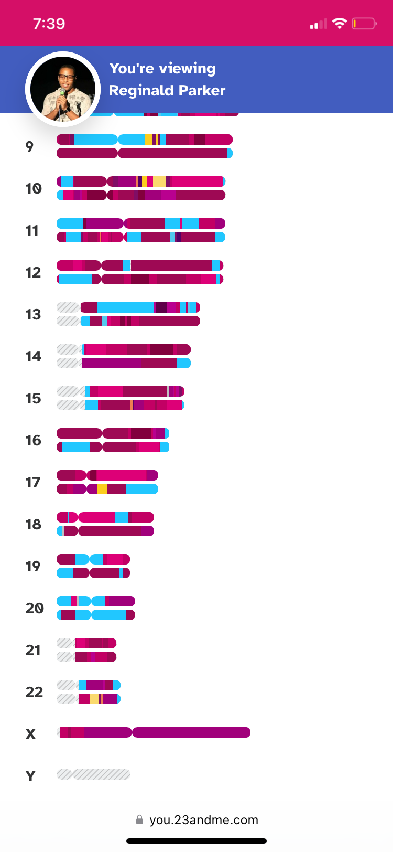

**Notes:**

1. **Reginald Parker’s x-chromosome is entirely sub-saharan African.**

**Attachments: 12 & 13**

**Tribal member Ashley Harris**

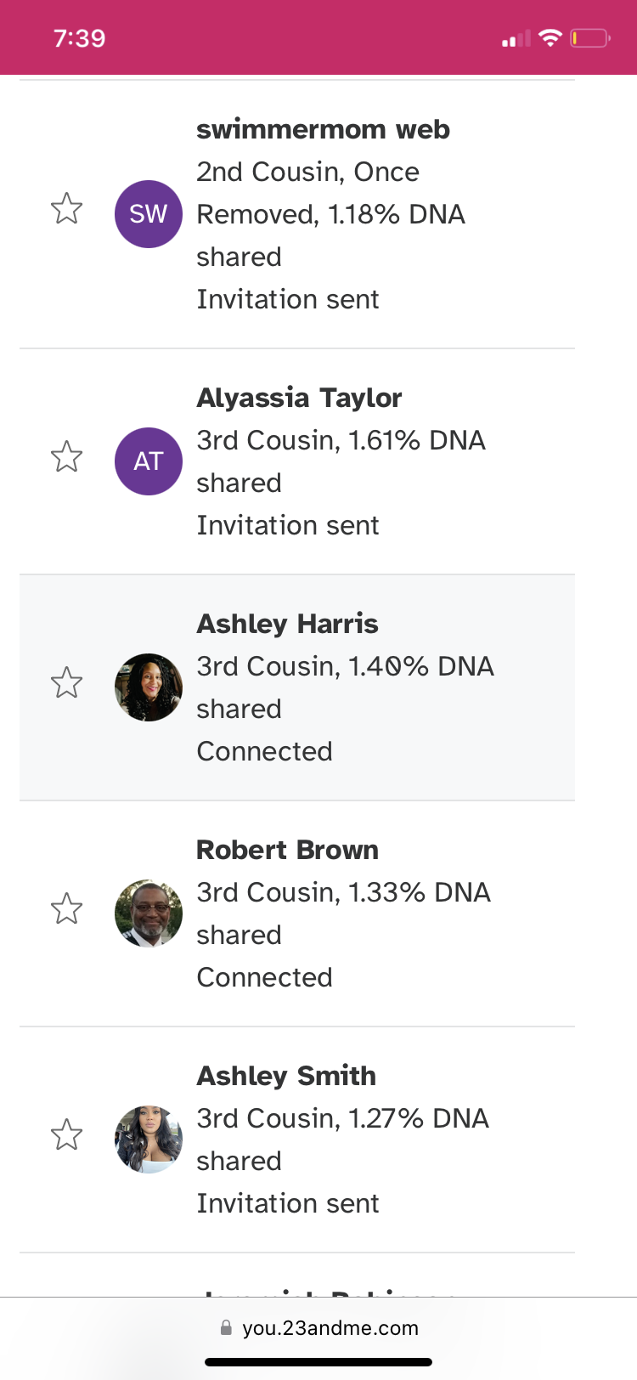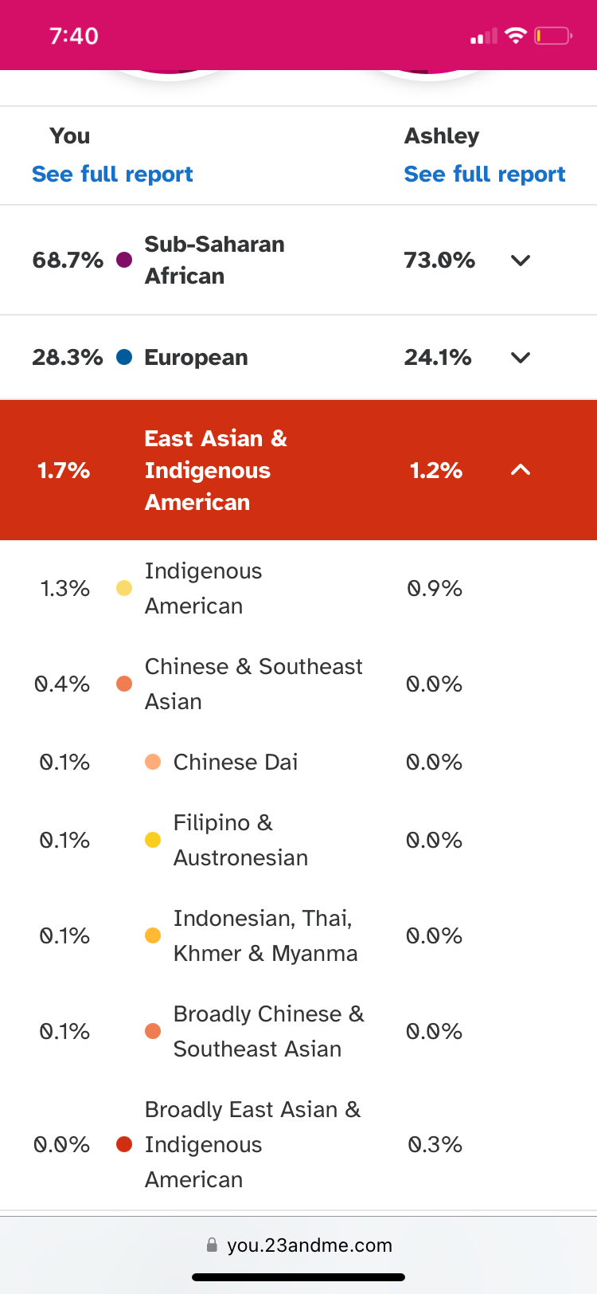

**Attachments: 14 & 15**

**Tribal member Hundley Jenkins**

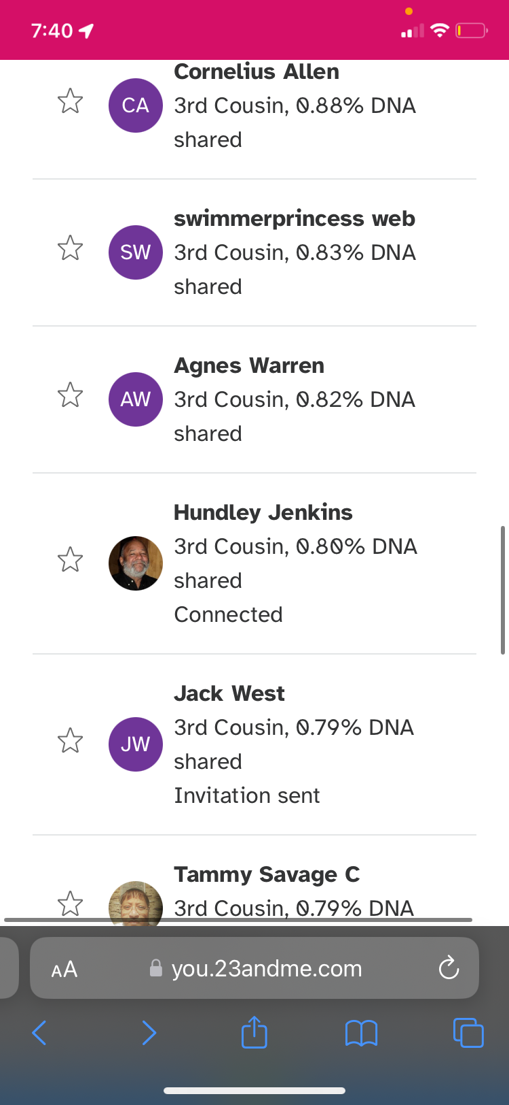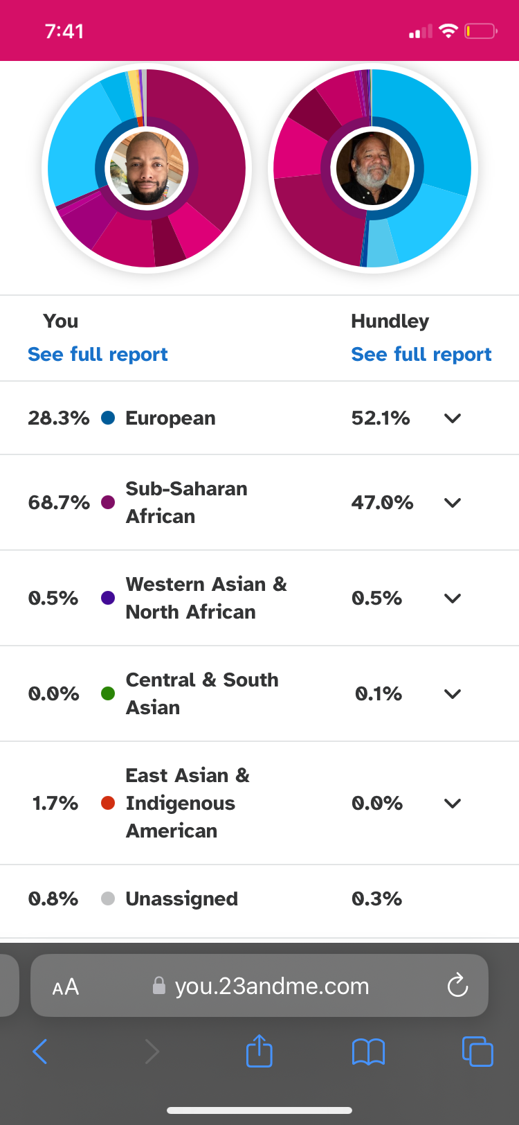

**Attachments: 16 & 17**

**Tribal member Harold Morris (Jefferson)**

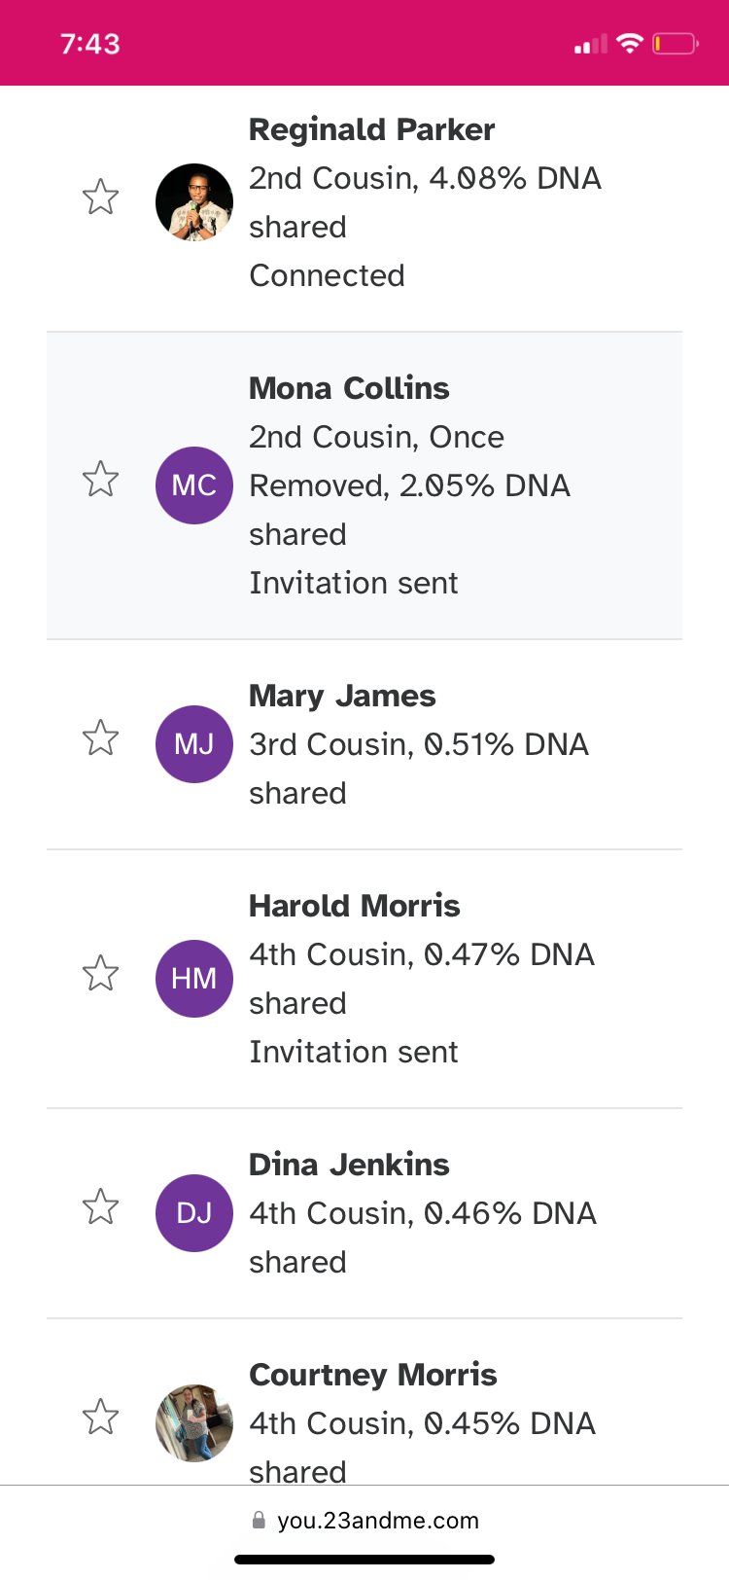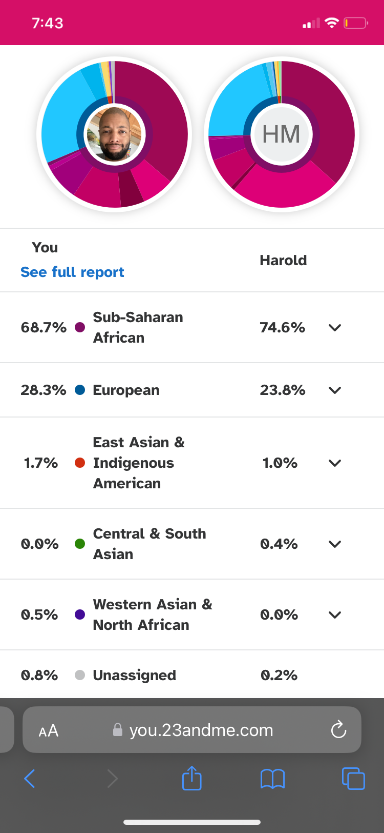

**Attachment: 18 & 19**

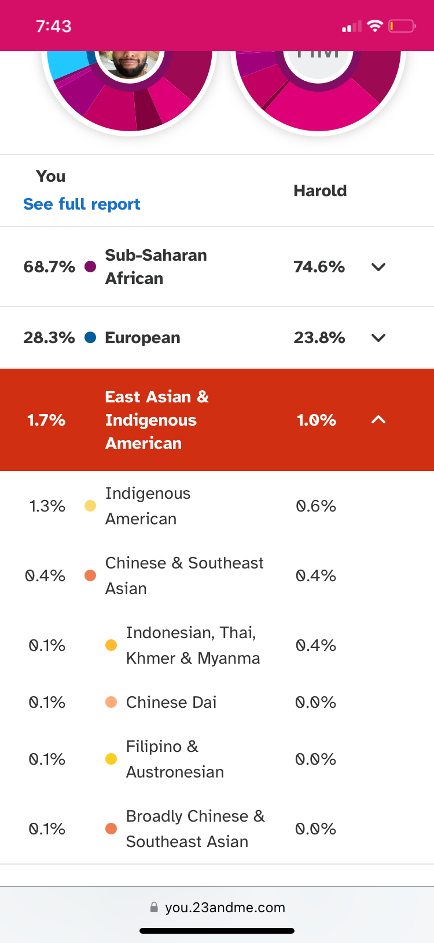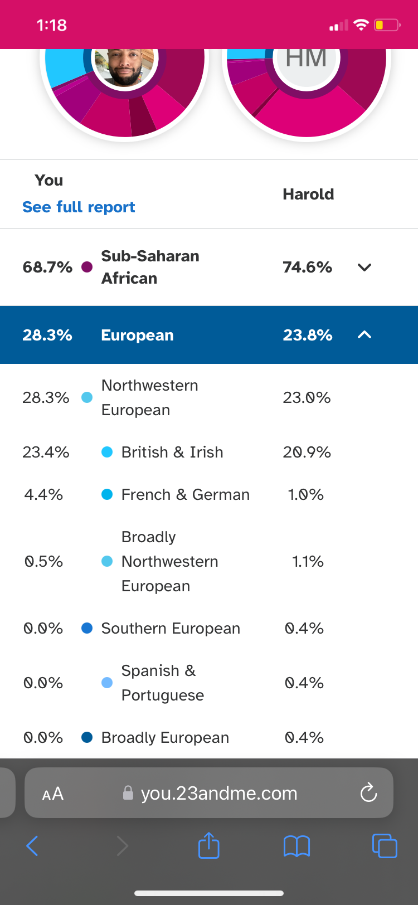

### India Hatten

**Description: A non-tribal member with significant Indigenous American ancestry, and an Indigenous x-chromosome.**

**Attachment: 20, 21, 22**

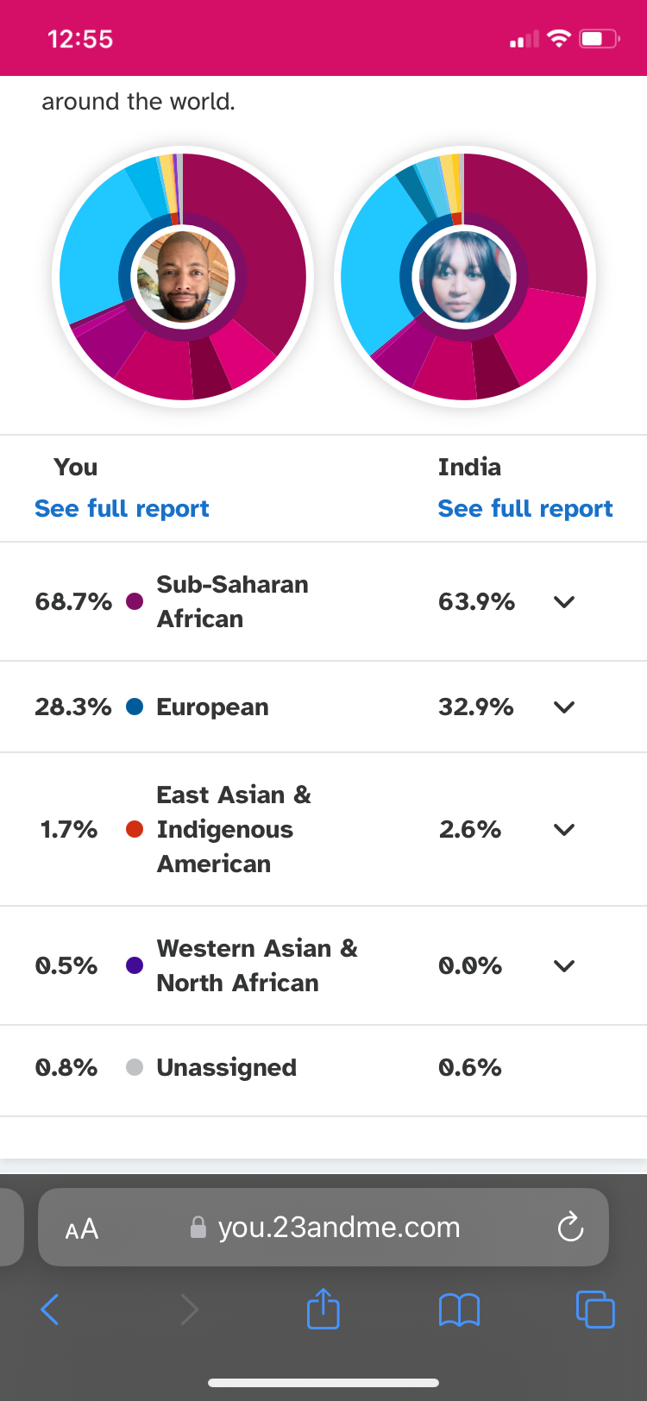

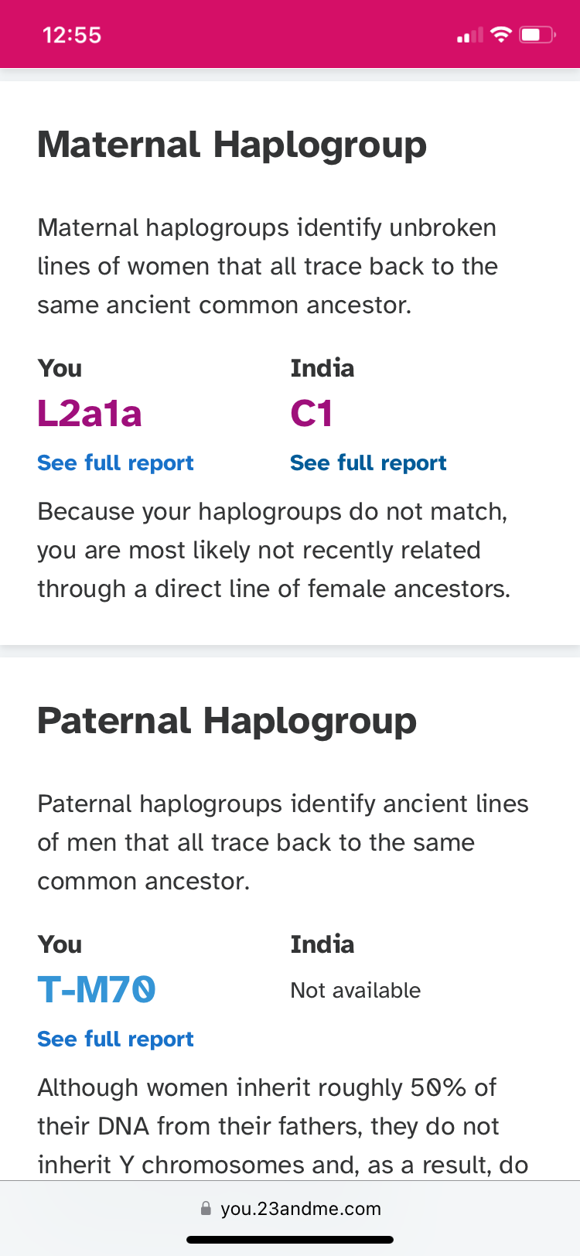

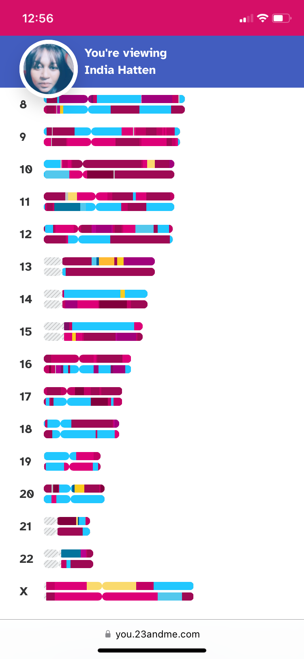

**Note:**

1. **Note the Indigenous American (yellow) markers on India’s x-chromosome.**
2. **Compare India’s x-chromosome to that of Ashton Jefferson (Morris) and Reginald Parker.**
3. **India is 100% white-passing, but 63.9% Sub-Saharan African.**

### Other Indigenous American chromosomes.

**Attachments: 23 & 24. Michael Hatten has an Indigenous American maternal chromosome.**

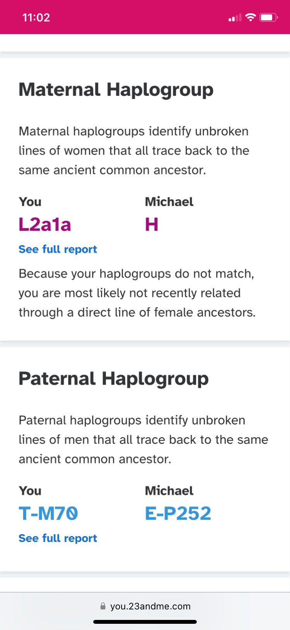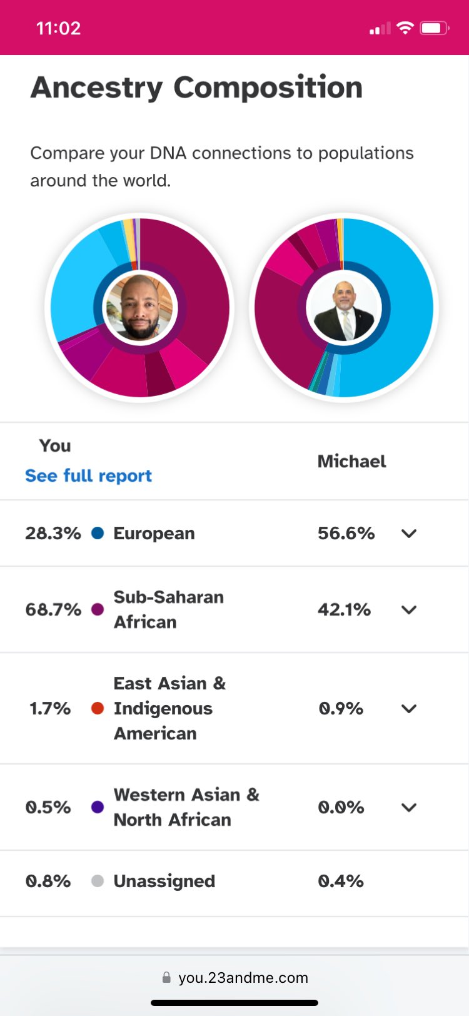

**Attachments: 25 & 26. Karen has an indigenous American maternal chromosome.**

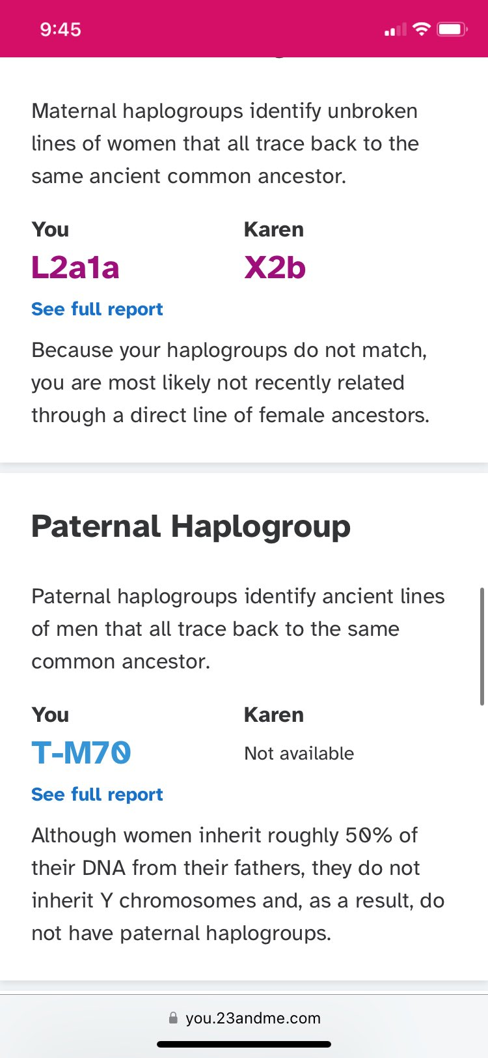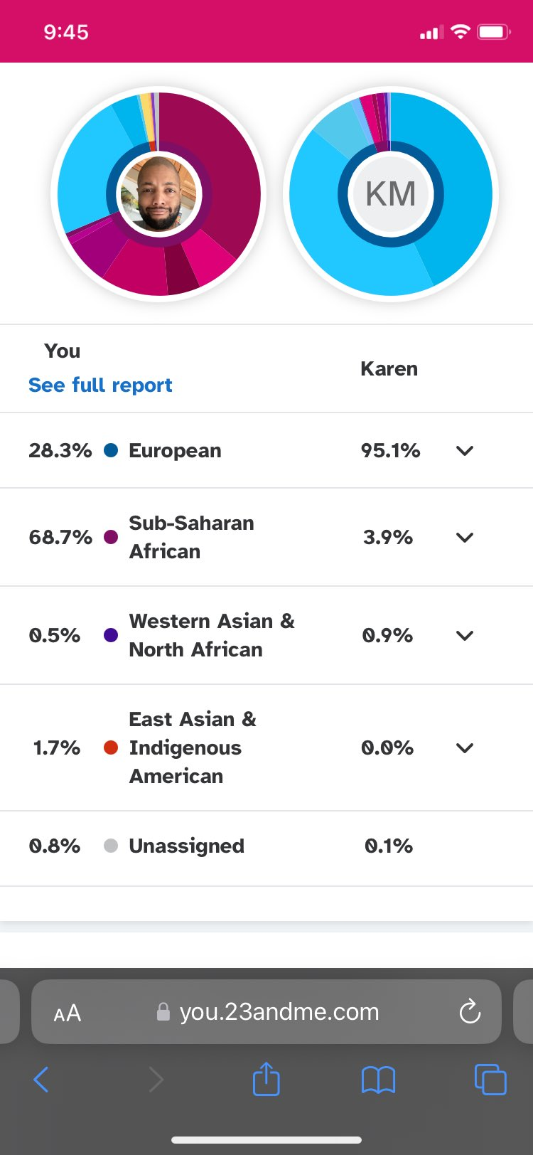

**A DNA match with a person with ¼ Indigenous American Ancestry**

**Attachments: 27.**

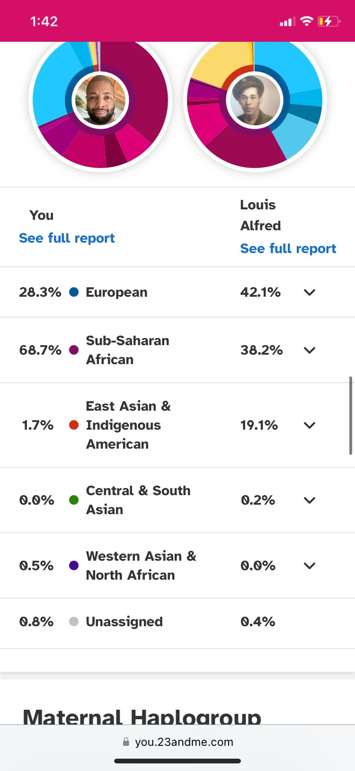

### An African-American from Virginia’s 23andMe results.

**Attachments: 28 & 29**

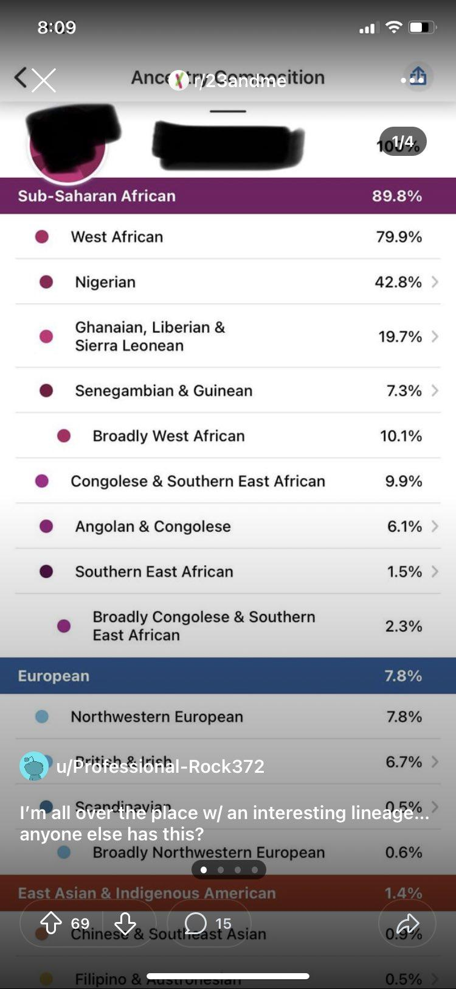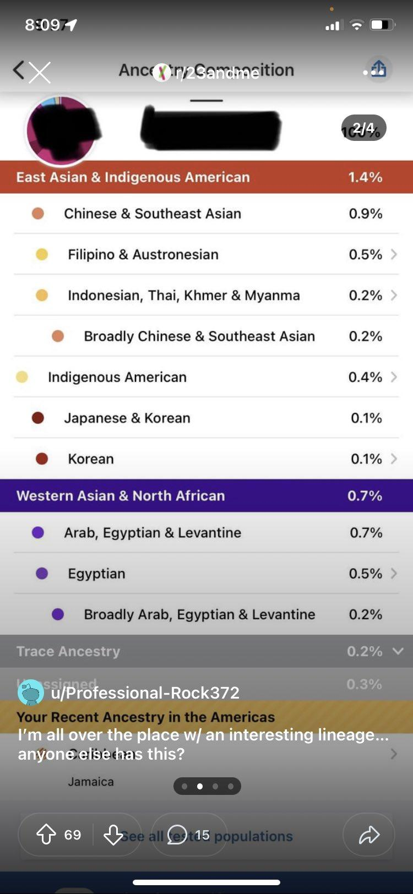

**Notes:**

1. **This Virginia man has recent Indigenous American ancestry.**
   1. **His DNA shows Chinese, Japanese and Korean markers alongside Egyptian, like Ashton.**

### A Latino’s 23andMe results.

**Attachments: 30**

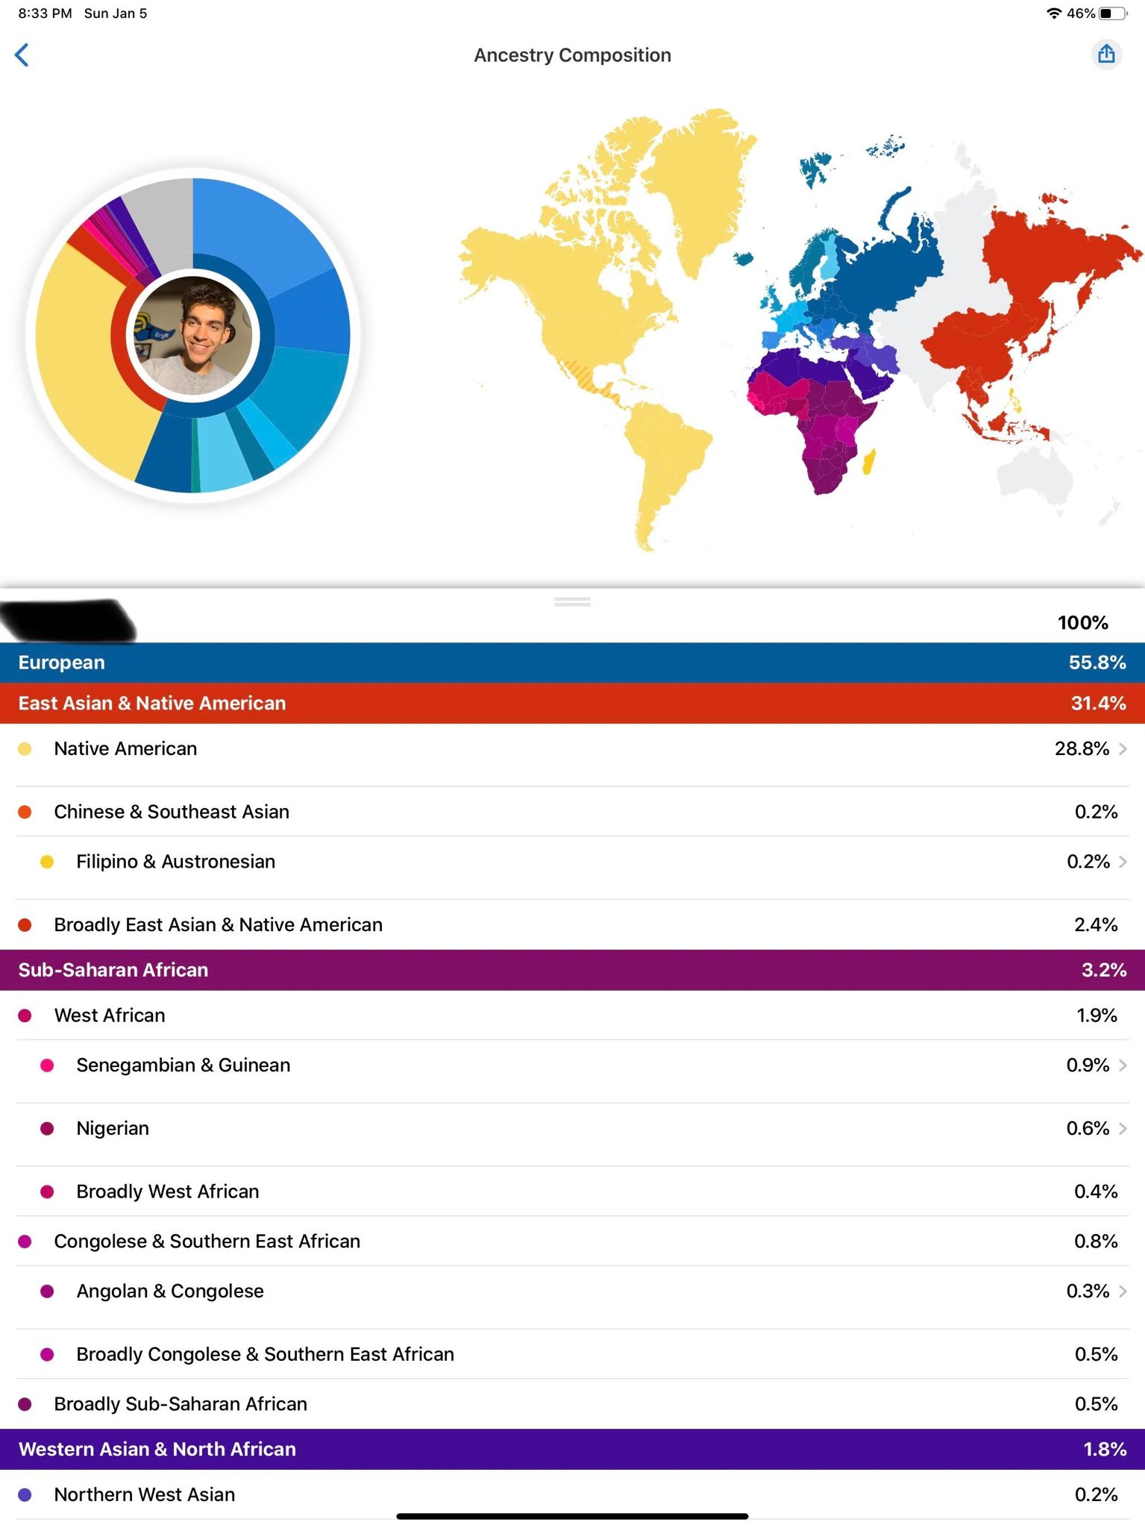

**Notes:**

1. **Note the Chinese ancestry.**

### 

### A half Mexican, half African American’s 23andMe results

**Attachment: 31 & 32**

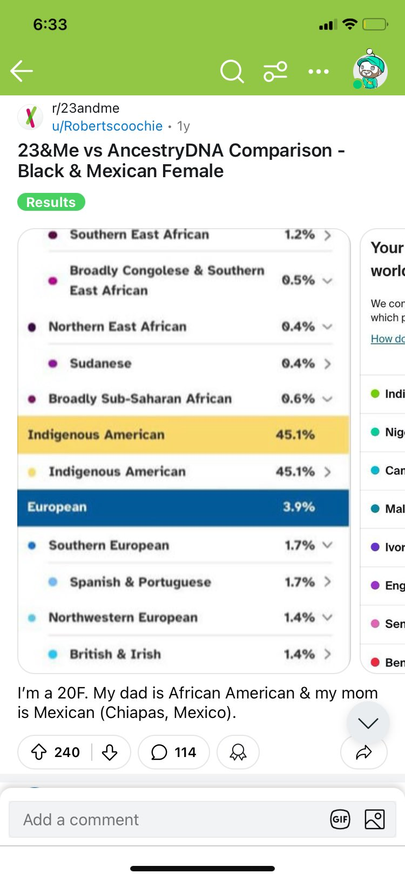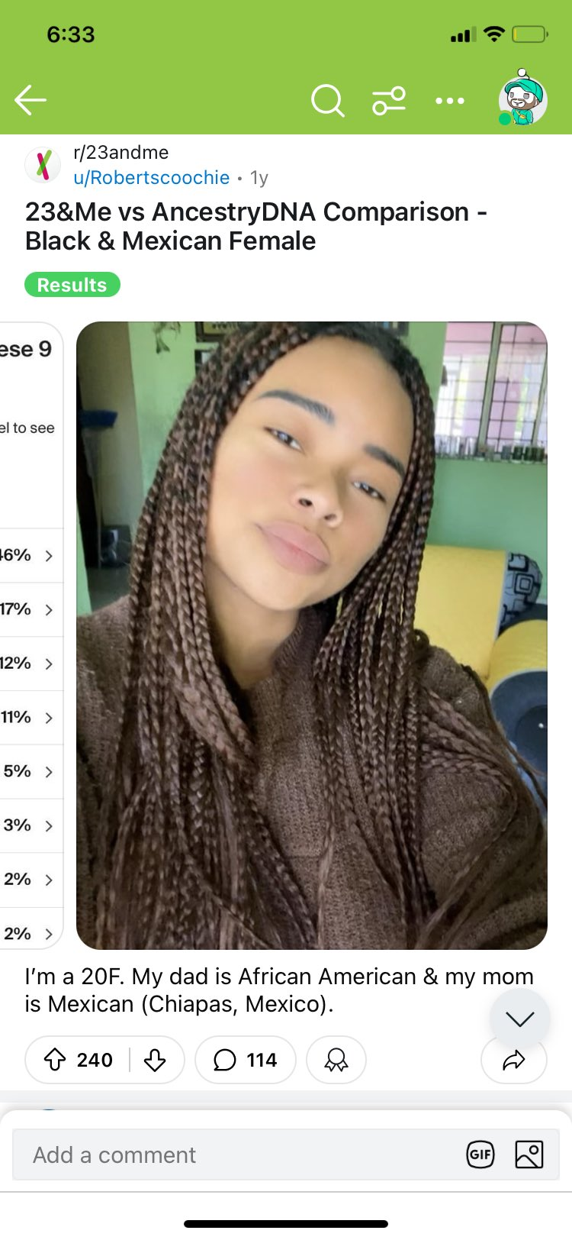

**Notes:**

1. **Even at 45.1% Indigenous American ancestry, almost half, this half Mexican female is still phenotypically (visually) African-American passing.**
2. **Early mixed-race Indigenous Americans with African ancestry were easily mistaken or disguised as African Americans or as slaves.**

### A full Navajo person’s 23andMe results

**Attachment: 33**

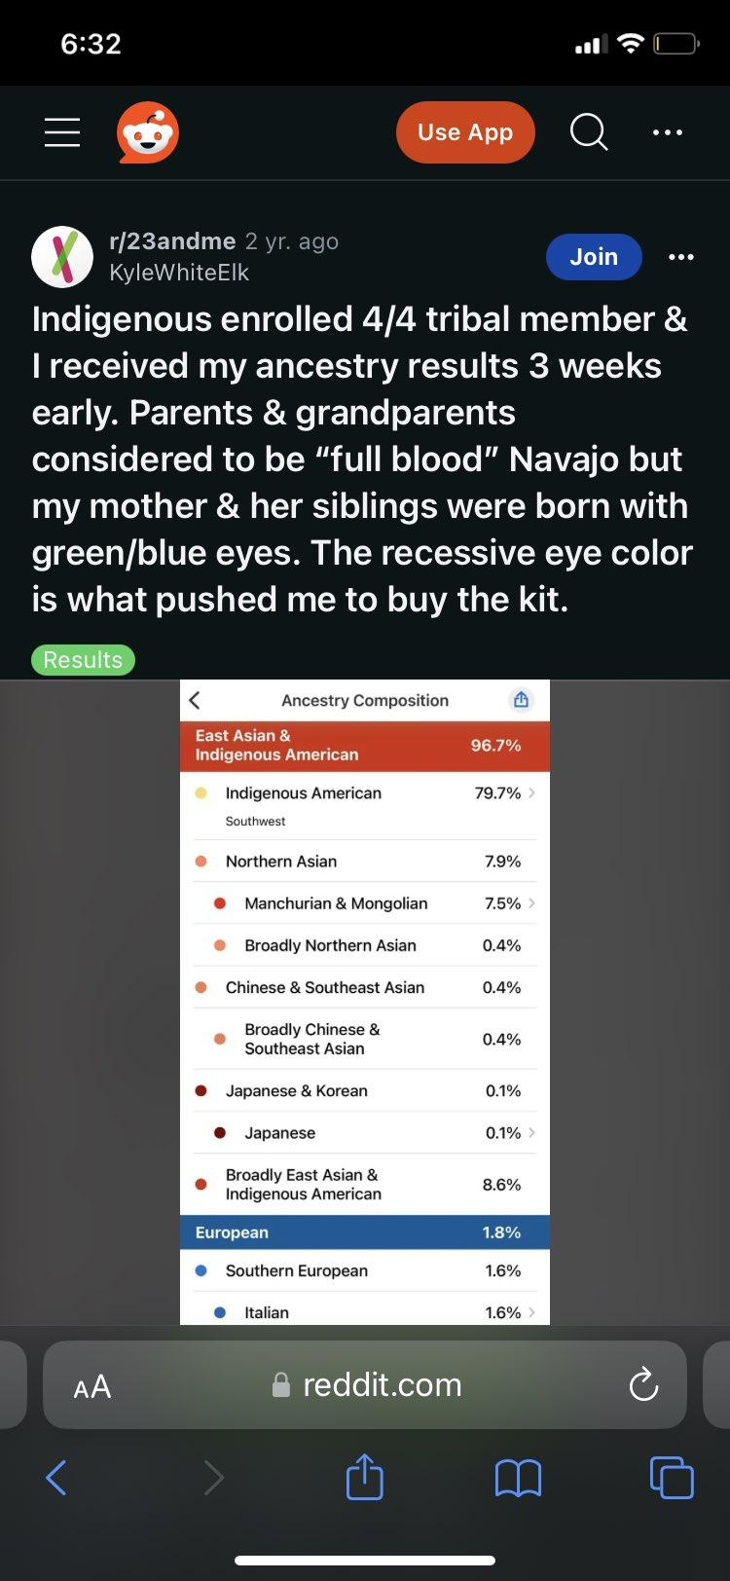

**Notes:**

1. **Note the Manchurian & Mongolian, Chinese, and Japanese & Korean ancestry.**

### A modern Powhatan

**Attachment: 34**

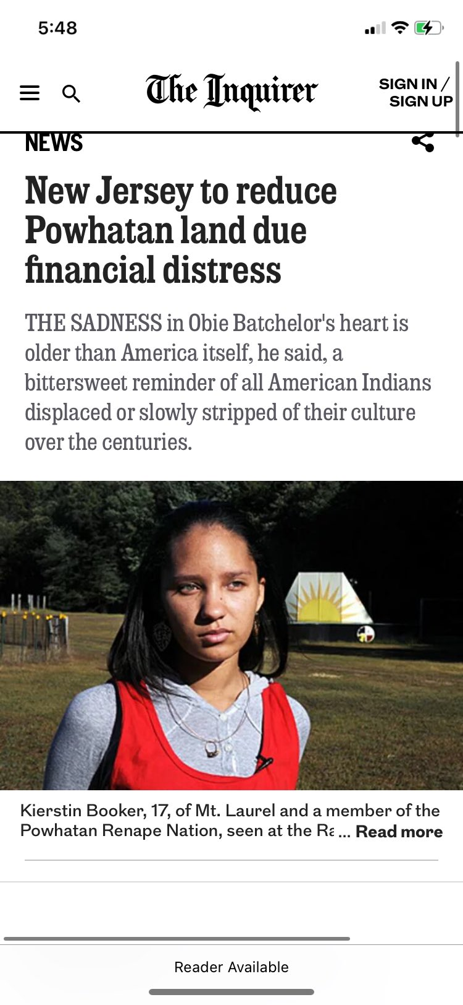

### GEDMatch Ancient DNA Matches

**Attachment: 35**

According to my results, I’ve matched with the following ancient Paleo Native Americans: [F999970 Kennwick, USA](https://en.wikipedia.org/wiki/Kennewick_Man); [F999919, Clovis, Montana](https://en.wikipedia.org/wiki/Anzick-1); [F999963, Bot15, Brazil; and F999963, Bot17, Brazil](https://www.researchgate.net/publication/267574852_Two_ancient_human_genomes_reveal_Polynesian_ancestry_among_the_indigenous_Botocudos_of_Brazil).

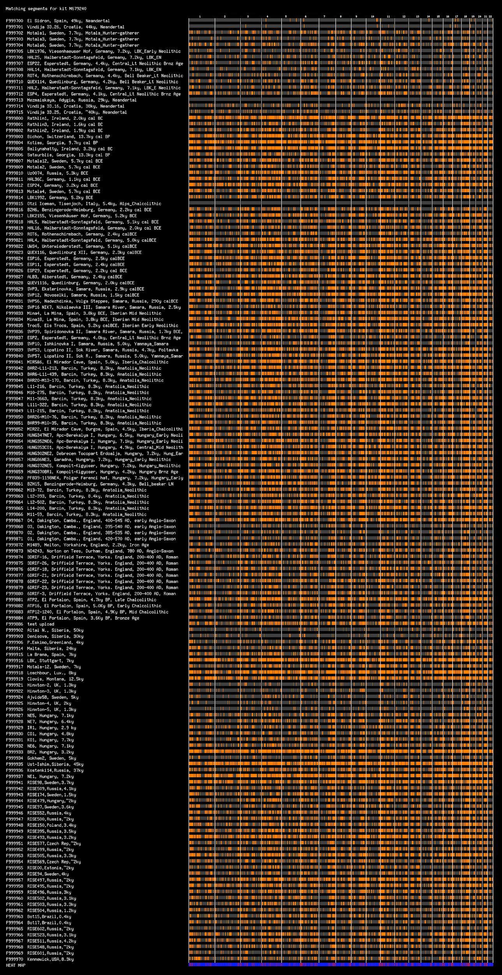

### Miscellaneous

**Attachments: 36 & 37. A full Navajo’s results.**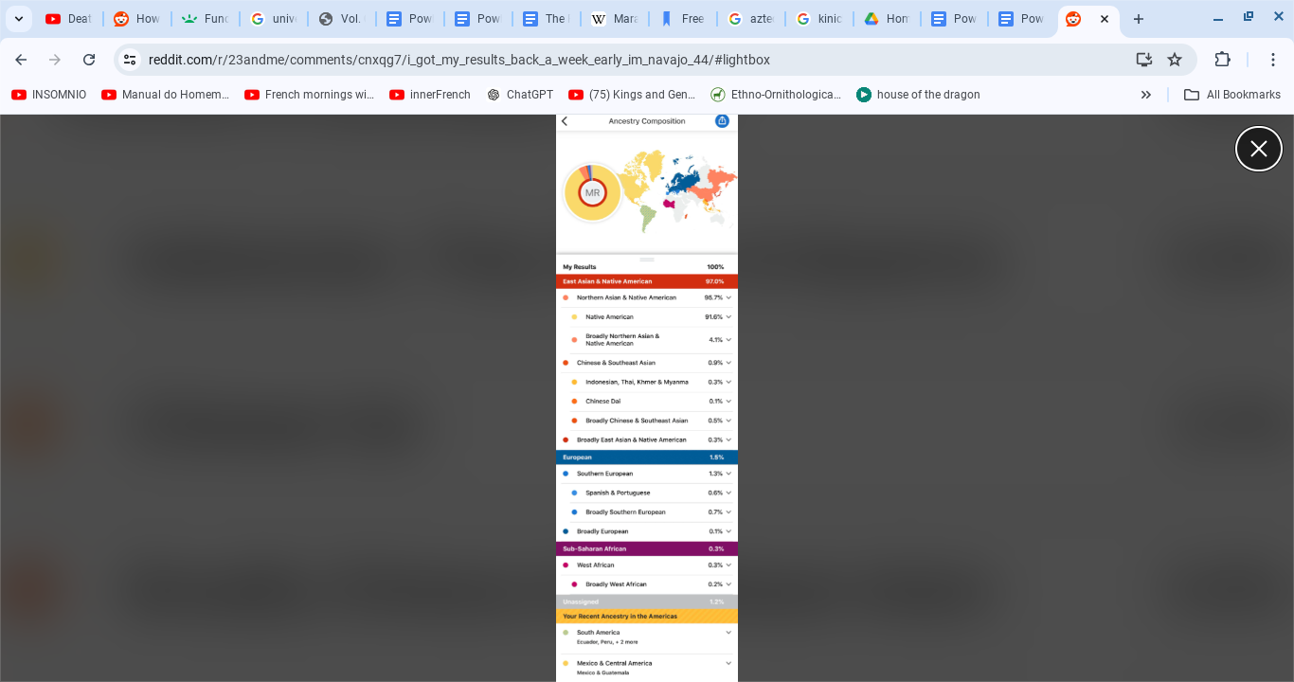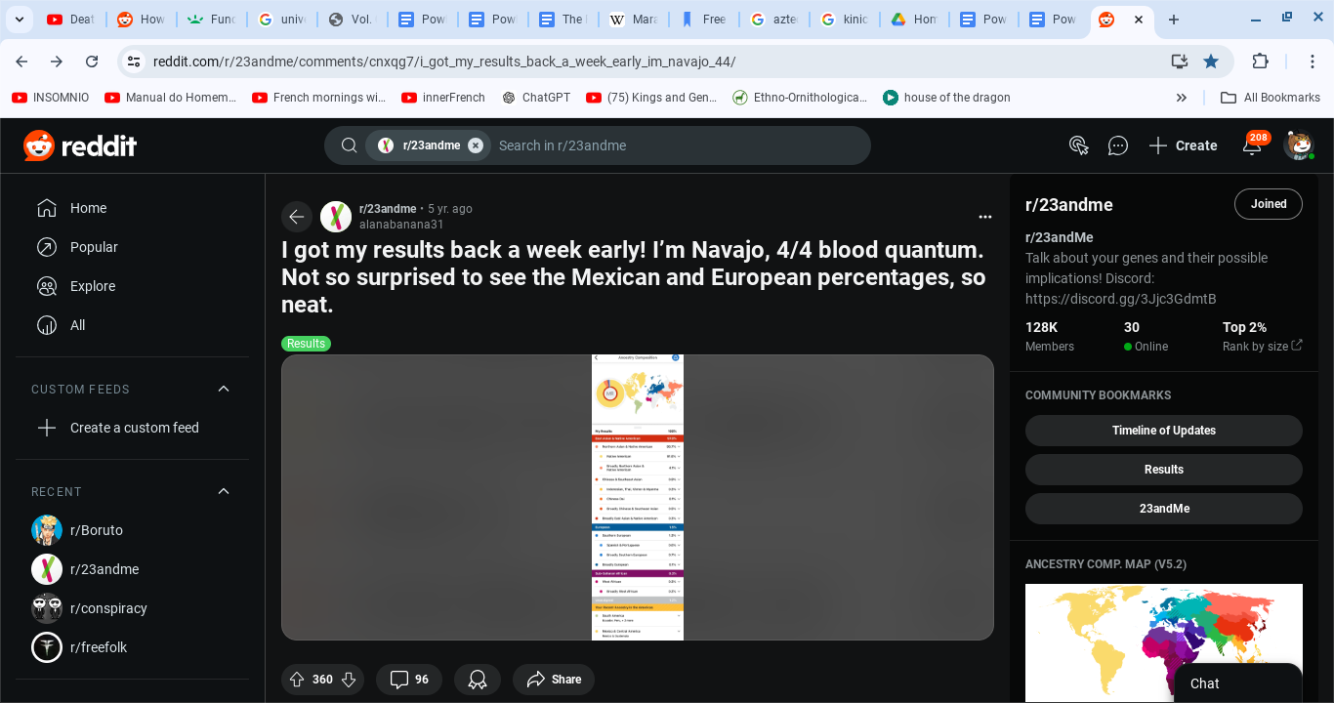

**Attachments: #38 – #42. A Latino DNA Match.**

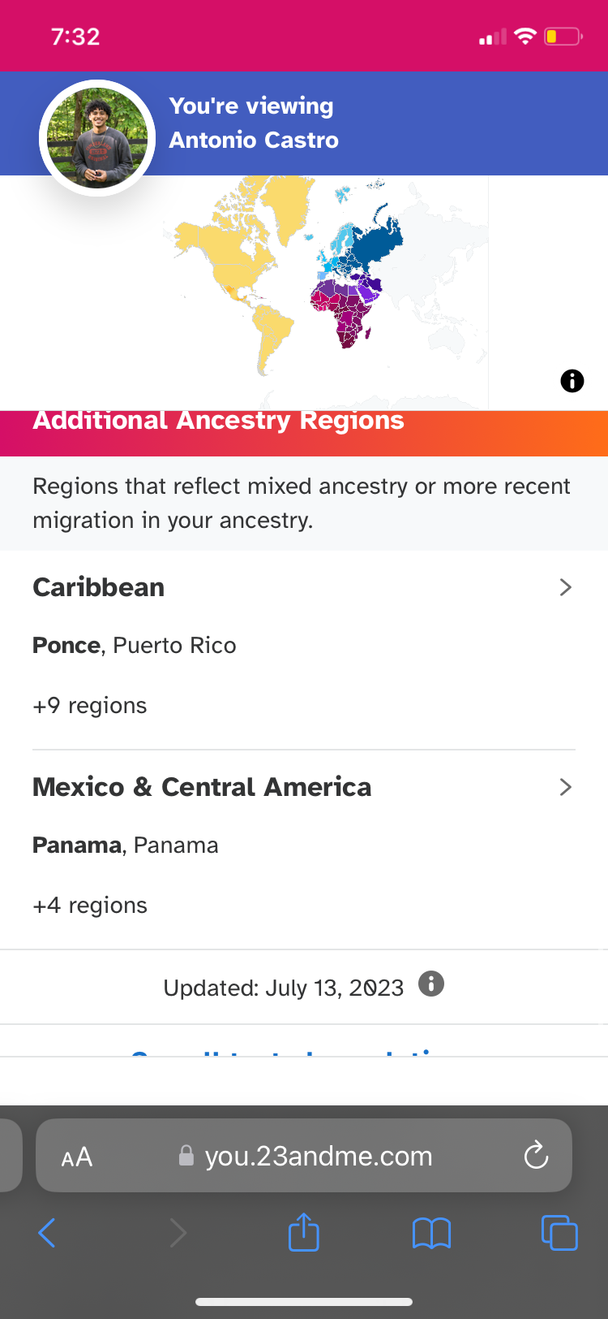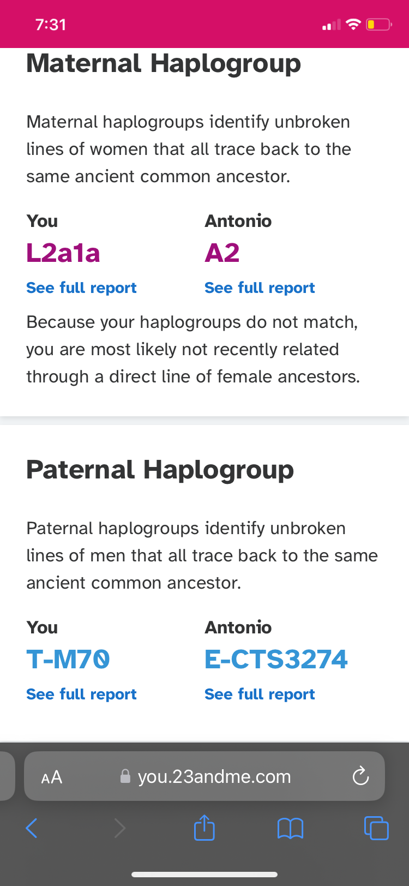

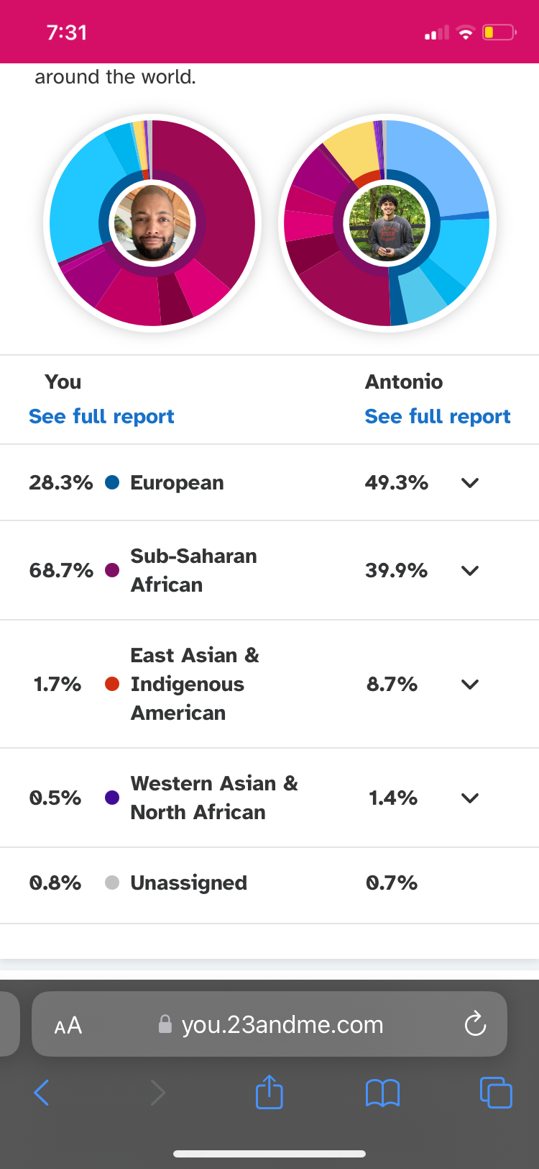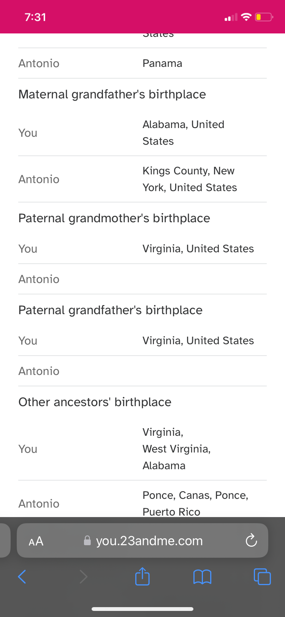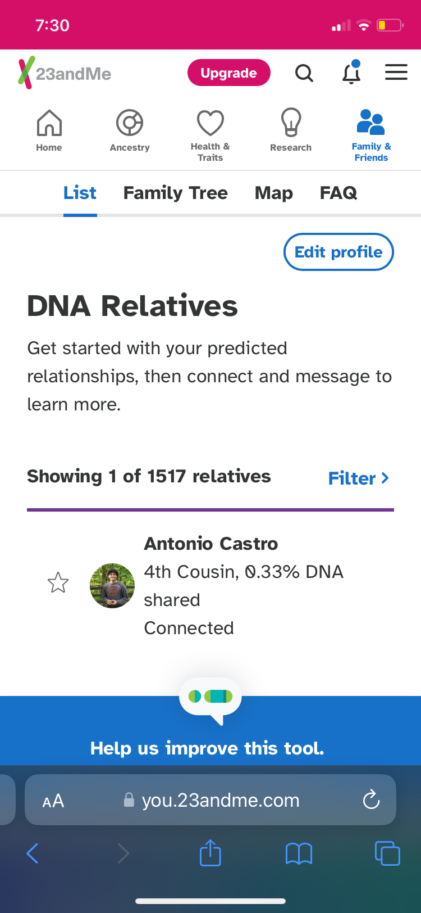

**Attachments: 43 & 44. Hundley’s maternal chromosome is Greek.**

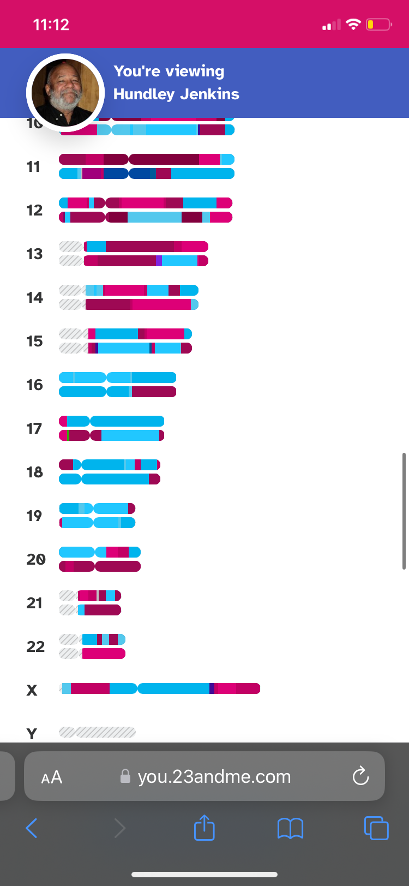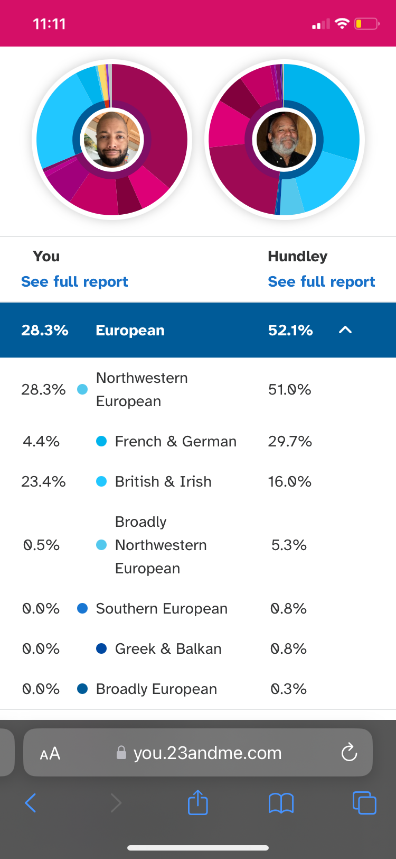

Hundley is the product of a Greek woman who moved to Powhatan at an unknown time.

**Attachments: 45 & 46. Tribal member Alfred Morris (Jefferson) founded the First Antioch Church in Powhatan, Virginia.**

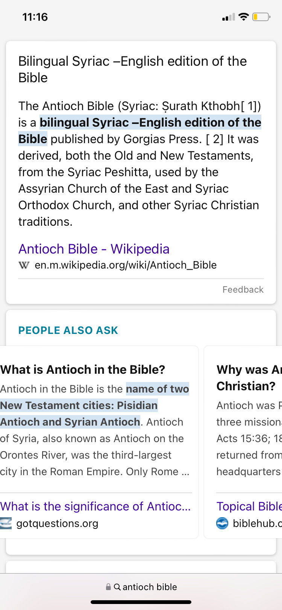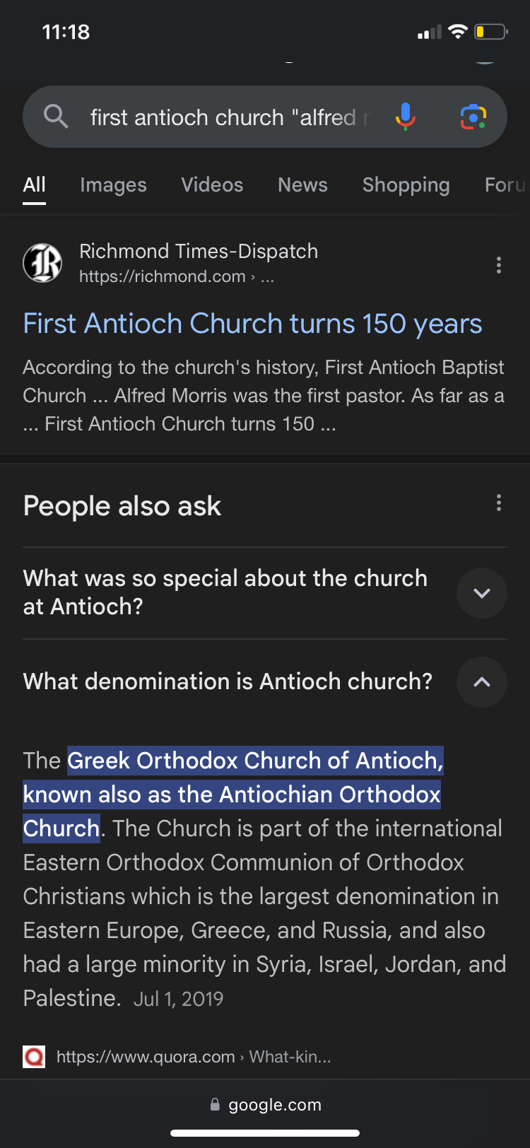

**Attachments: 47 & 48**

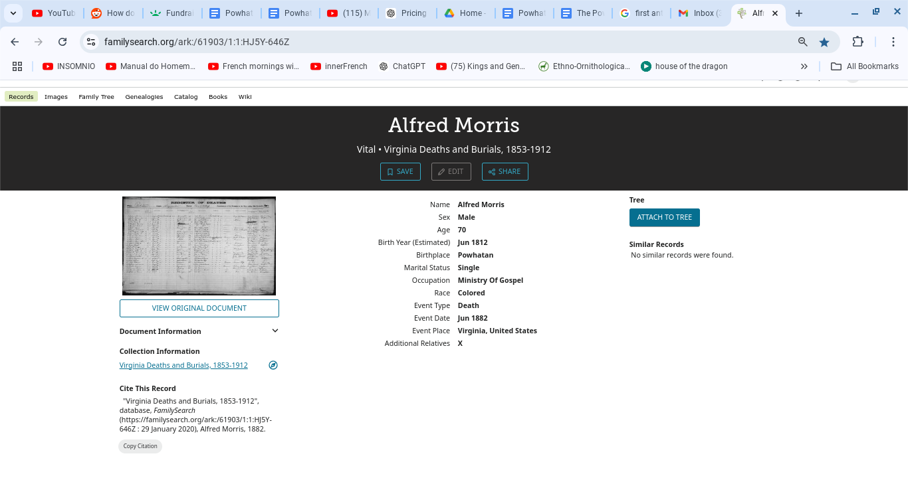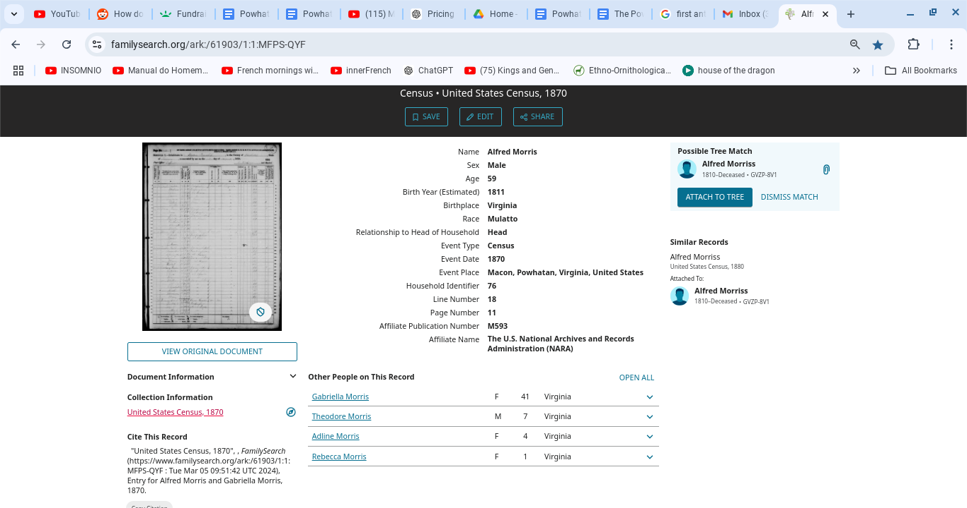

**Attachment: 49**

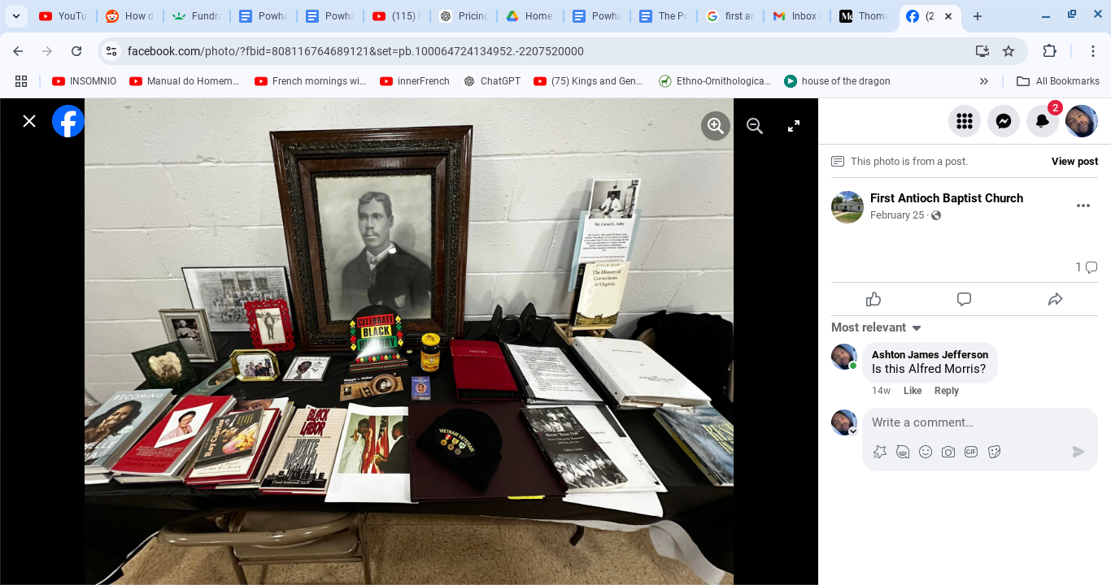

**Attachments: 50, 51. Tribal member Ashton James Snow Jefferson (Morris)’s chromosomal match with Thomas Jefferson III.**

## 

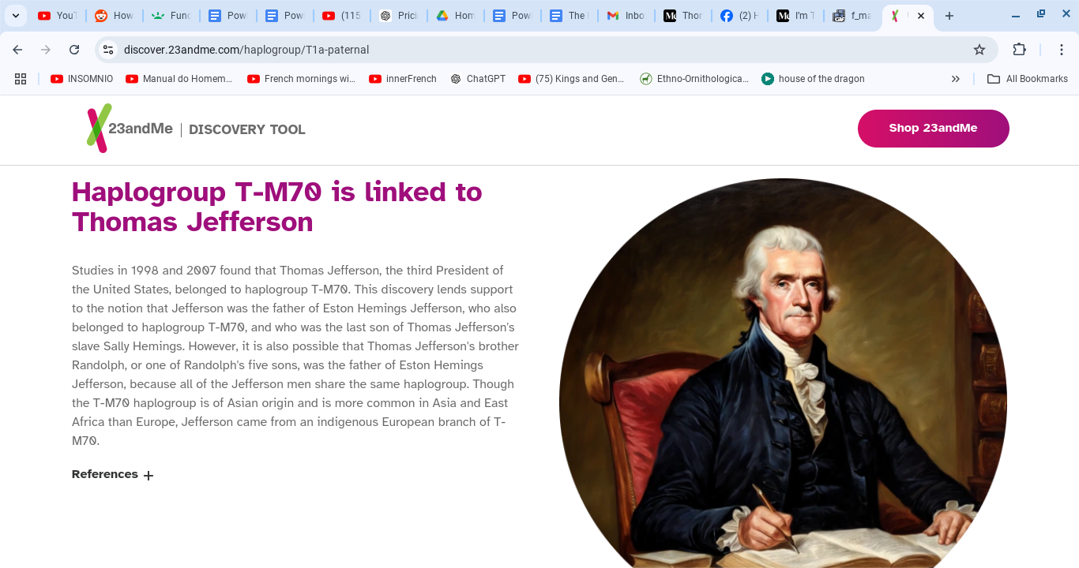

**Attachment: 52. The 1860 Slave Schedule in Powhatan, Virginia.**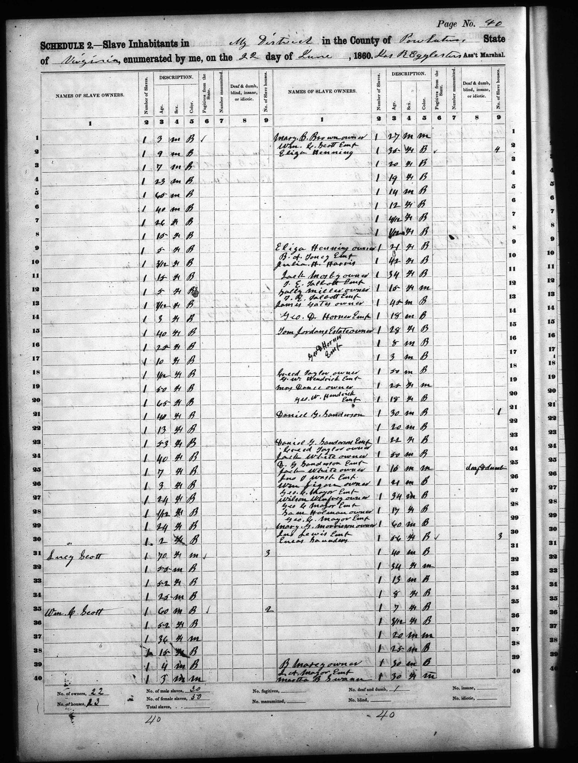

**Attachments: 53 & 54.**

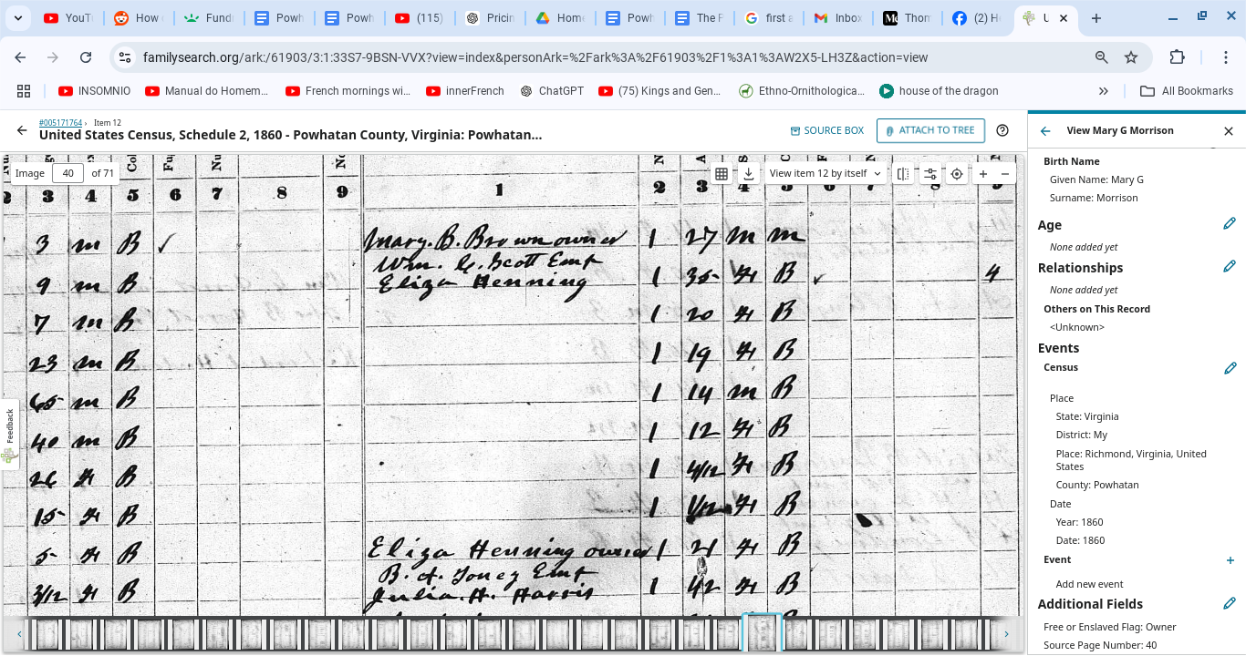

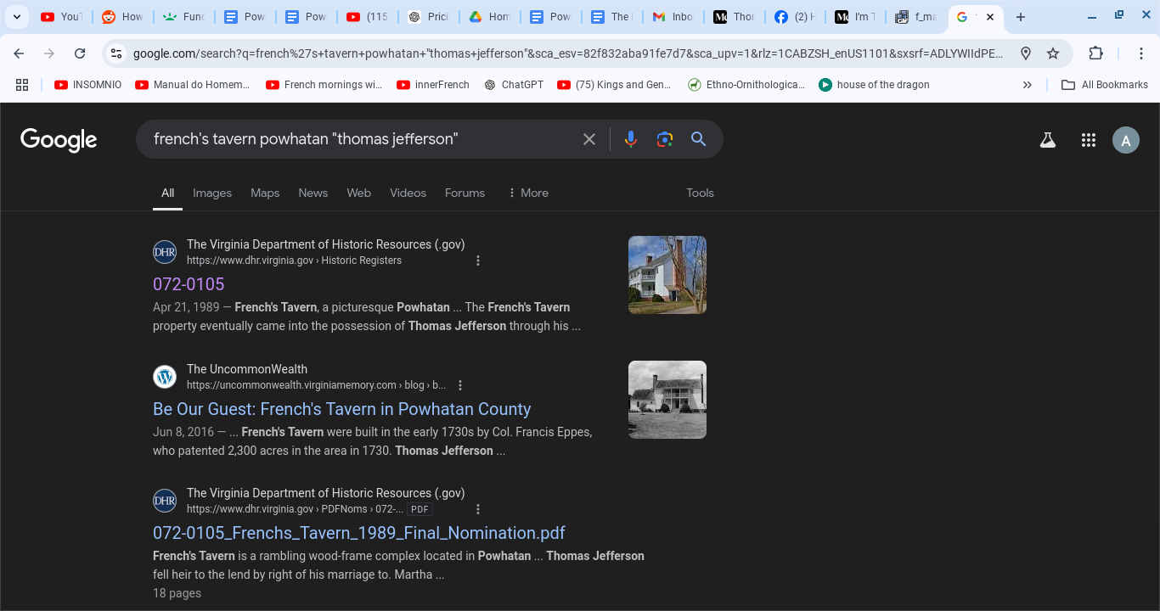

**Attachment: 55**

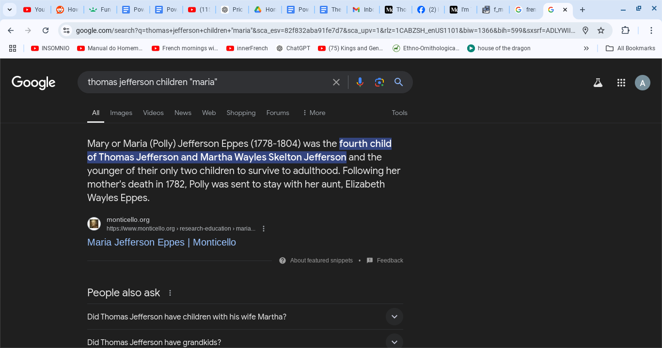

**Attachment: 56. Tribal member Thomas Morris (Jefferson IV)’s marriage certificate stating “F, Maria” in reference to his aunt Maria Jefferson Eppes.**

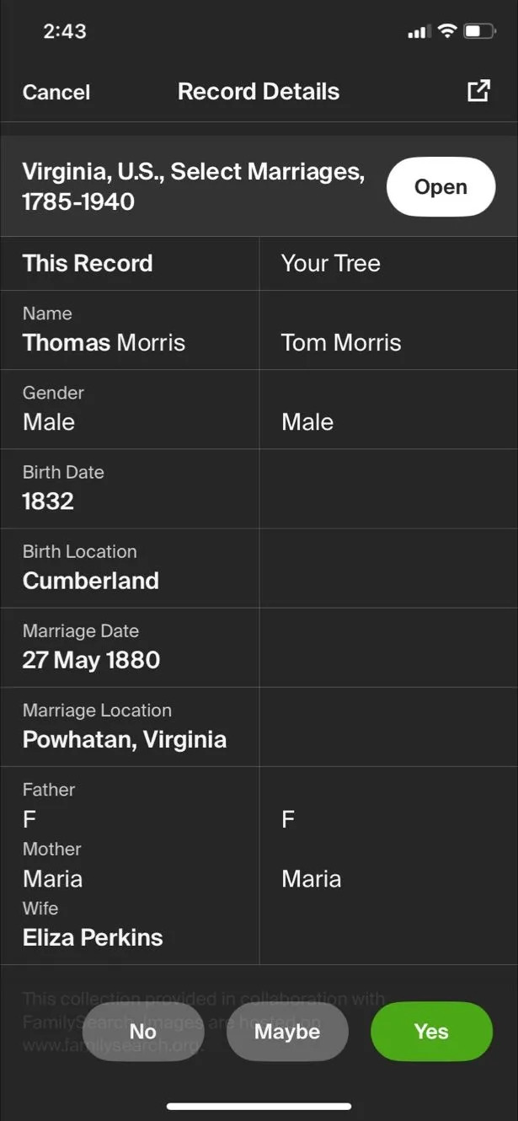

## 

## 

## Genealogical Records

We are selecting the Colored residents of Virginia. By Virginia State Law as of the 1924 Racial Integrity Act, all of these people had their vital documents edited to say “Colored” instead of “Indian”.

**Richmond, Virginia**

**Peter Helms Mayo of Powhatan Seat, Richmond, Virginia**

**Royal Family / Powhatan Mayos**

Powhatan Seat was the Royal Residence of King Powhatan. The ancestors of Peter Helms Mayo were the residents of Powhatan Seat from 1726 – 1865. [citation needed[

Peter Helms Mayo inherited an unknown number of slaves. The races, ages, and genders of the Mayo are unknown. [134]

He sired a *Colored* bastard named George, whose son with a *Colored* woman named Eadie was named Morris.

Morris married a *Colored* Randolph bastard and descendant of enslaved persons named Ann.

Morris was born in Powhatan County. His parents were undocumented slaves in Richmond, Virginia.

Peter Helms Mayo purchased a cottage in Powhatan, Virginia before his death. [131]

The Native American descendants of Peter Helms Mayo, then called by the Commonwealth of Virginia *Colored*, are the heirs of Powhatan Seat and our Royal Family. [131] [134]

**Morris Mayo & Ann Eliza Randolph** (https://www.familysearch.org/ark:/61903/1:1:XRWZ-QX2)

Morris and Ann had about 9 children total:

1. Susan Mayo
2. Samuel Mayo
3. Albert Mayo
4. Morton Mayo
5. Manda Mayo
6. Morris Mayo
7. George Mayo
8. Ida Mayo
9. Lucy Mayo

**Attachments: 1, 2**

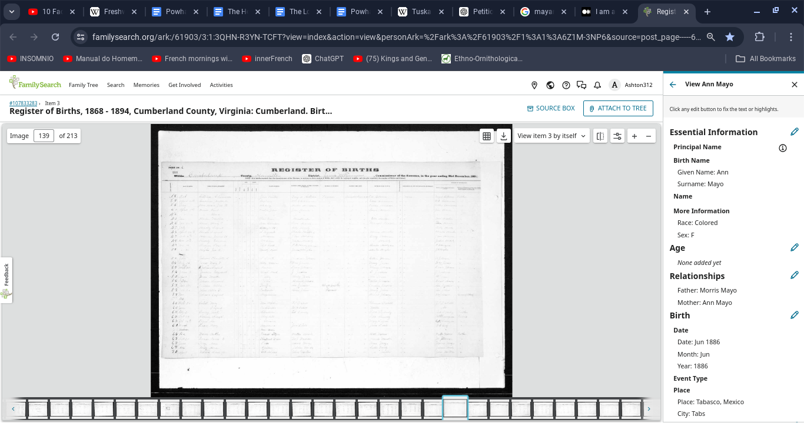

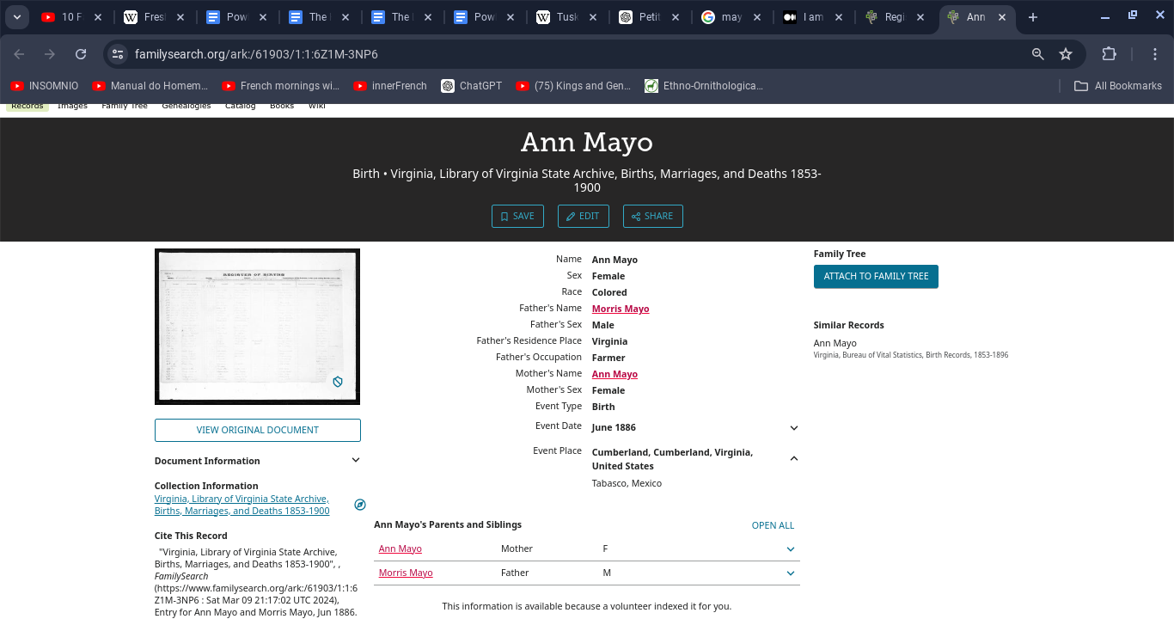

**Attachment: 3**

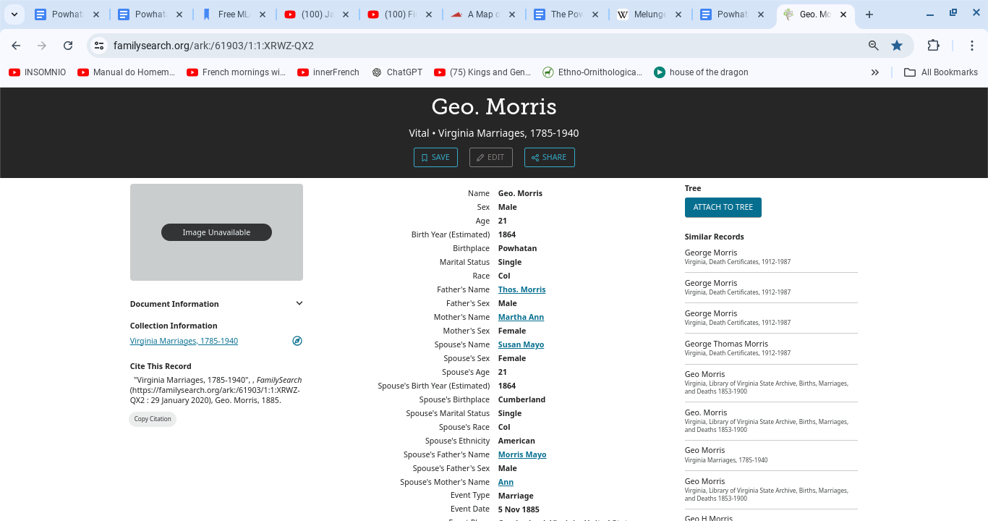

**Morris (Jefferson), Miles, Johnson, Towns/Tongs, Hundley, Wells, Randolph Families of Powhatan, Virginia**

**Powhatan / Powhatan Mohemenchoes**

1. **Thomas & Martha Ann Morris (b. ~1840)** (https://www.familysearch.org/ark:/61903/1:1:XRWZ-QX2)
2. **William & Maria Miles (b. ~1834)** (https://www.familysearch.org/ark:/61903/1:1:XRW6-X2T)
3. **Beverly Johnson & Eliza Wells (b. ~1834)** (https://www.familysearch.org/ark:/61903/1:1:XRW6-X2T)
4. **Vival Townes & Francis Hundley (b. ~1850)** (https://www.familysearch.org/ark:/61903/1:1:6Z5B-MD33)
5. **Henry & Page Hundley (b. 1818)** (https://www.familysearch.org/ark:/61903/1:1:XRMP-29V)
6. **Abraham Johnson & Sallie Miles (b. ~1865)** (https://www.familysearch.org/ark:/61903/1:1:XRMC-YBM)
7. **Andrew Miles & Rachel Johnson (b. ~1834)** (https://www.familysearch.org/ark:/61903/1:1:XRMC-6JS)
8. **Wade & Charity Johnson (b. ~1839)** (<https://www.familysearch.org/ark:/61903/1:1:XRMC-JQ5>)

**Attachment: 4, 5**

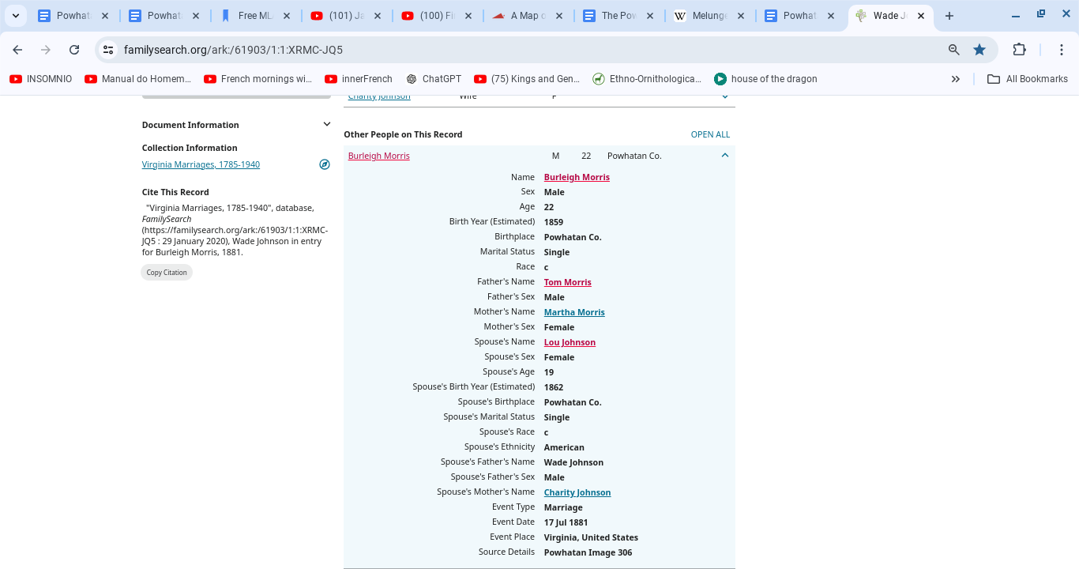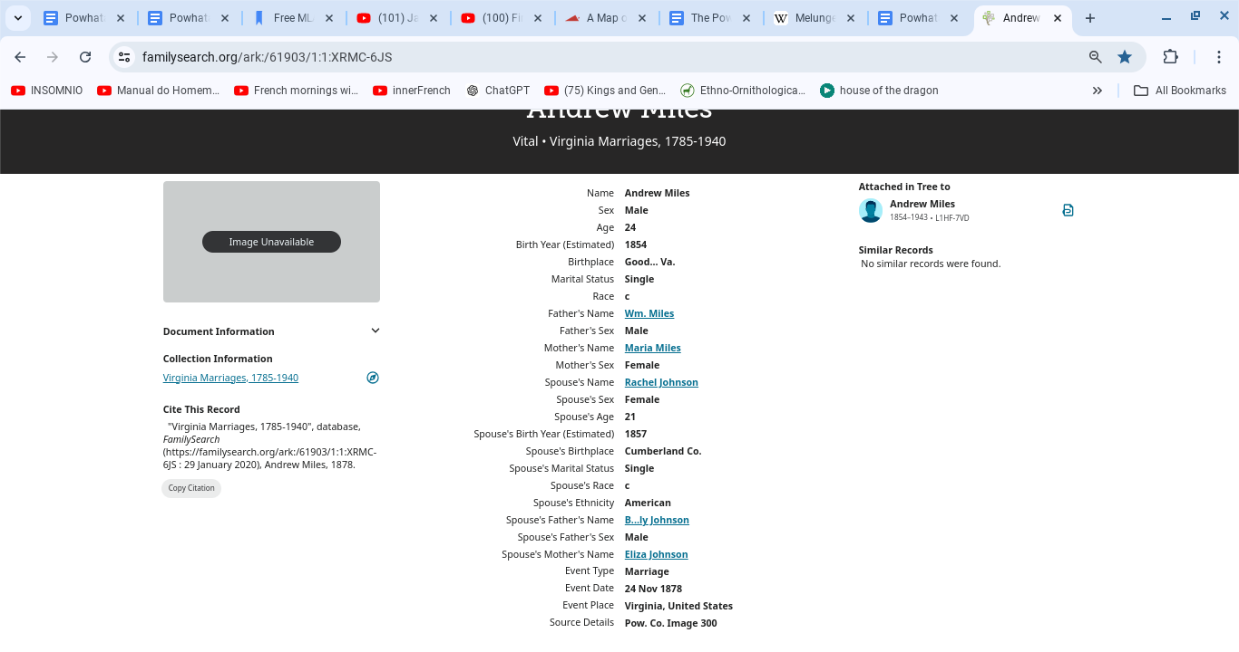

**Attachment: 6, 7**

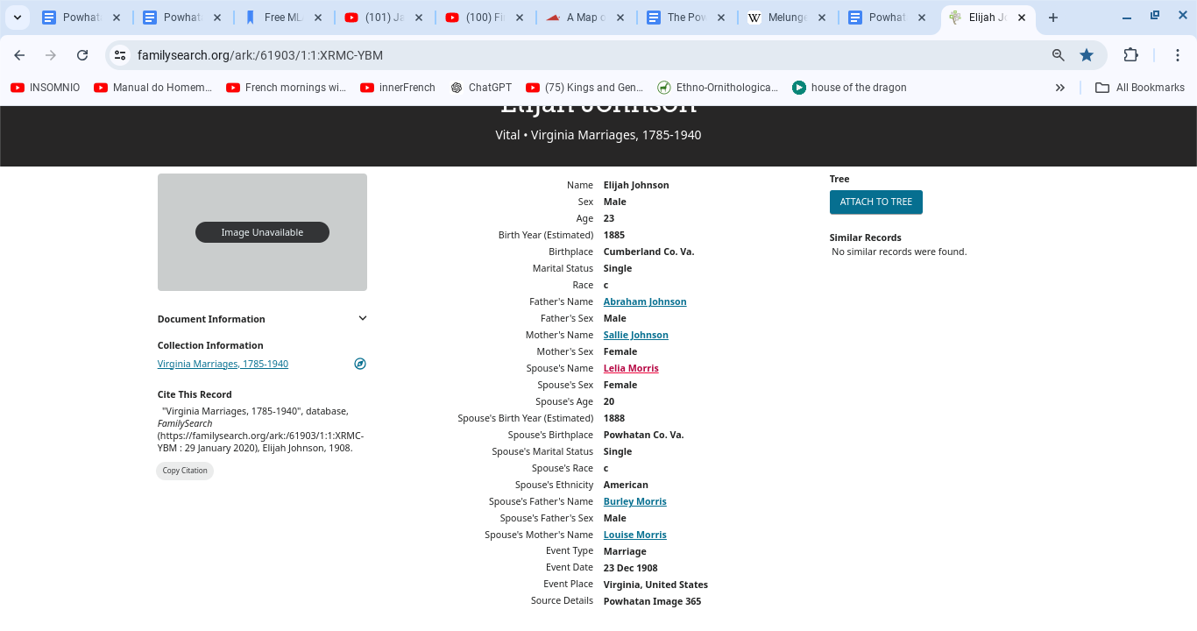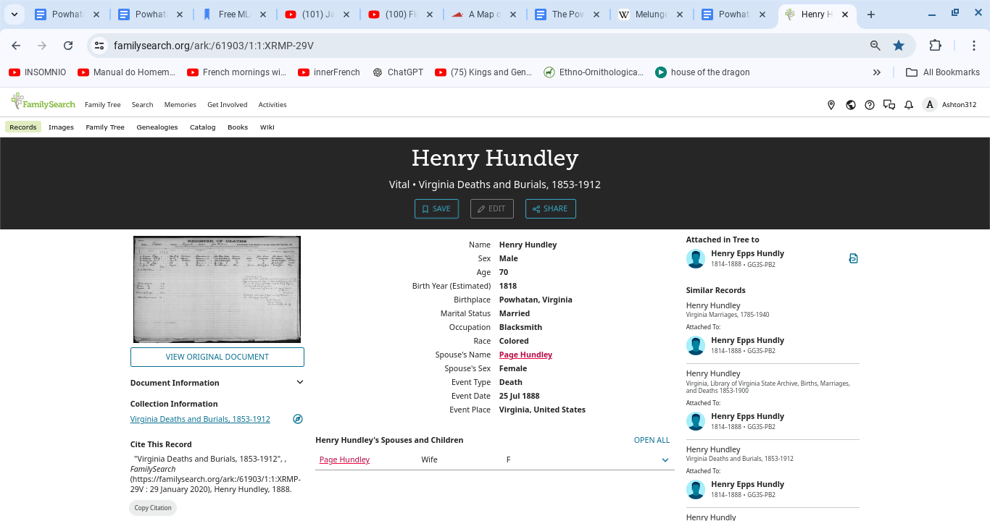

**Attachment: 8, 9**

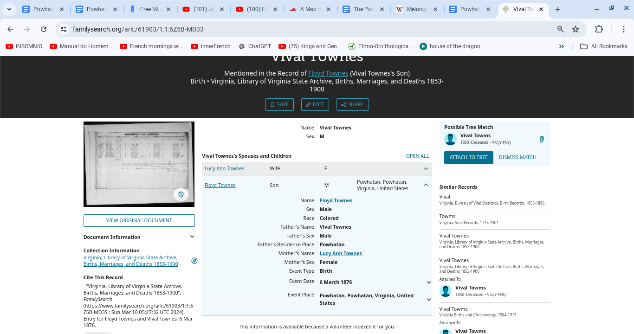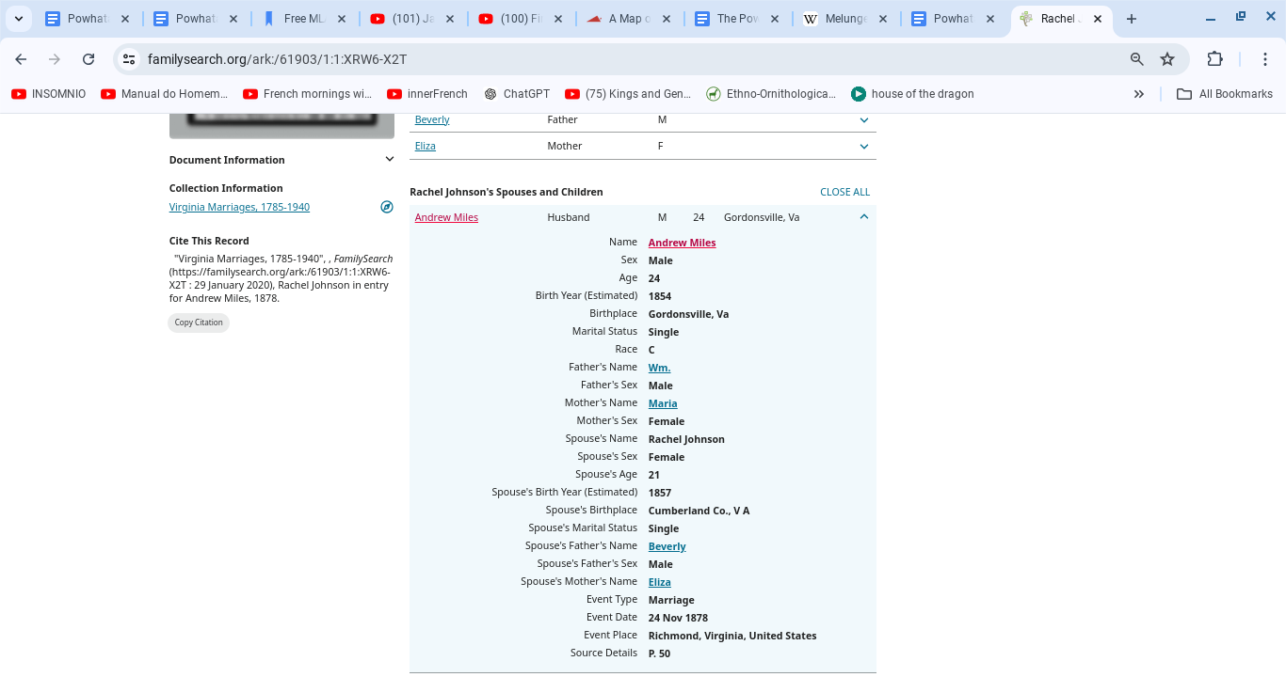

**Franklin**, **Campbell**, and **Pittsylvania** Counties, Virginia.

Monacans / Monahacan / Tutelo / Powhatan Tutelo

1. **Elick** and **Emily Craft:**

**(https://www.familysearch.org/ark:/61903/1:1:6ZG1-BLXM)**

1. **Jack (b. ~1827)** and **Lucy Hodnett (b. ~1850): (**[**https://www.familysearch.org/ark:/61903/1:1:627K-7XCM**](https://www.familysearch.org/ark:/61903/1:1:627K-7XCM)**, https://www.familysearch.org/ark:/61903/1:1:6ZGB-LRMW)**
2. **Chelsea** and **Drucilla Madison: (https://www.familysearch.org/ark:/61903/1:1:XR6S-9Q4)**
3. **T.S** and **Nancy Holland**

**(**[**https://www.familysearch.org/ark:/61903/1:1:XR6S-9Q4**](https://www.familysearch.org/ark:/61903/1:1:XR6S-9Q4))

**Attachment: 10, 11**

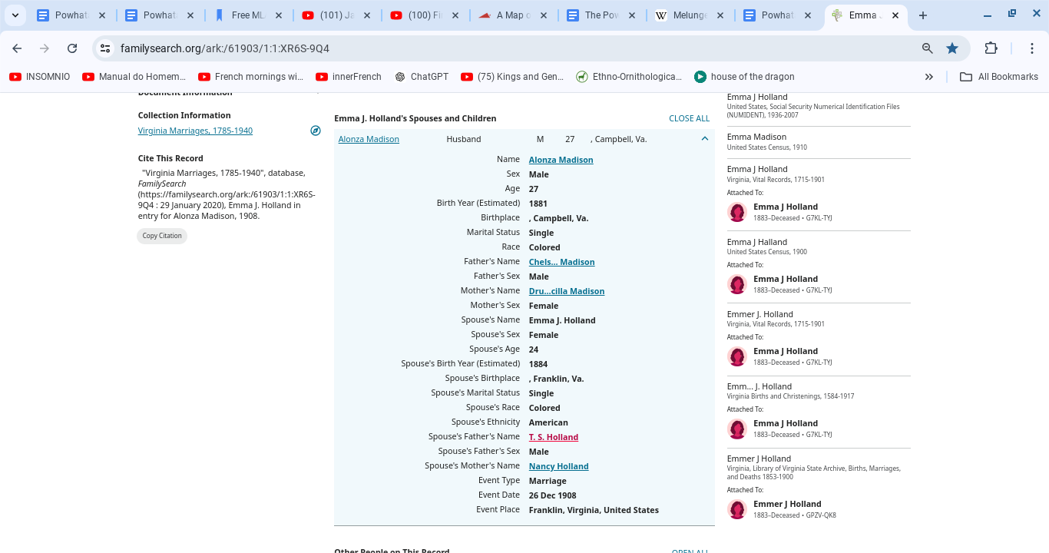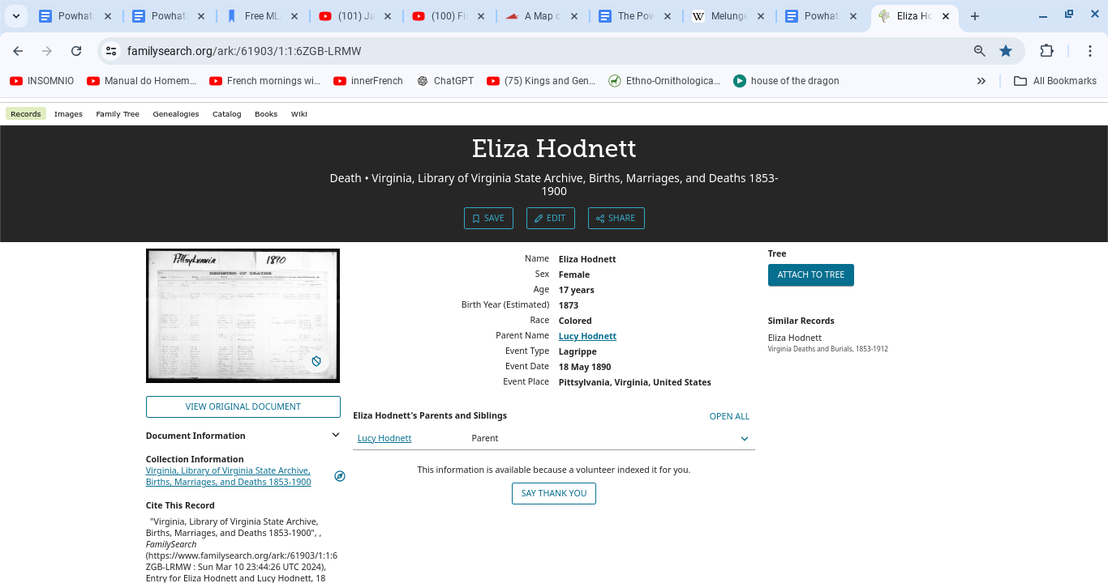

**Attachment: 12, 13**

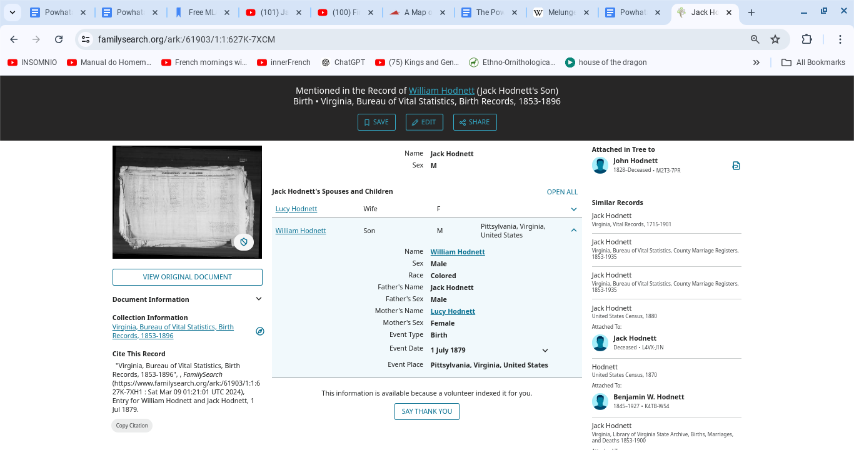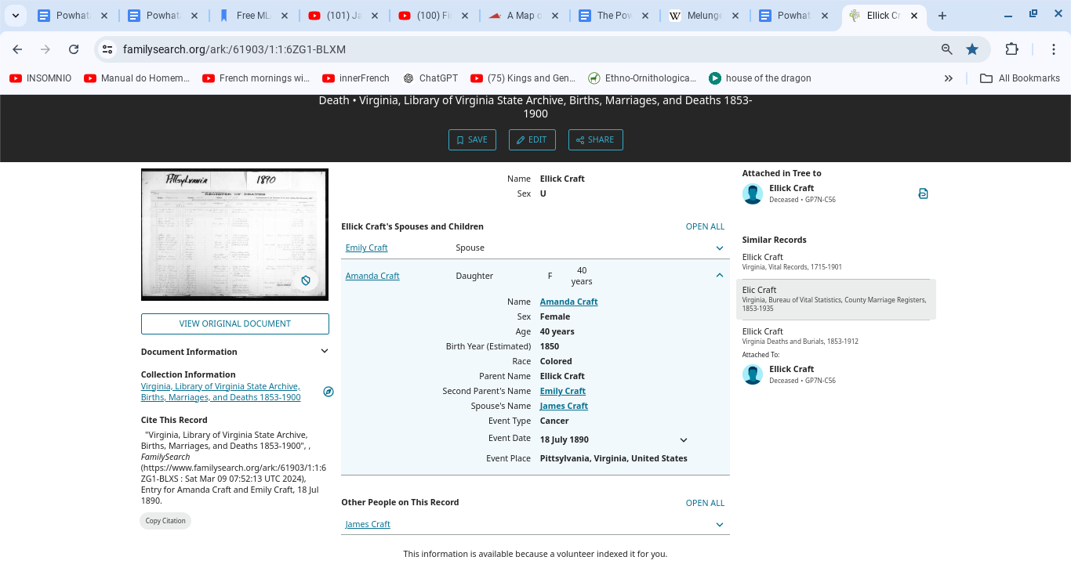

**Henry** County, Virginia.

Tutelo / Powhatan Tutelo

1. **Abe Craighead** and **Frances Harris Craighead: https://www.familysearch.org/ark:/61903/1:1:XRVC-Z3S**
2. **Anthony Harris and Elizabeth Williams: https://www.familysearch.org/ark:/61903/1:1:XRHV-8W4**
3. **Matilda Baker-Craighead:** [**https://www.familysearch.org/ark:/61903/1:1:XRMM-9W6**](https://www.familysearch.org/ark:/61903/1:1:XRMM-9W6)

**Attachment: 14**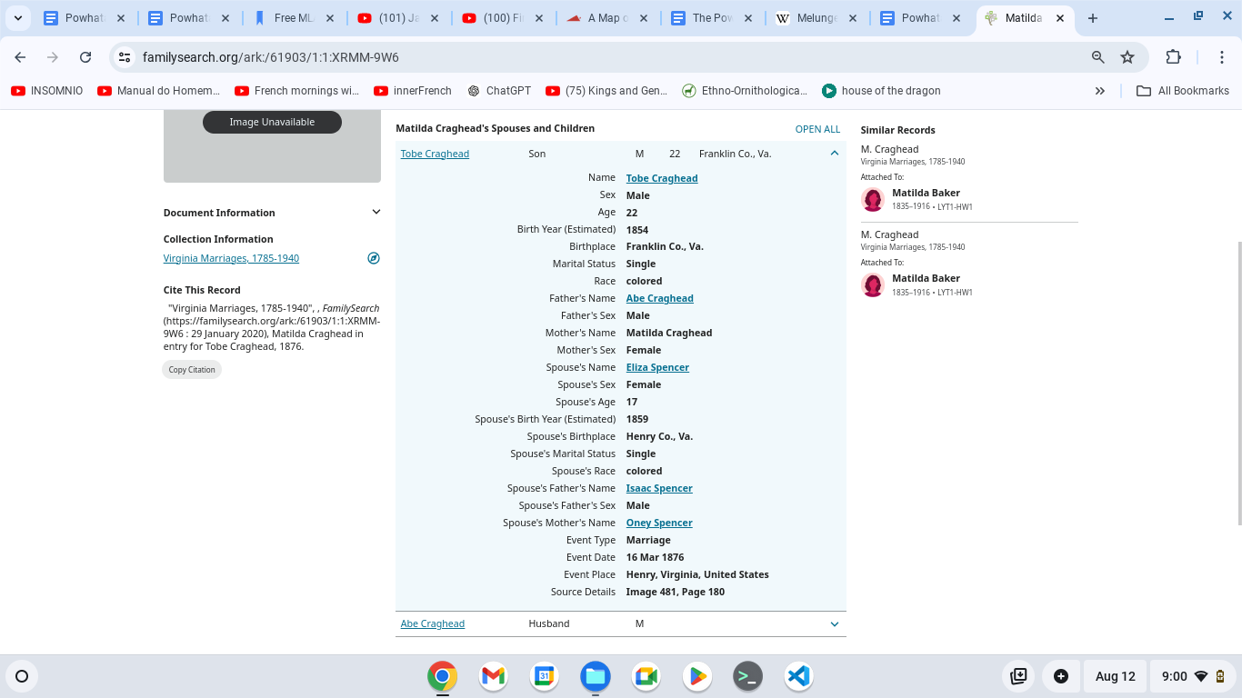

**Attachment: 15, 16**

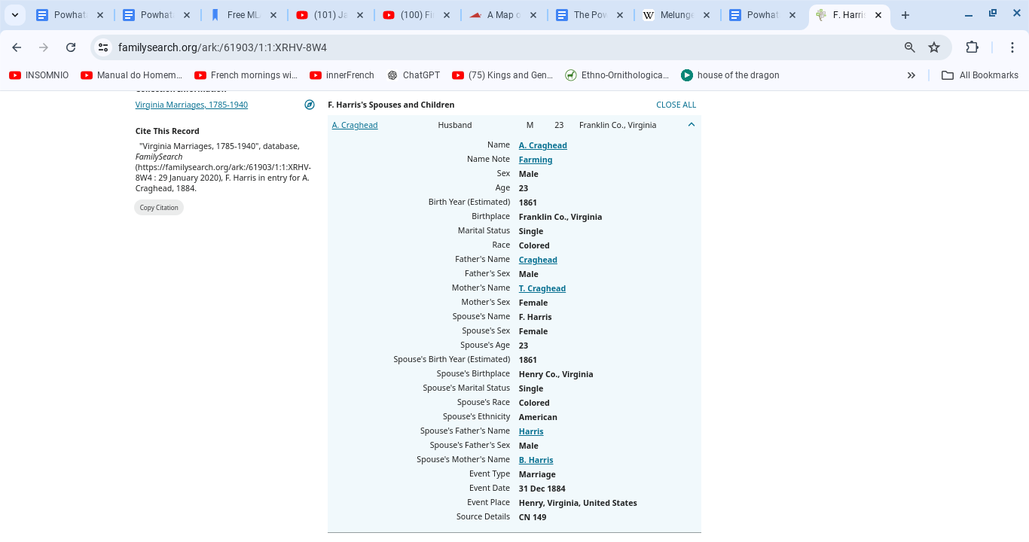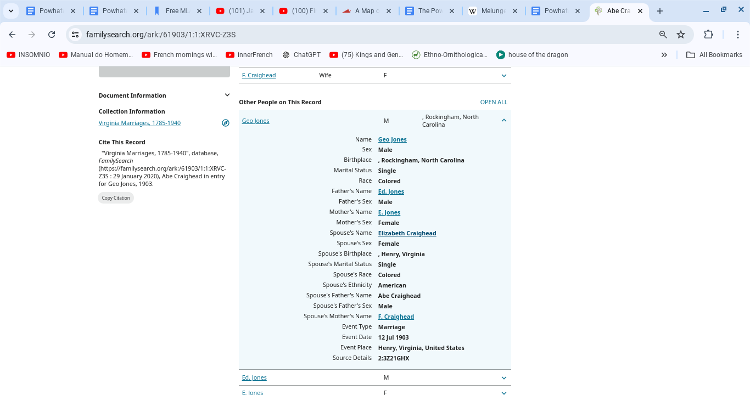

**Louisa** County, Virginia, and **Washington, District of Columbia**

**Monasicappono / Natchotank**

1. **Arthur Bolden** and **Polly Ragland: https://www.familysearch.org/ark:/61903/1:1:FWMZ-T82**
2. **Abram Mitchell** and **Alice Tyler:** [**https://www.familysearch.org/ark:/61903/1:1:X5BF-VQR**](https://www.familysearch.org/ark:/61903/1:1:X5BF-VQR)

**Attachment: 17, 18**

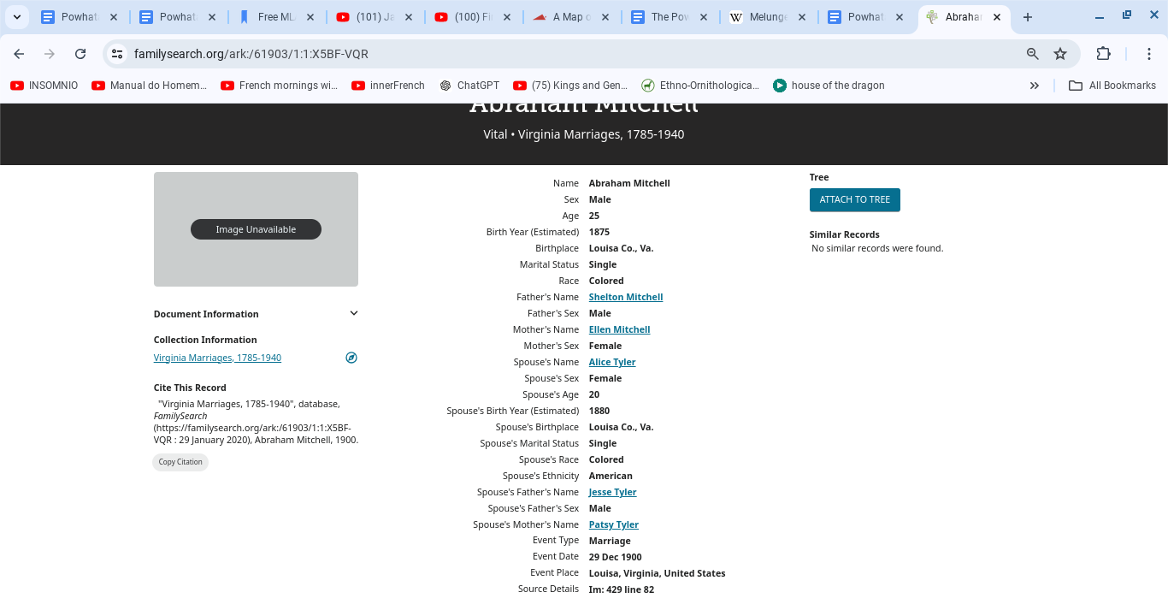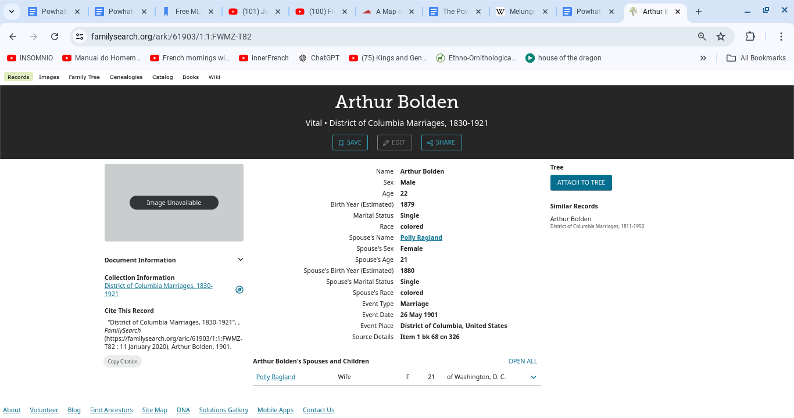

**Snow Hill, Wilcox** County, Alabama.

Tuskaloosa

1. **Frank Snow** and **Sarah Purifoy (https://www.familysearch.org/ark:/61903/1:1:Q2D7-CF3Y)**
2. **Berry Purifoy** and **Emerline McCondichie (https://www.familysearch.org/ark:/61903/1:1:FQJ1-3ZX)**
3. **Archie Mackie** and **Malissa Thompson (**[**https://www.familysearch.org/ark:/61903/1:1:FQVM-T2B**](https://www.familysearch.org/ark:/61903/1:1:FQVM-T2B)**)**

**Attachment: 19**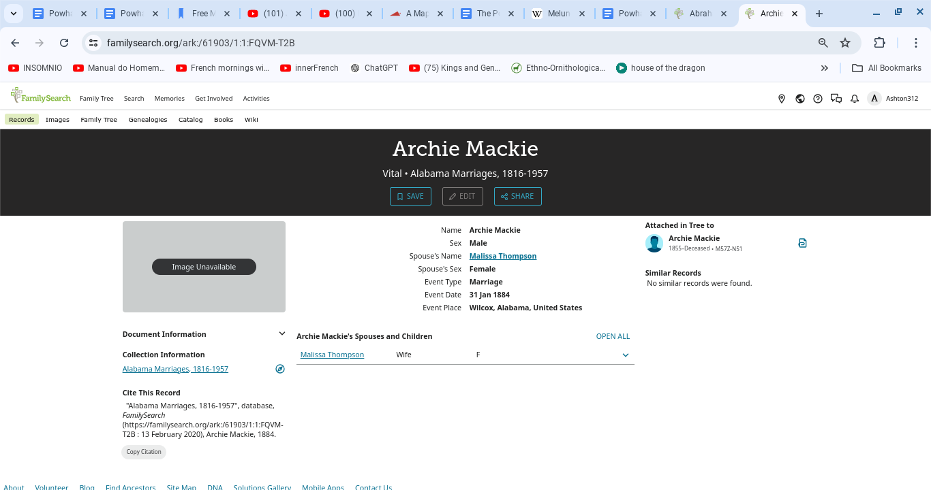

**Attachment: 20, 21**

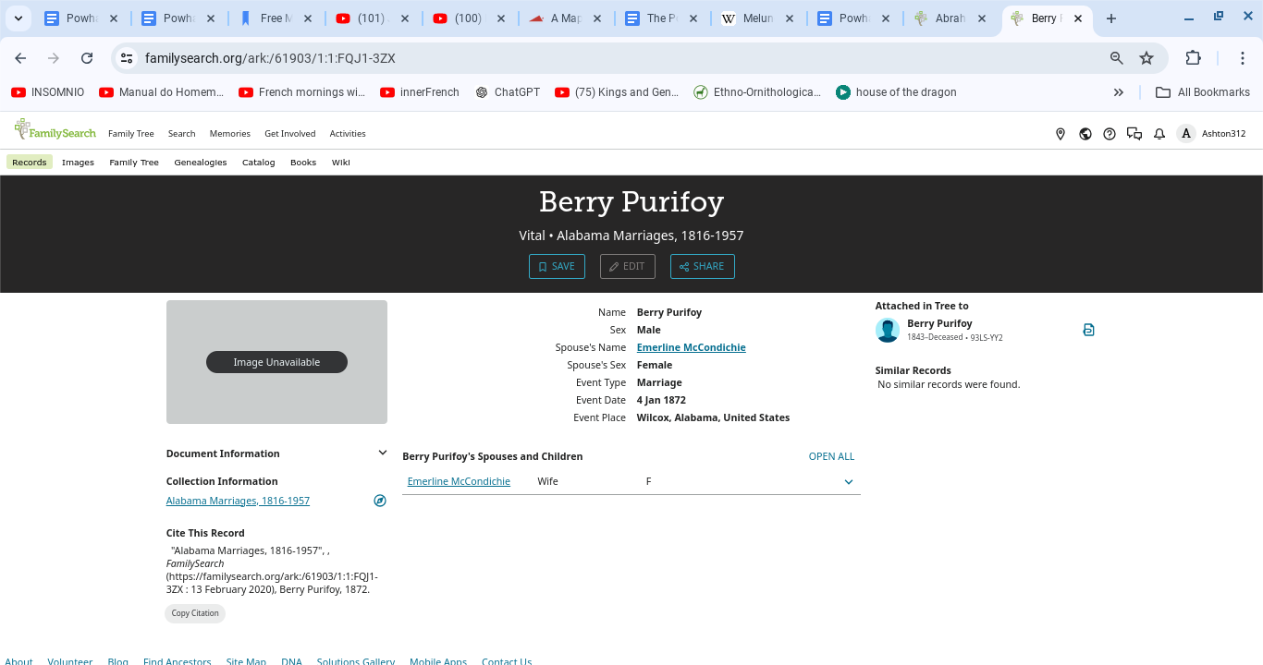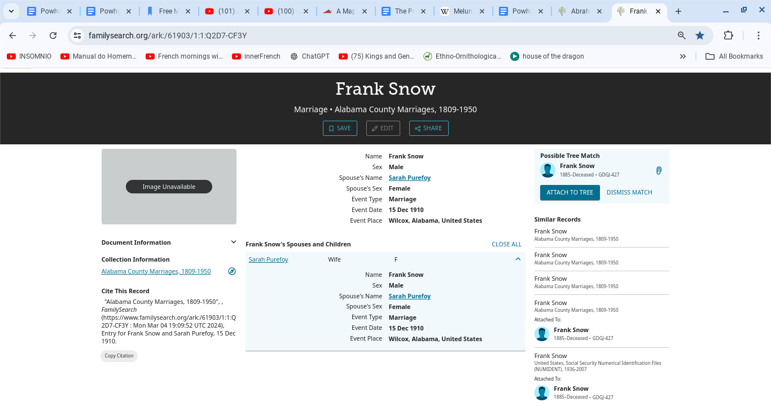

**Attachment: 22. Tribal member Berry Purifoy’s death certificate from Texas.**

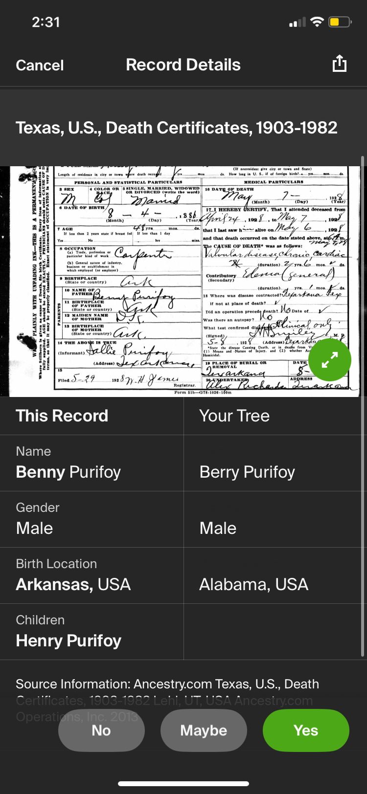

## Reservation Parcels

**Attachments: 1, 2**

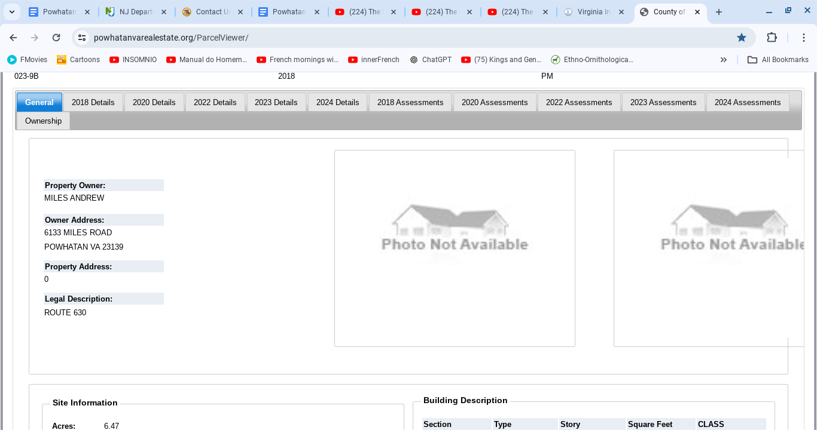

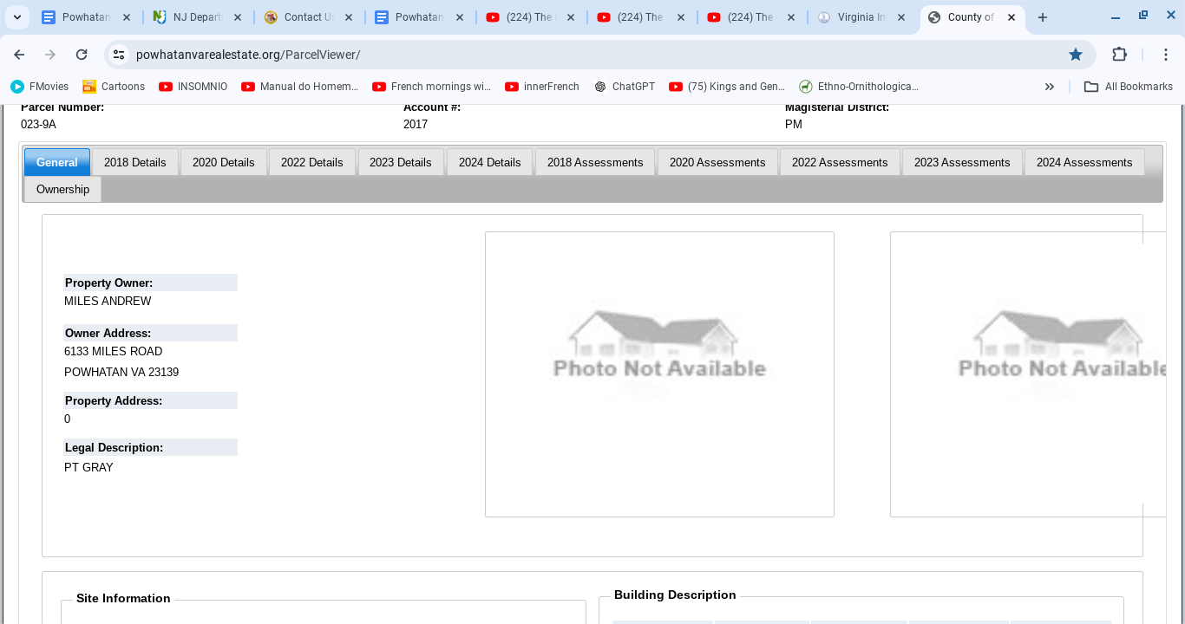

**Attachments: 3, 4**

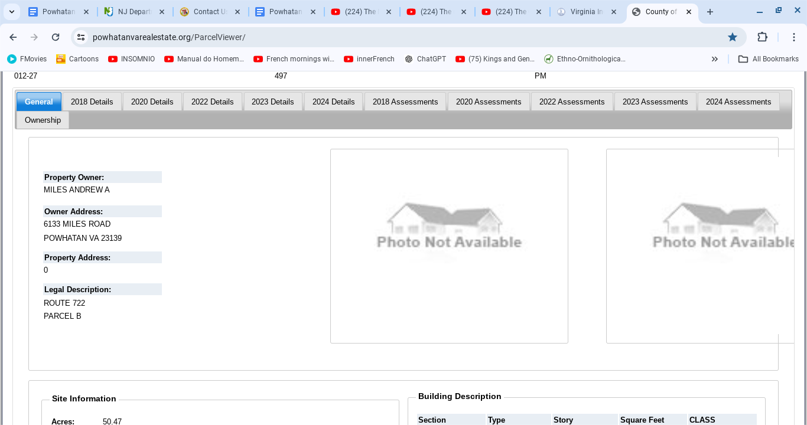

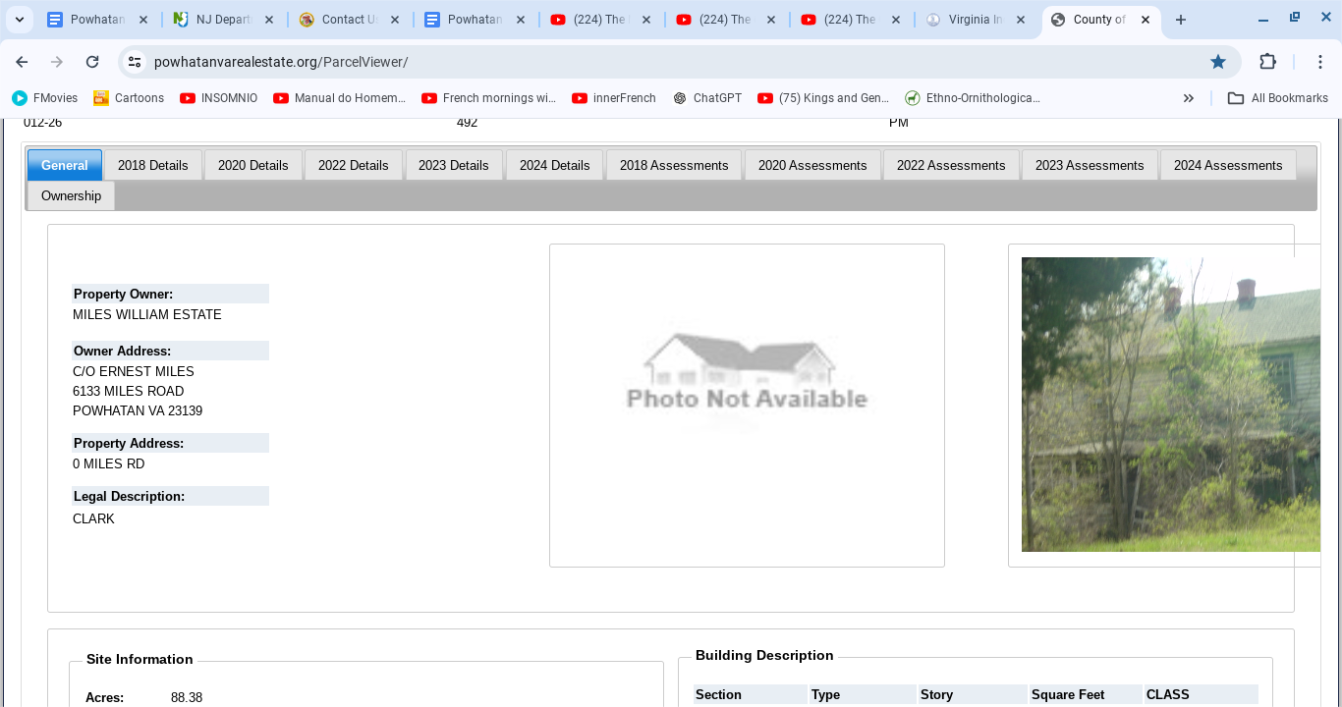

**Attachments: 5, 6**

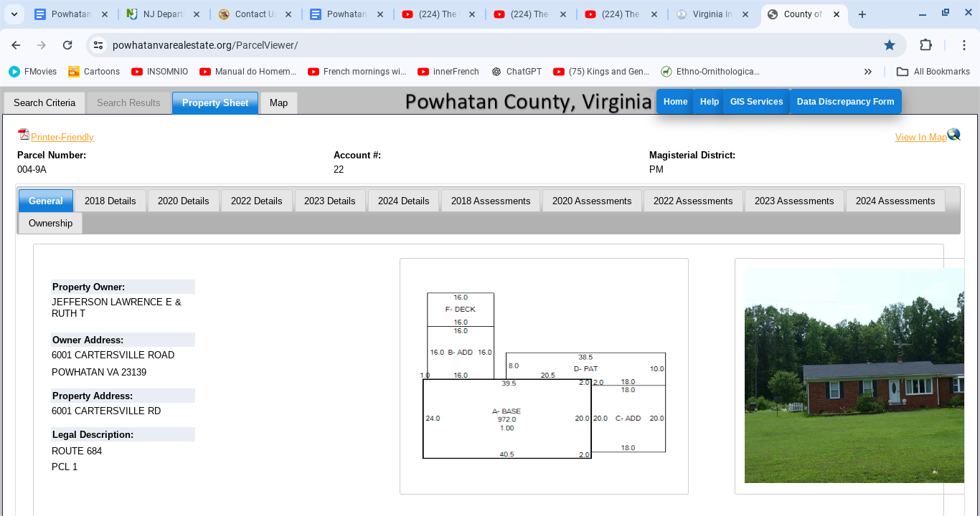

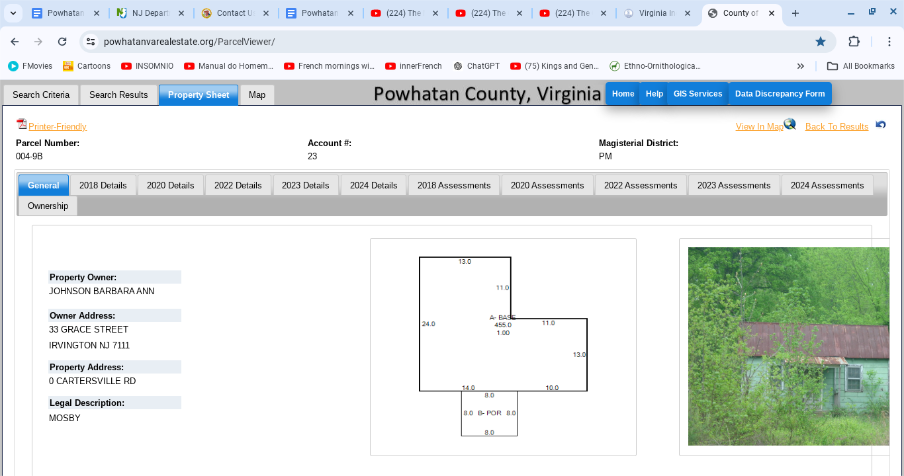

**Attachments: 7, 8**

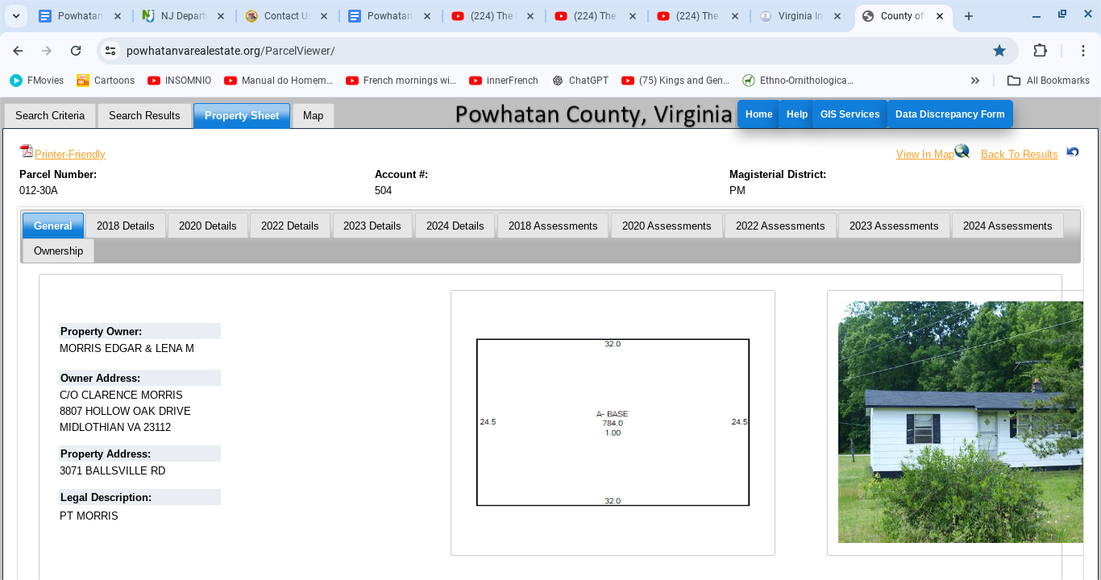

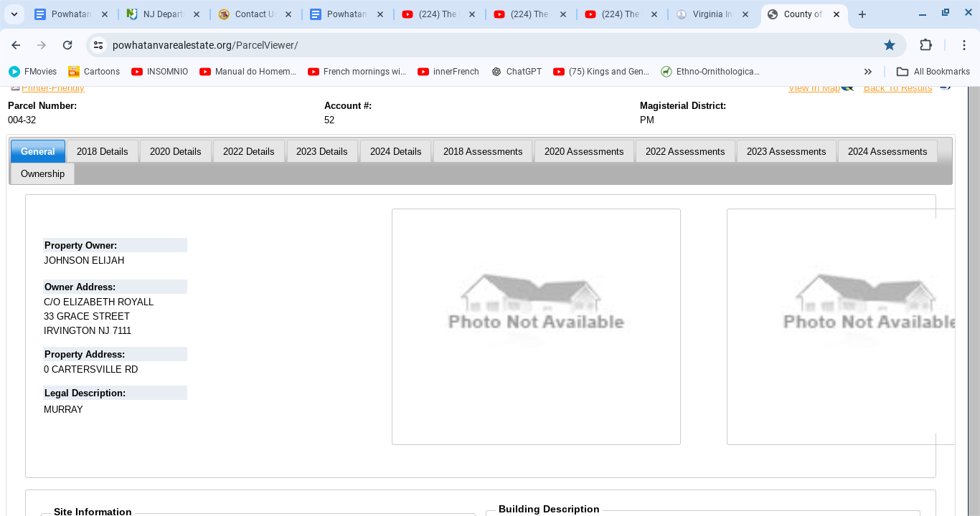

**Attachments: 9, 10**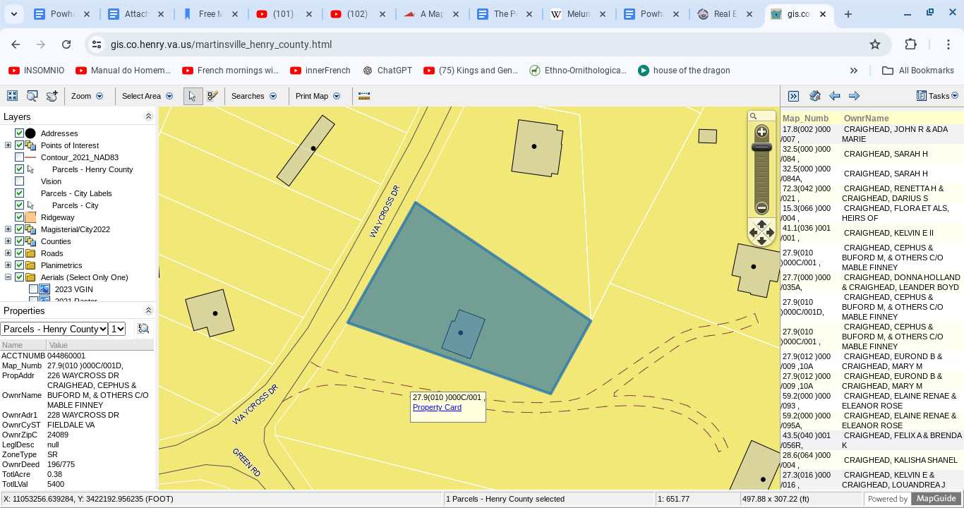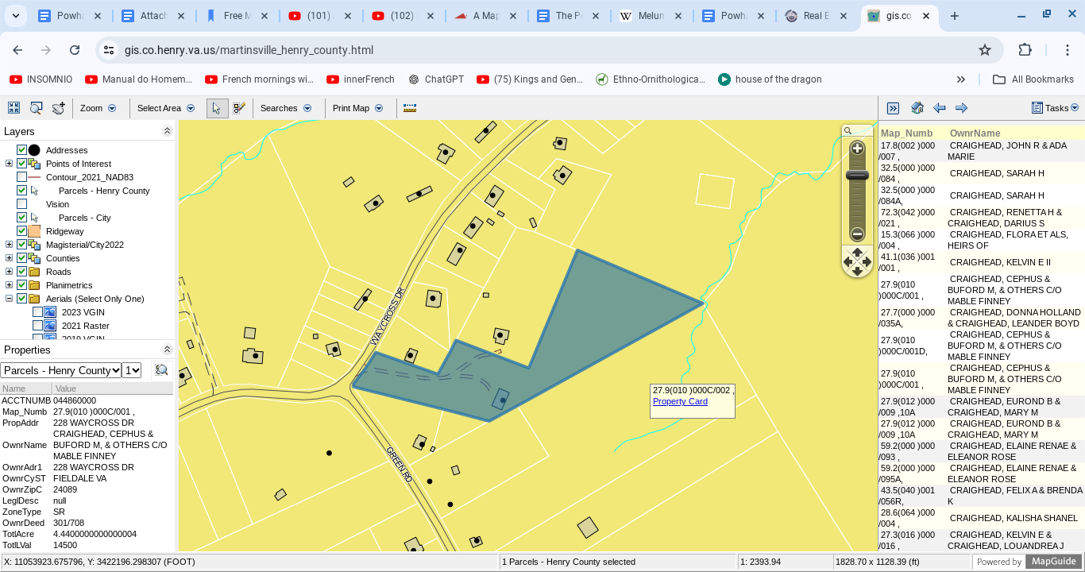

## Maps

**Attachments: 1 – 5**

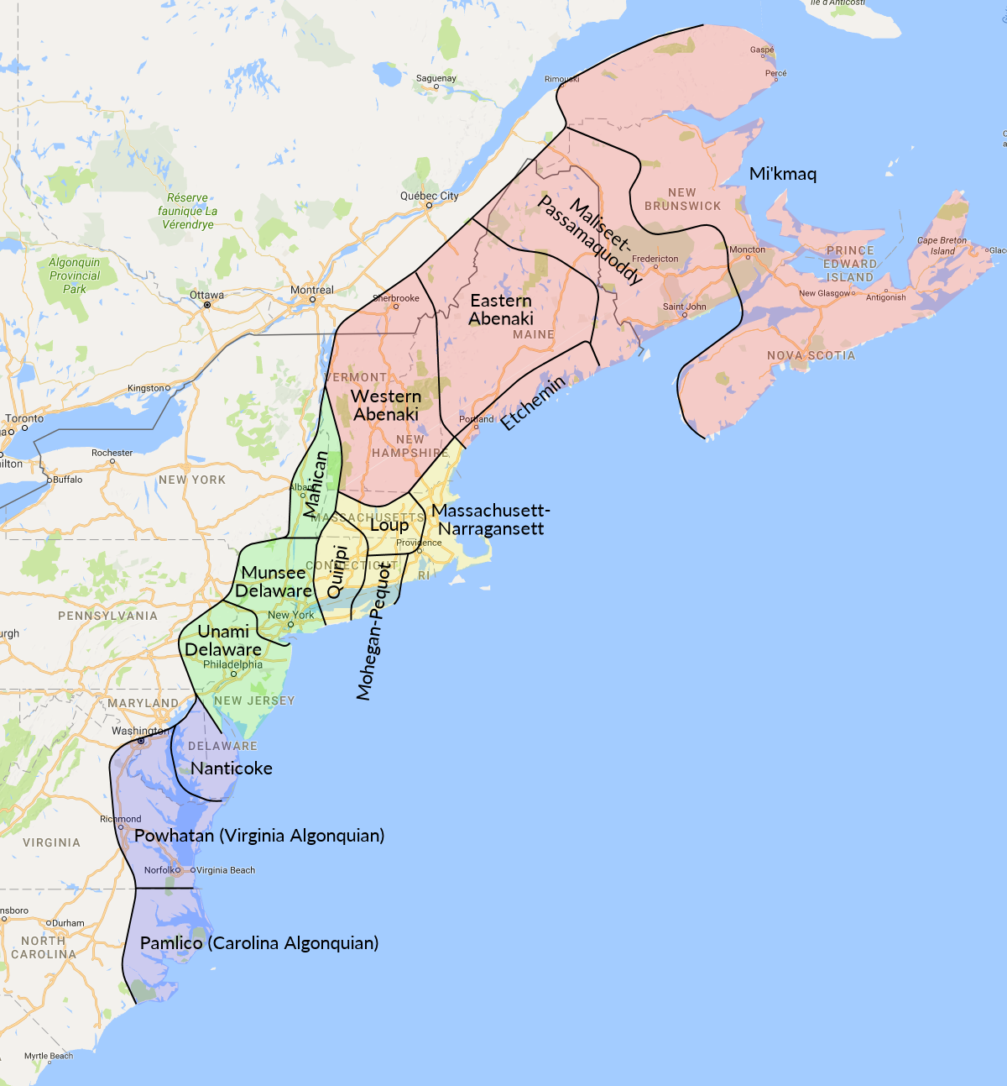

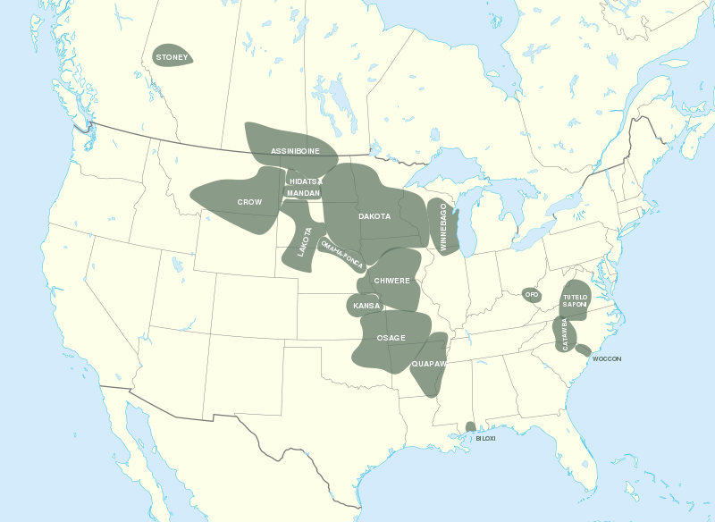

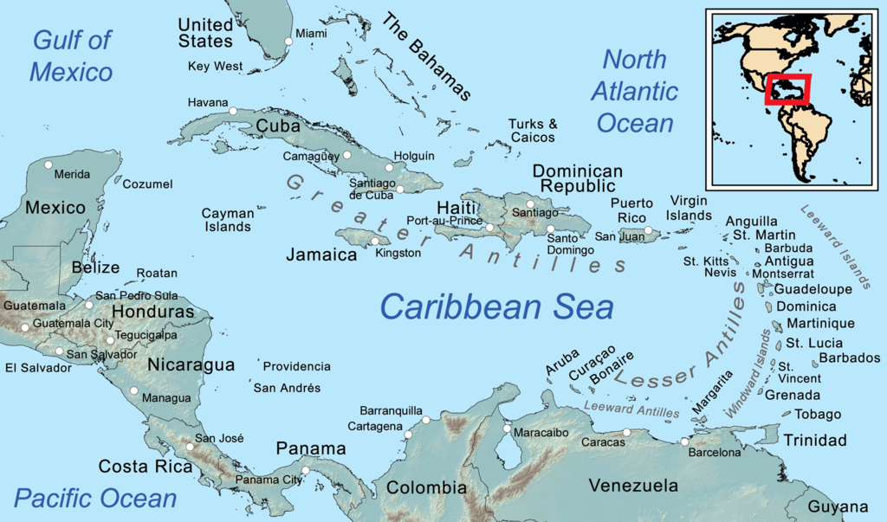

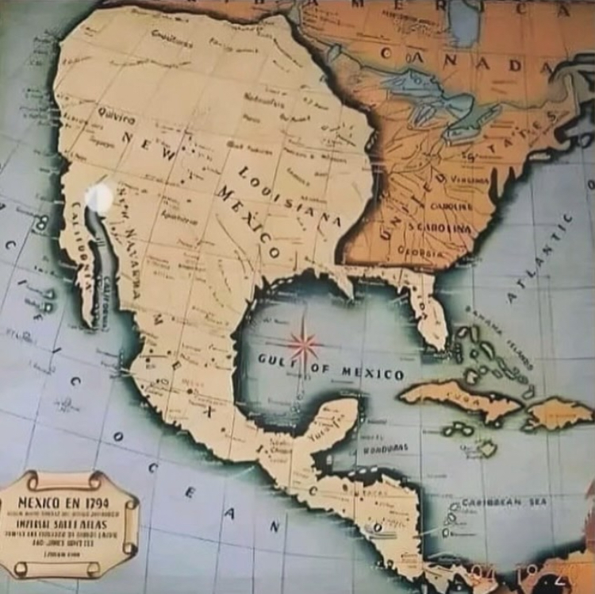

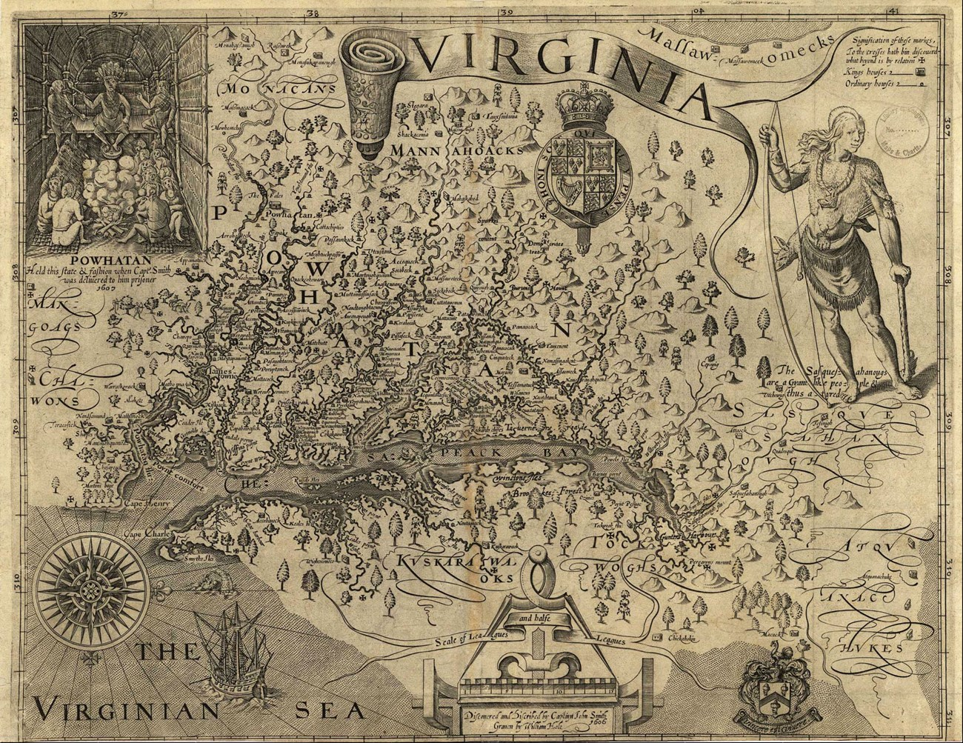

## Thomas Jefferson’s Indigenous Census

**Attachment: 1**

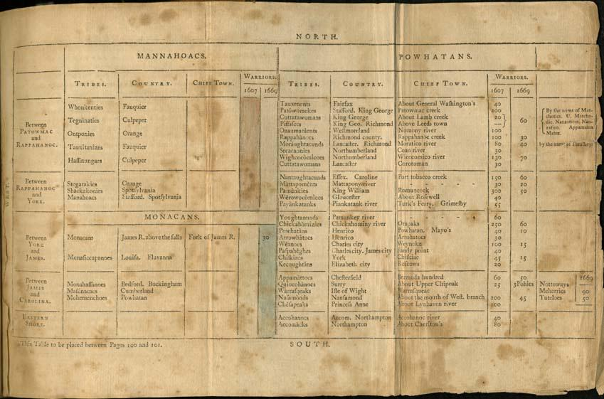

## Tribal Members

**Attachments: 1 – 7**

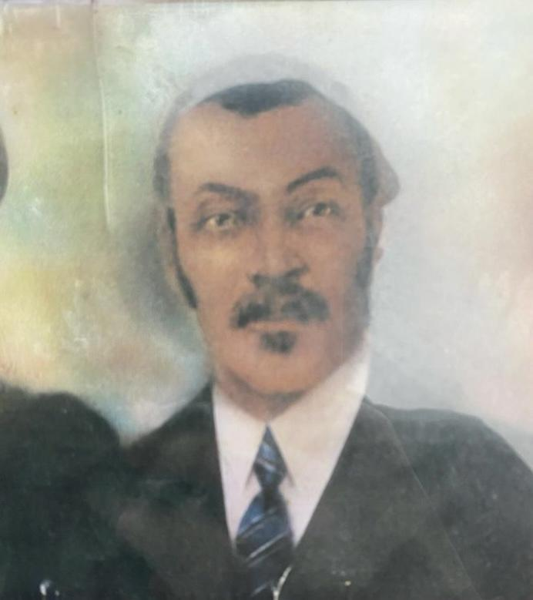

Andrew Miles. Former Chief and reservation owner.

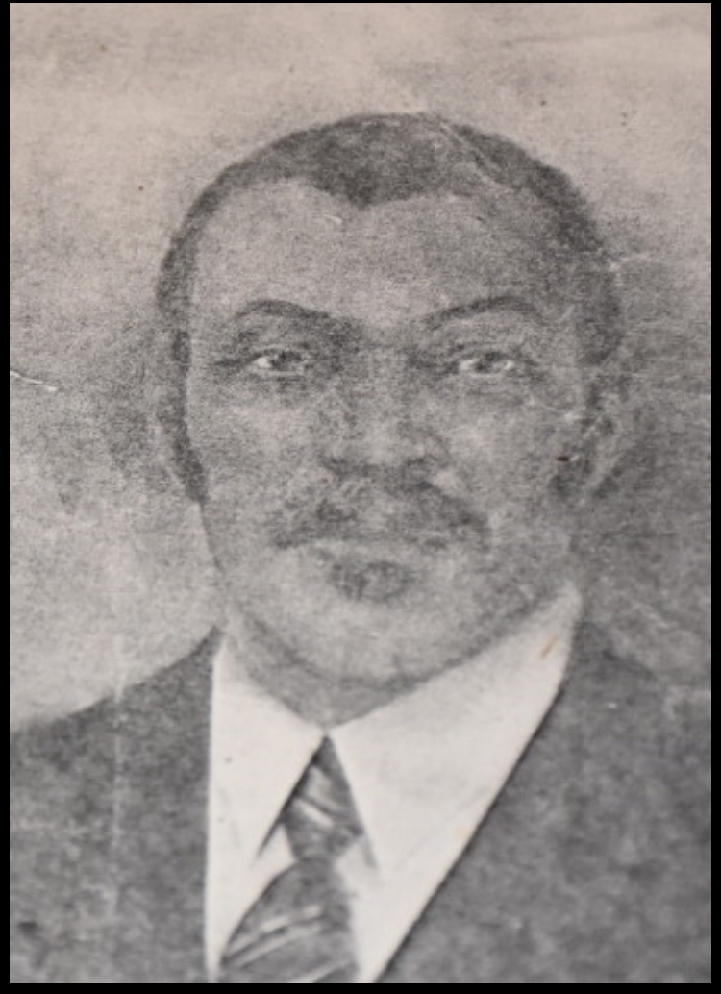

Andrew Miles. Former Chief and reservation owner.

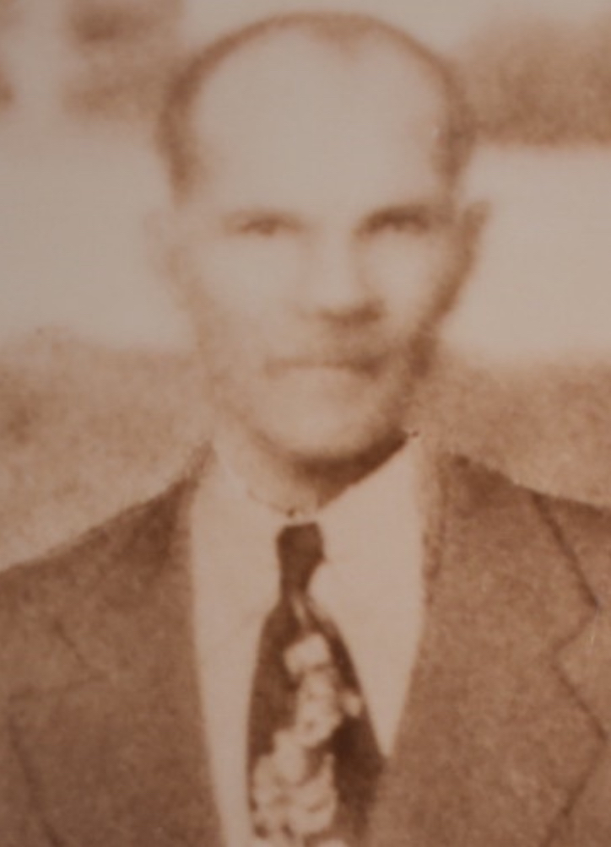

William Miles. Former Chief and reservation owner.

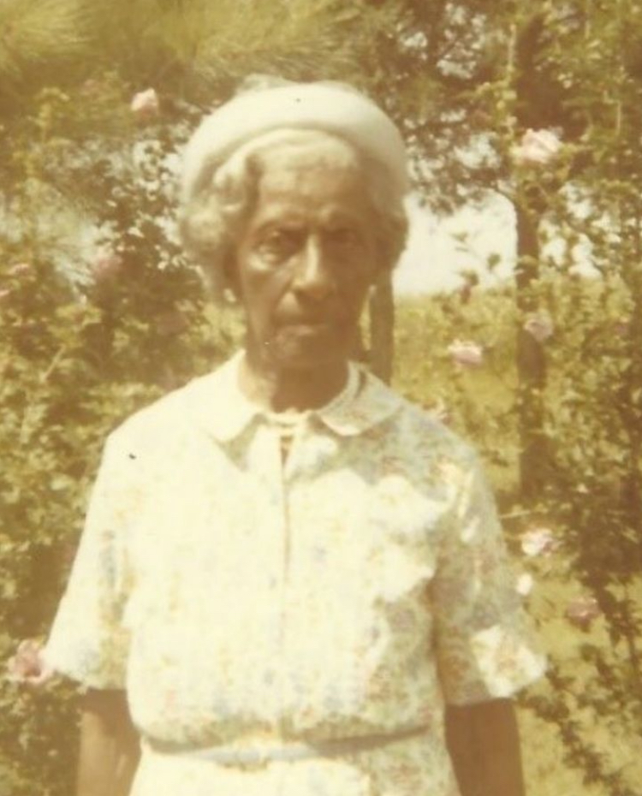Page Townes-Miles.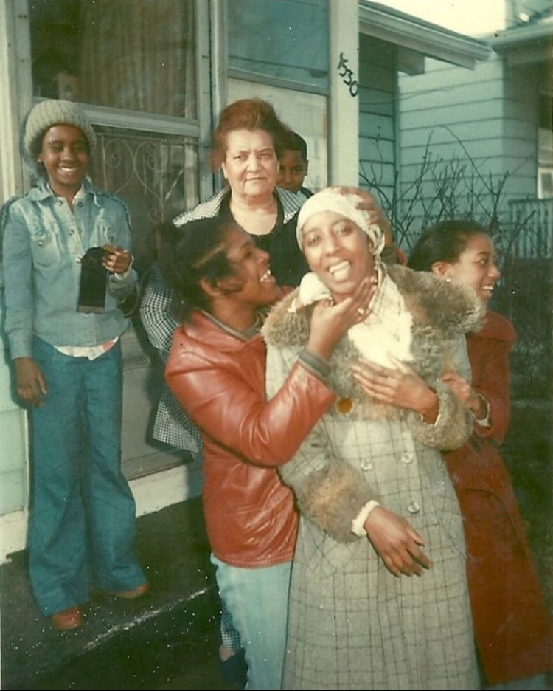Thomas Jefferson’s grandchildren. Barbara Ann Johnson, Steven Todd Morris (Jefferson), Estelle Carrie Johnson-Bolden, Carol Ann Royall-Hatcher, and Peggy-Ann Royall, Chief and owner of their reservation.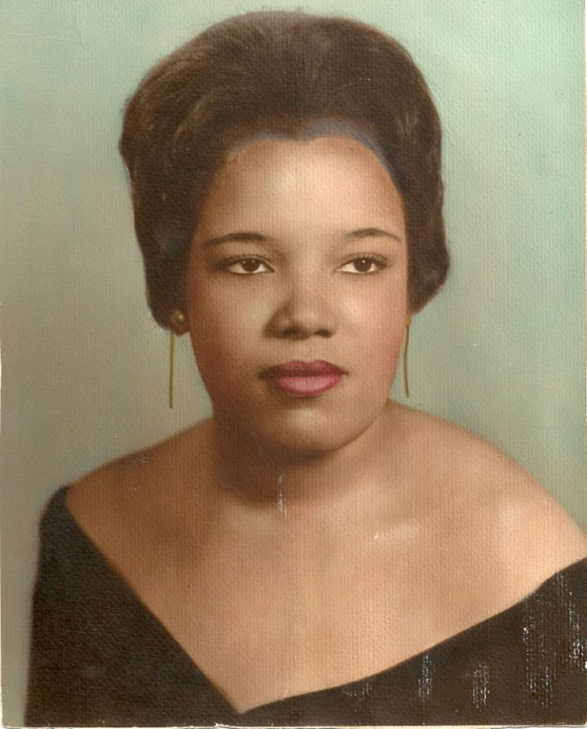Thomas Jefferson’s granddaughter, Geraldine Louise Bolden-Morris (Jefferson)

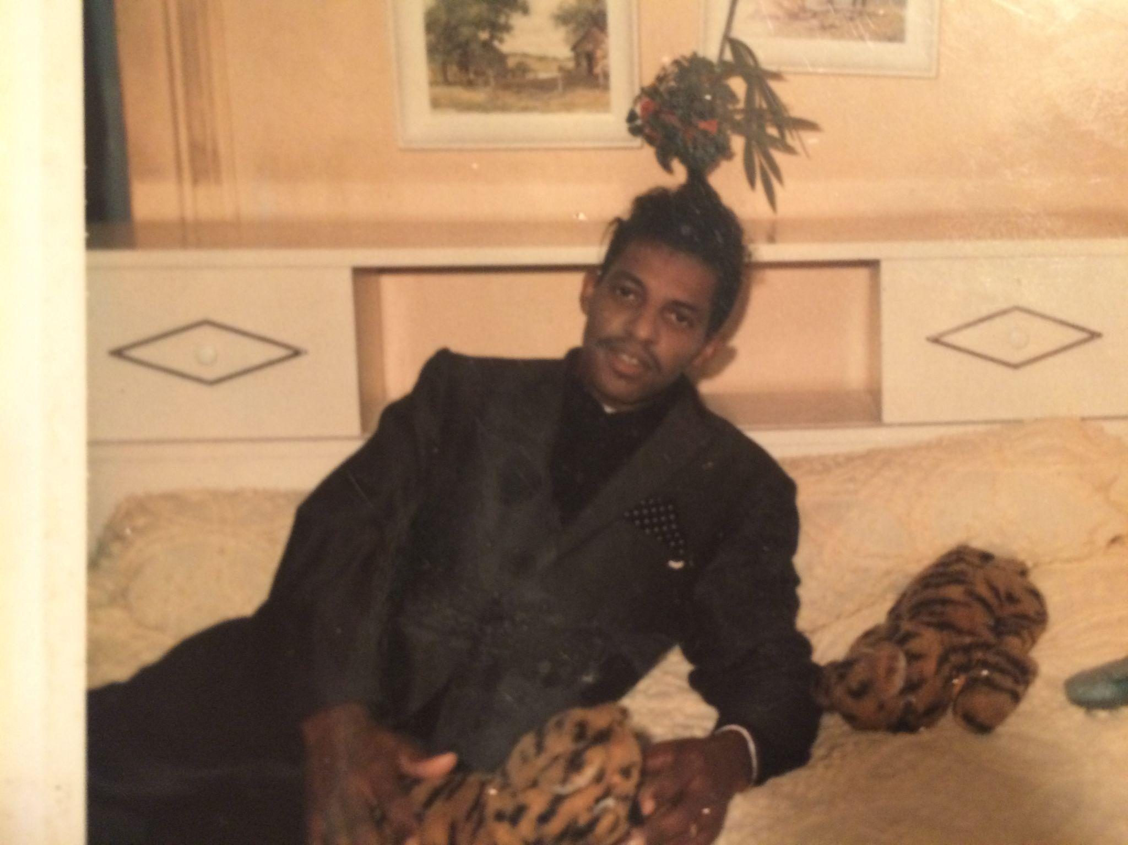

Thomas Jefferson’s grandson, Arthur Lee Morris (Jefferson).

## 

## Miscellaneous

**Crystal vs Sheila Daniels (Founder Effect & Genetic Drift)**

**Attachments 1 & 2:**

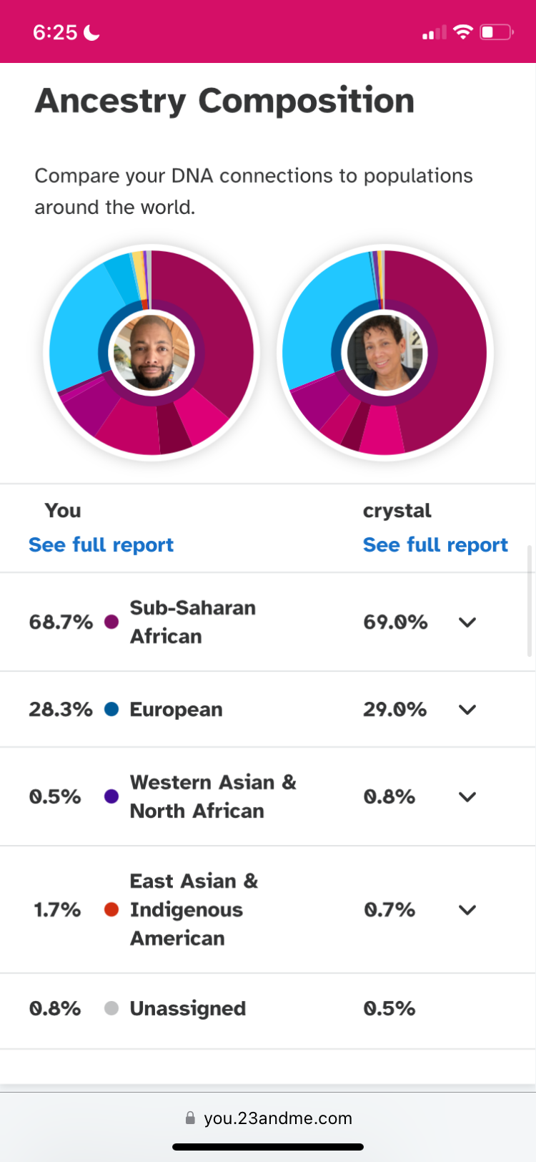

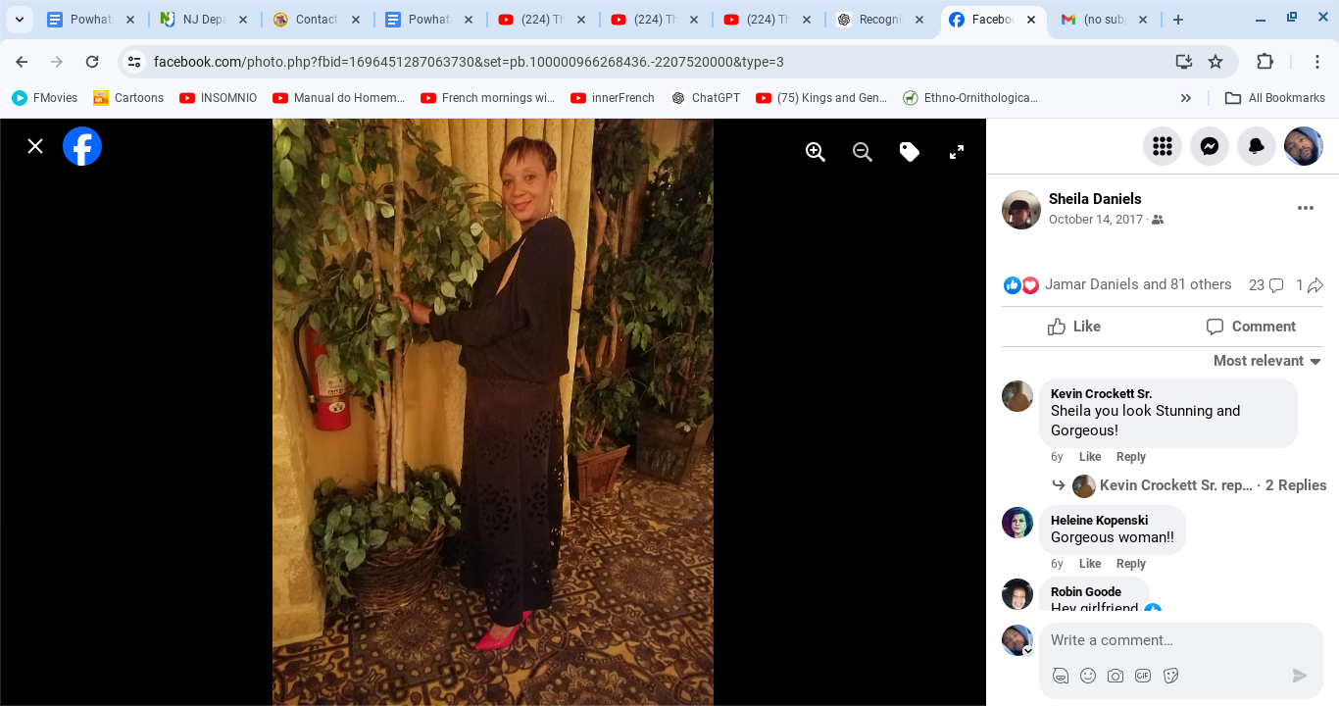

**Attachment: 3. Daniel Henry Craighead’s World War II draft card displaying his employer’s name as: *Pocahontas Fuel Company*.**

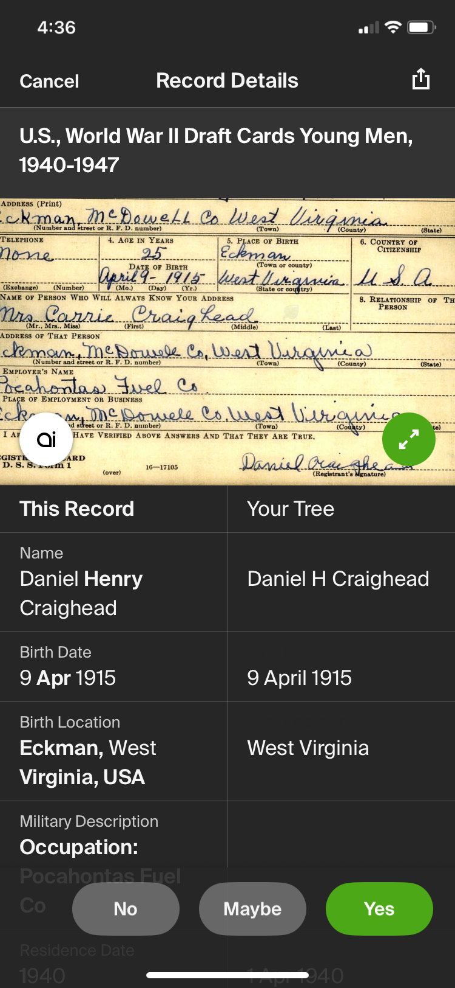

**Attachments: 4, 5. Tribal members that integrated into the Choctaw and Creek tribes.**

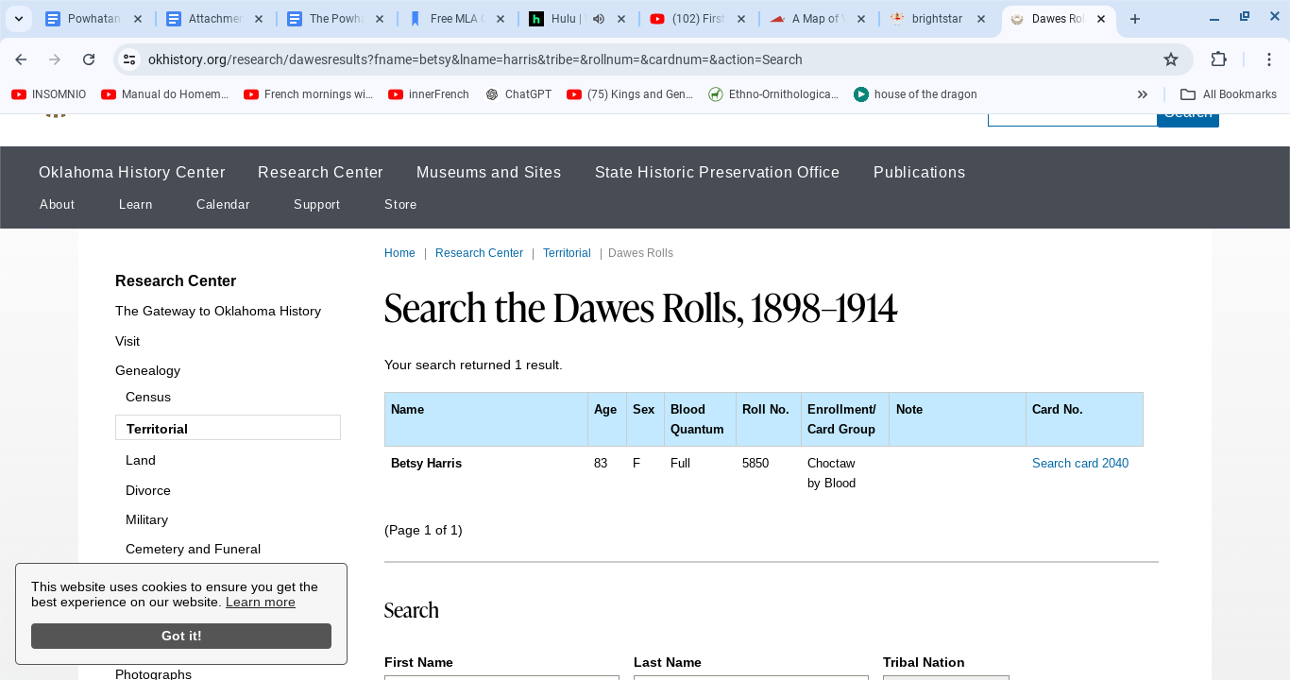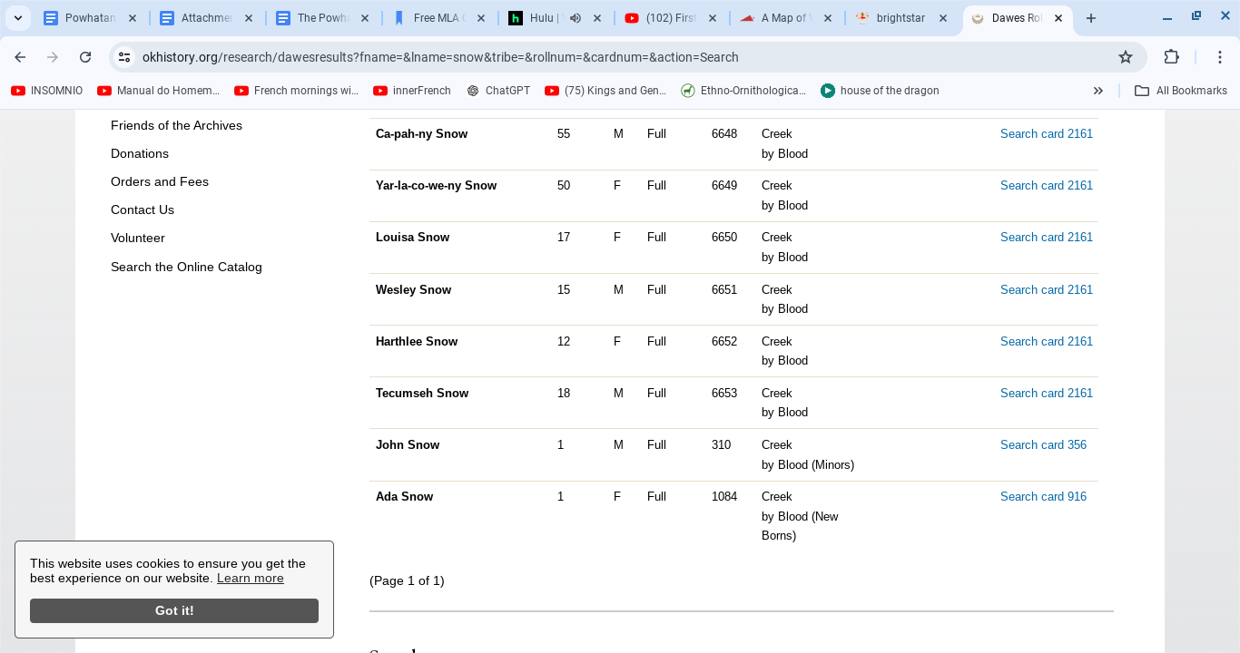

**Attachments: 6, 7. Tribal members that integrated into the Cherokee and Creek tribes.**

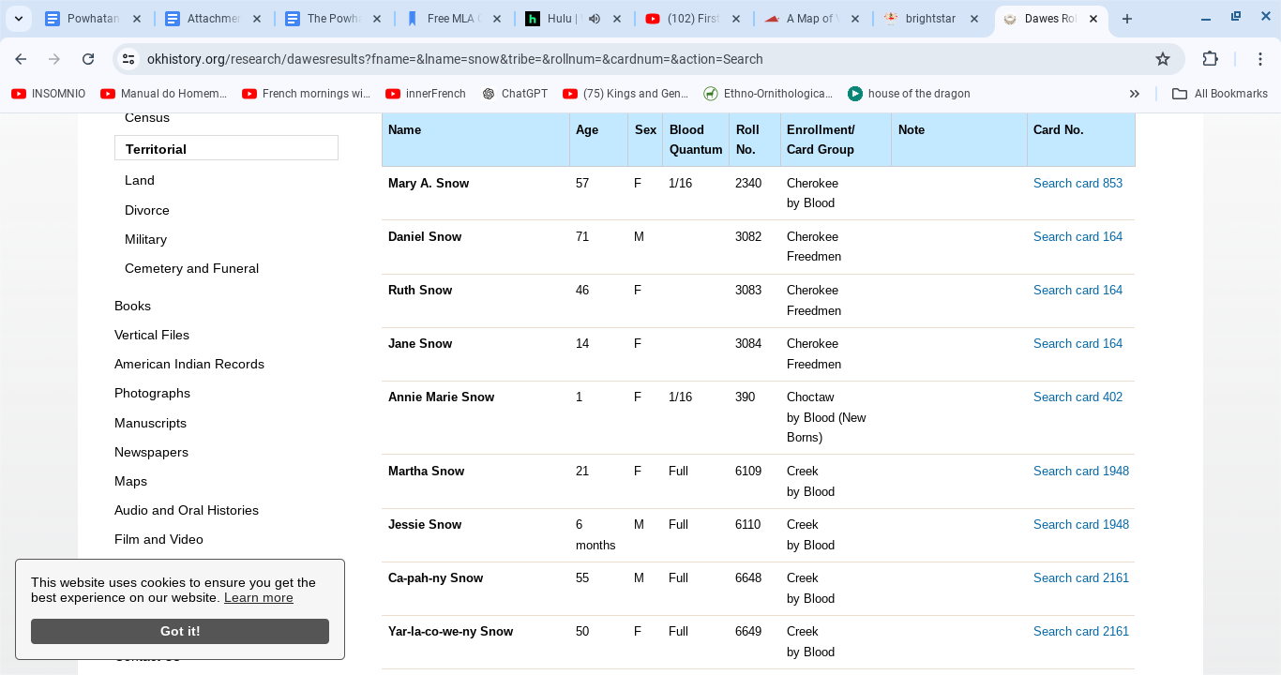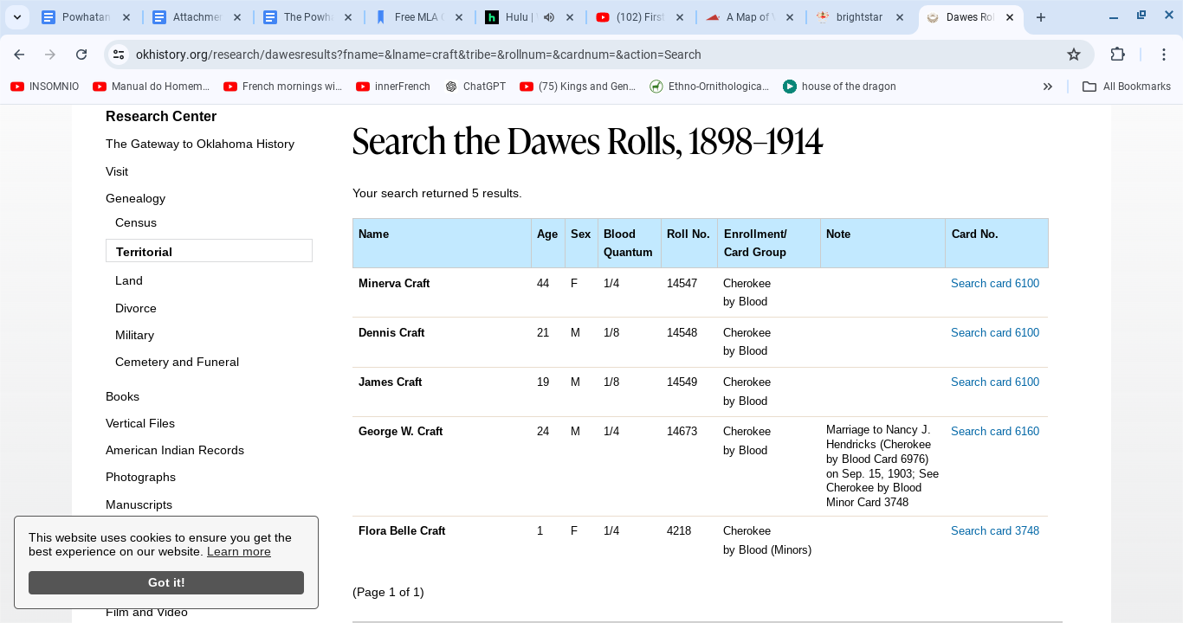

**Attachment: 8. Family tree displaying Cherokee Wolf clan members.**

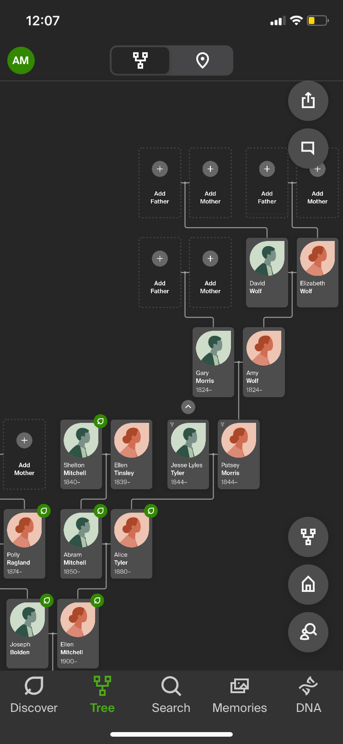

**Attachment: 9. The last speaker of Tutelo. [28]**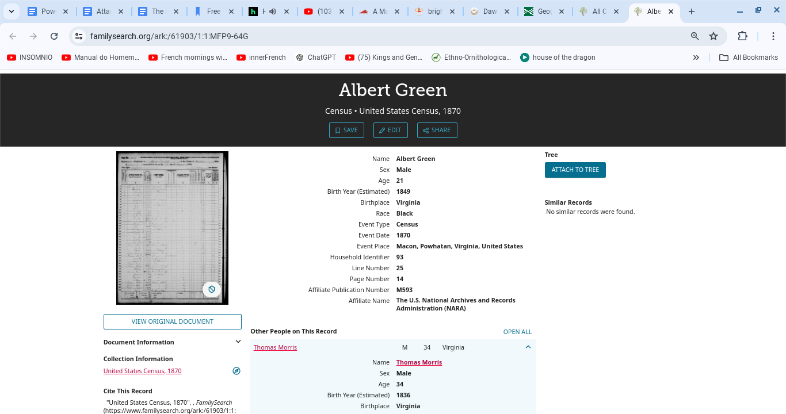

**Attachment: 10. A death certificate featuring Thomas Morris (Jefferson IV).**

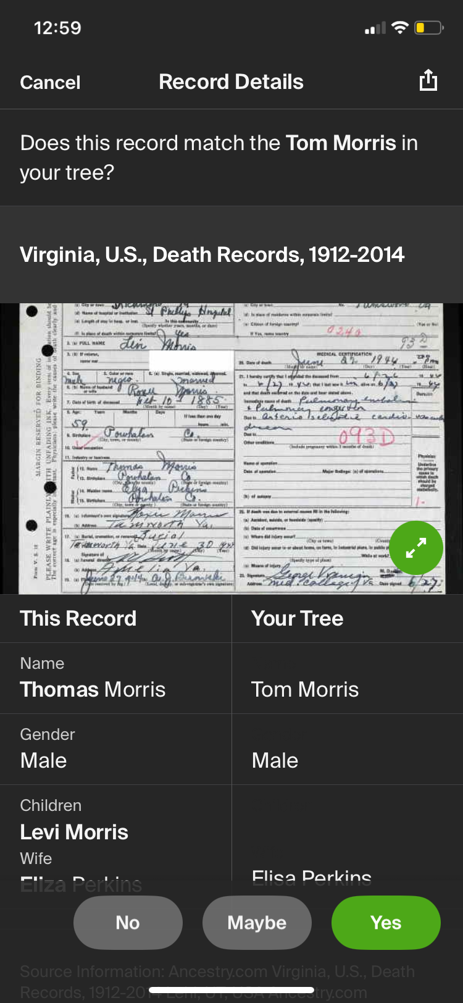

Note:

1. Thomas Morris (Jefferson IV) relocated and re-married in Marion Junction, Dallas, Alabama from Powhatan, VA.
2. In Powhatan, VA, Thomas was Colored. In Alabama he was Negro.
3. Berry Purifoy, similarly, was Negro/Black in Alabama. But, in Texas he was Colored.

**Attachment: 11. Thomas Morris (Jefferson IV) last marriage in Alabama.**

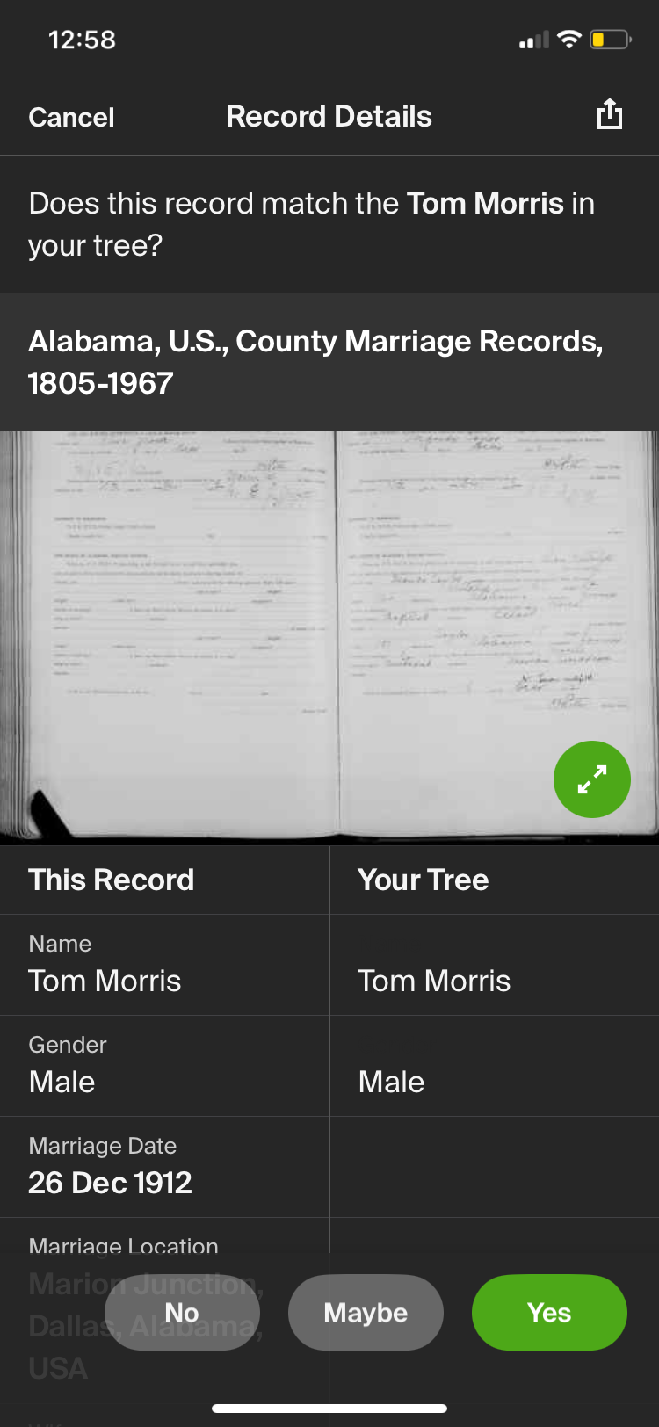

**Attachment: 12. Family of tribe member Dionna Lang. Our babies are still born as described by Captain John Smith. [61]**

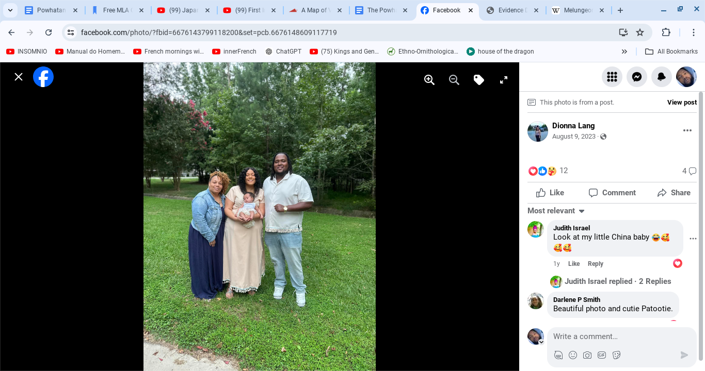

**Attachment 13. Steven Todd Morris (Jefferson), then wife Belinda Craighead-Morris (Jefferson), and son Ashton James Snow Jefferson (Morris). Our babies are still born as described by Captain John Smith. [61]**

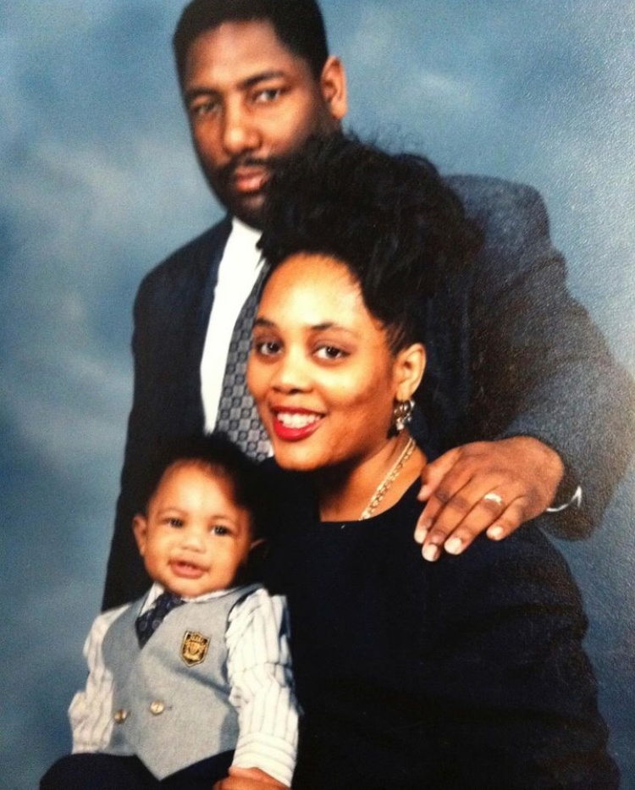

**Attachment: 14. Geraldine Bolden marriage to Arthur Morris (Jefferson).**

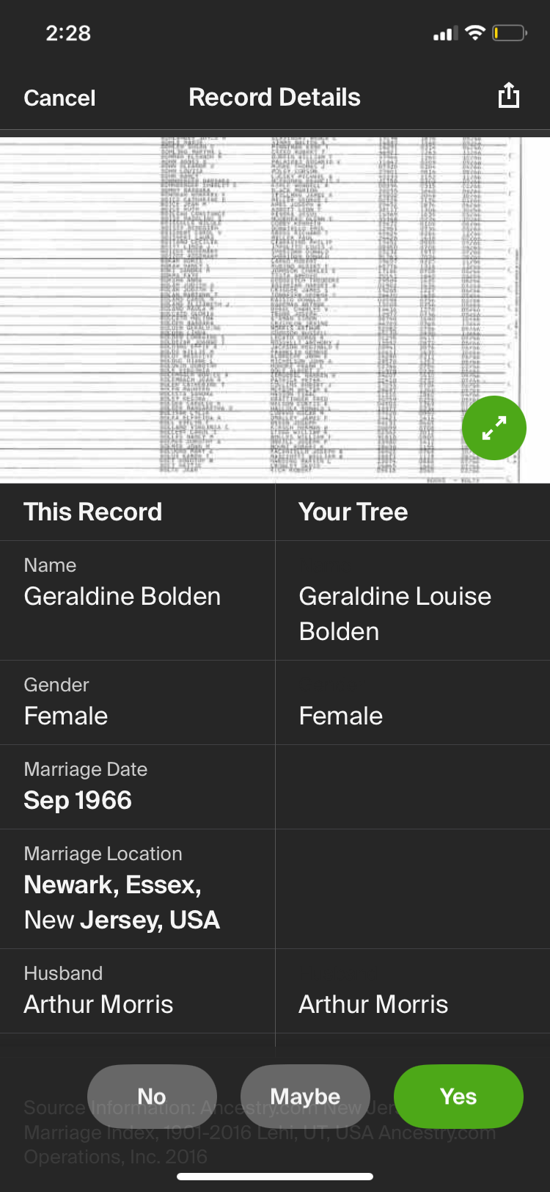

**Attachment: 15, Estelle Johnson-Bolden’s funeral card.**

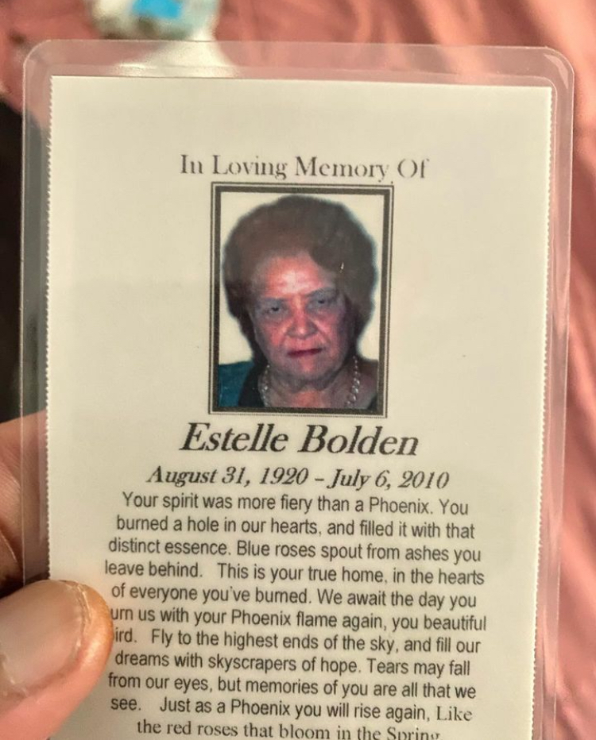

**Attachments: 16, 17. Estelle Johnson-Bolden listed as “Black” despite being, by all appearances, a white woman.**

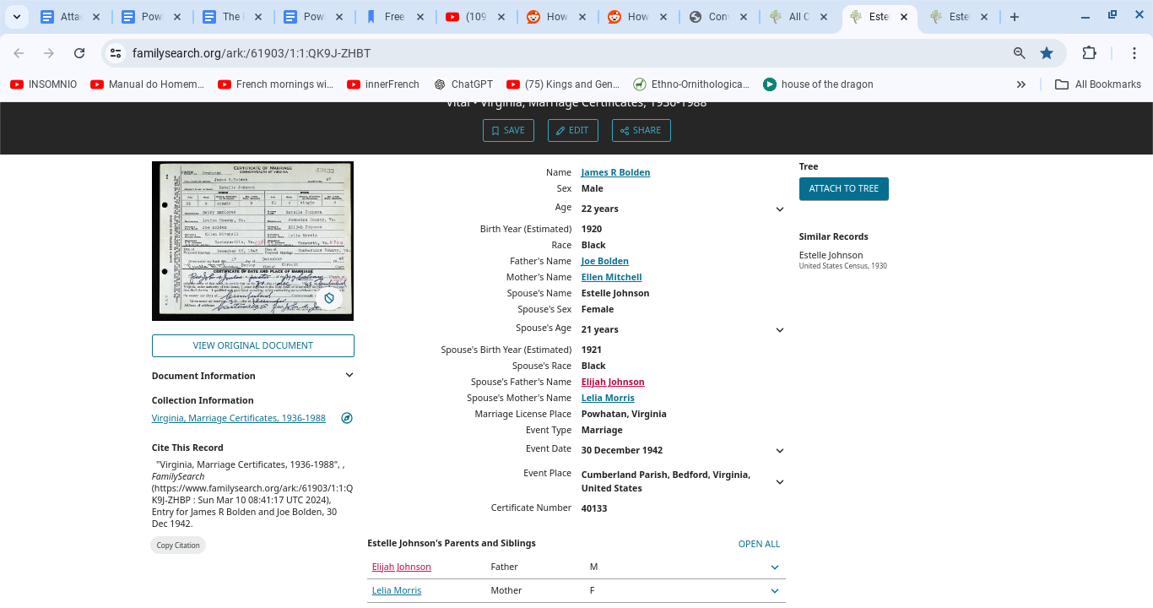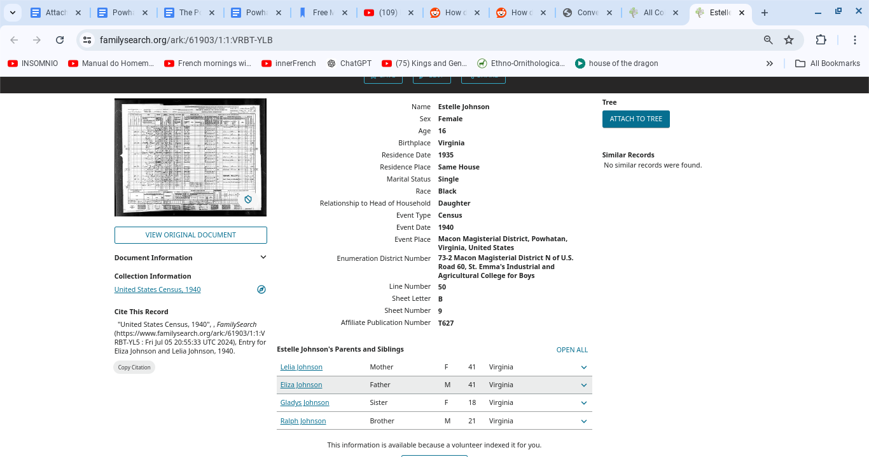

Proof of enslavement: **Works Cited, 135**.

**Attachments: 18 – 21. A Powhatan dictionary [38] featuring the word “maraca”.** 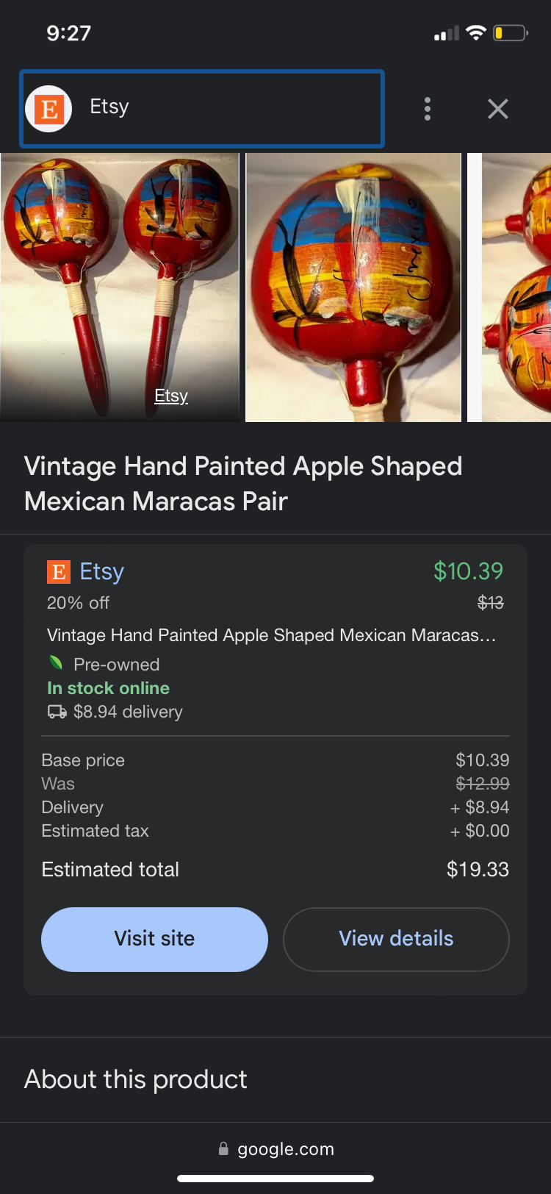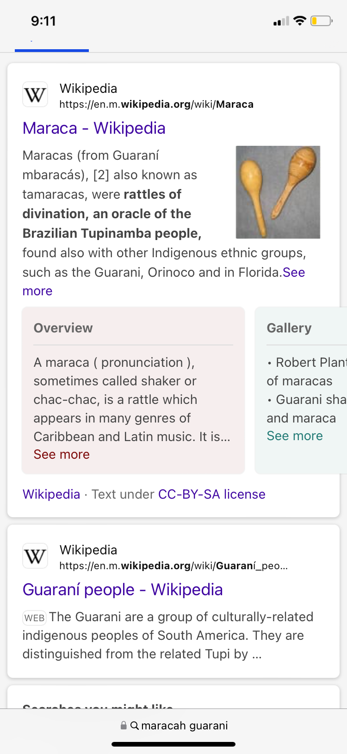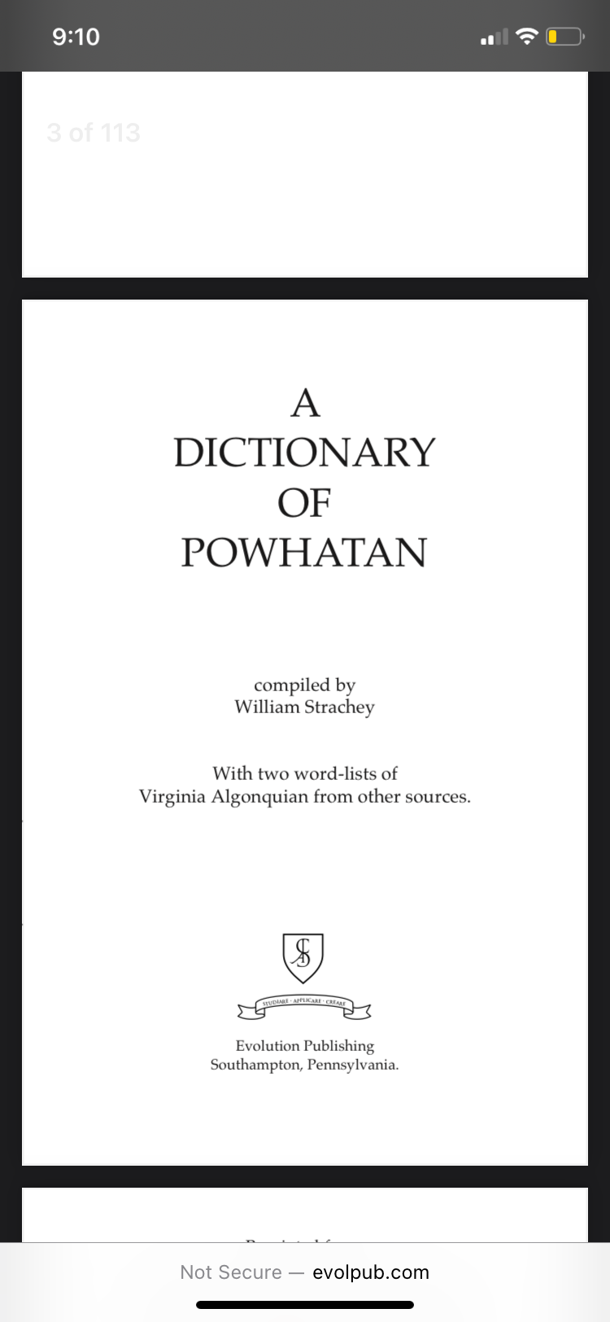

**Attachments: 22, 23, 24. The origin of Powhatan’s problem. The First Antioch Baptist Church that Alfred Morris founded in Powhatan, Virginia posted a picture of him with a celebrate Black lives ribbon. When juxtapositioned next to an indigenous Colombian, this man has no hint of African ancestry despite being enslaved after the third Anglo-Powhatan war.**

